**SIR BHAVSINHJI POLYTECHNIC INSTITUTE, BHAVNAGAR**



**ELECTRIC HOWEBOARD**

A Report

Submitted by

**JETHAVA SHARAD B. 166490302050**

**KALSARIYA PARTH H. 166490302054**

In fulfillment

For the award of the degree

Of

Diploma Engineering

In

Automobile Department



Gujarat Technological University, Ahmadabad, 2019

##### 

Automobile Department

April

2019

**CERTIFICATE**

Date:

This is to certify that the dissertation entitled “ELECTRIC HOWERBOARD” has been carried out by **MR. JETHAVA SHARAD B.** (**166490302050) MR.KALSARIYA PARTH H.(166490302054**) under my guidance in fulfilment of the Diploma of Engineering in **AUTOMOBILE(6TH SEMESTER)** of Gujarat Technological University, Ahmadabad during the academic year 2019

Reviewed By: **M.J Gohil Sir**

Examiner Sign:

H.O.D.

AUTOMOBILE DEPARTMENT

SIR B.P.T.I, BHAVNAGAR

ACKNOWLEDGEMENT

We express our sincere gratitude to our institute **SIR BHAVSINHJI** **POLYTECHNIC INSTITUTE** which has helped use in all respect to reach our goal.

No work can be done without the help of other people, things and other intermediaries. This is because intermediate direct with the work that is to be done.

I feel highly appreciated and grateful to **M.J.Gohil** Sir for their continuous support and guidance .For giving valuable ideas and suggestion my report on **ELECTRIC** **HOWERBOARD**, providing us the necessary information.

I completed this report successfully and I am also thankful to **H.O.D. D.A.Dave** Sir.

**- Sharad B. Jethava**

**-Parth H. Kalsariya**

**LIST OF CONTENT**

|  |  |  |
| --- | --- | --- |
| **Chapter No.** | **Chapter Name** | **Page No.** |
| 1 | Introduction of howerboard | 5 |
| 2 | Working of electric howerboard | 6 |
| 3 | Use component and material | 7 |
| 4 | Advantage | 15 |
| 5 | Disadvantage | 16 |
| 6 | Conclution | 17 |
| 7 | Refrence | 18 |

**LIST OF FIGURE**

|  |  |  |
| --- | --- | --- |
| **Figure No.** | **Name of figure** | **Page No** |
| 1 | Motorized wheel | 8 |
| 2 | Electric motor | 9 |
| 3 | PVC pipe &alba | 9 |
| 4 | Battery fig. | 10 |
| 5 | Chair roller castor wheel | 11 |
| 6 | Screw & nut | 12 |
| 7 | Switch & wire | 13 |

* **INTRODUCTION**

* A howerboard is a levitating board used for personal transportation, first described by author M.K joseph in 1967 and populararized by the back of the future film franchise.
* Howerboard generally depicted as reseming a skateboard without wheels. During the 1990s there were rumors, fueled by director Robert zemeckis, that howerboards were in fact real, but not marketed because they were deemed too dangerous by parent’ groups. These rumors have been conclusively debunked.
* Electric howerboard concept has been used by many authors in various forms of media, for instance in the 1998 film future sport, used by dean cain’d character.

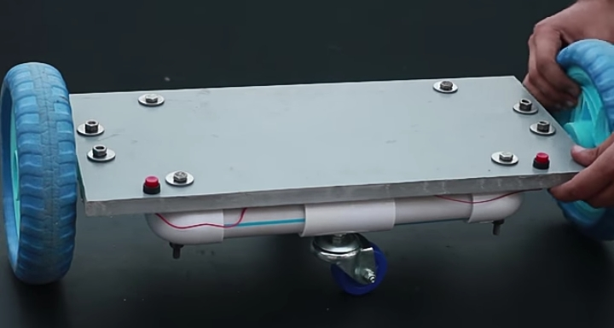

Fig. howerboard

* **WORKING OF HOWERBOARD**

The wheels of the hoverboard house the electric motors themselves.they also contain a tilt and speed motor.this detect the rpm (revolution per minute) of the individual wheel, and sends it to

The motor and speed control switch,located inside the main body,right next to the wheels.and working to pad control device is connected to the battery terminal. And two main wheel spot are chair wheel.

A electric howerboard is a self–balancing consisting of two motorized wheels connected to a pair of articulated pads on which the rider places their feet. The rider controls the speed by learning forwords or backwords,and direction of travel by twisting the pads.

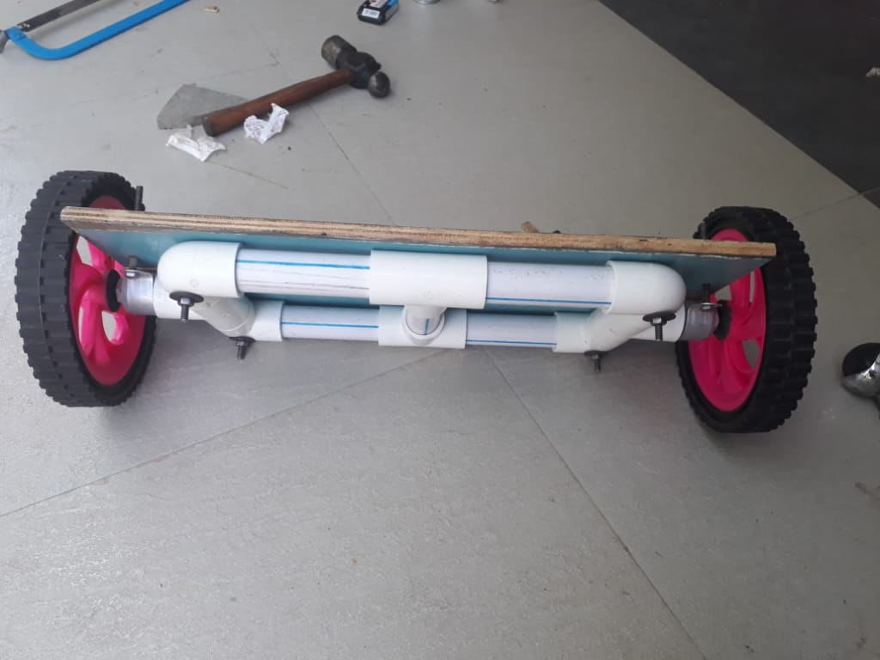

* **USE COMPONENT AND MATERIAL**
* Motorized wheel
* Electric motor
* PVC pipe & alba
* Battery
* Wires
* Switch
* Screw & bolt
* Wooden plate
* Chair roller castor wheel
* Electric adapter
* **MOTORIZED WHEEL**

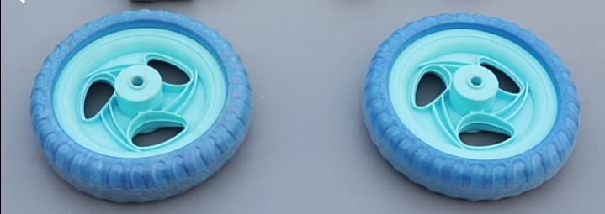

Fig. wheel

* This wheel is used to give spot to the motor.
* it is rotate with a motor.
* **ELECTRIC MOTOR**

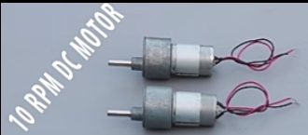

Fig. motor

* This motor is a 10 rpm motor.
* Its connection is given with battery.
* This Motor are made by plastic gear, so that it has the strength of 10 rpm.
* **PVC PIPE &ALBO**

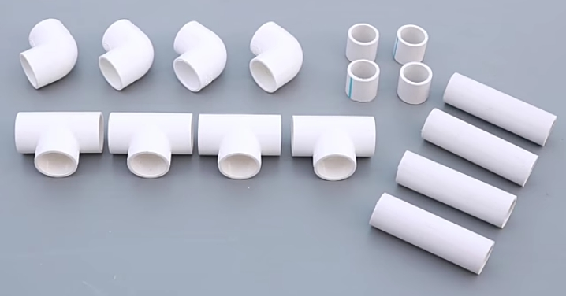

Fig. pipe & alba

* To make the order, it is 4 pipe and 4 alba and the different ones are taken back to make it like a body.
* Hole is applied to take an equal measure in all four corners.
* **BATTERY**

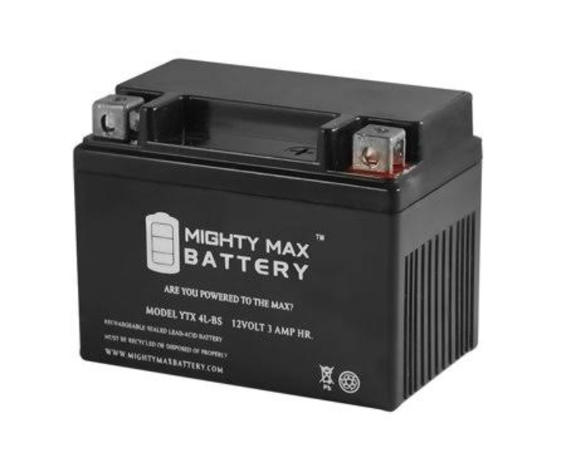

* This battery is 12 volt. It is fitted under a wooden suit.
* Through it the power is energized to the motor and its connection is accompanied by an arc.
* **CHAIR ROLLER CASTOR WHEEL**

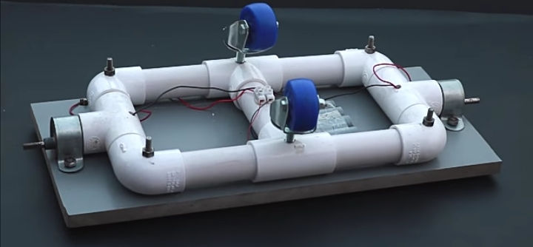

Fig. roller wheel

* The main function of the chair castor roller wheel is to give a spot to the wheel is to give a spot to the wheel with a motor.
* As, he goes ahead as a hoverboard he moves in the direction of the vehicle.

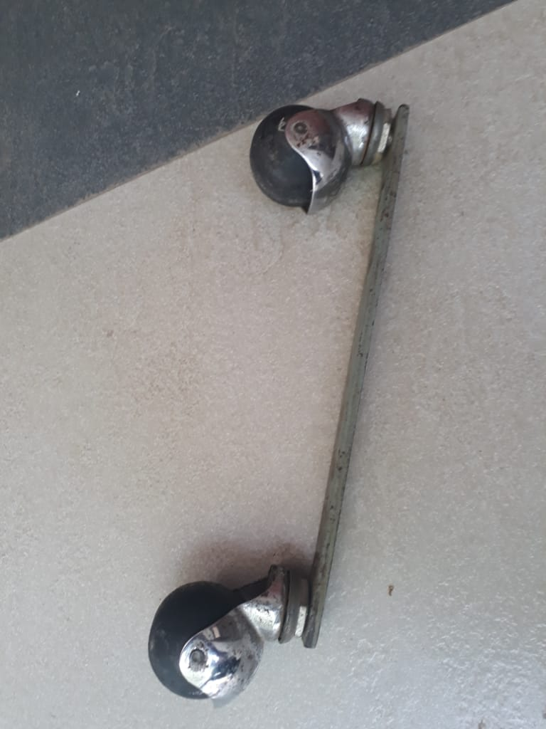

* **OTHER COMPONENT**

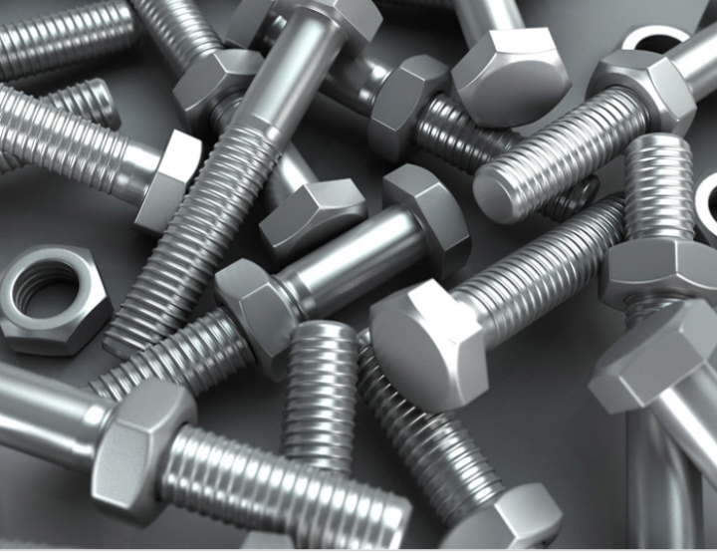

Fig. nut

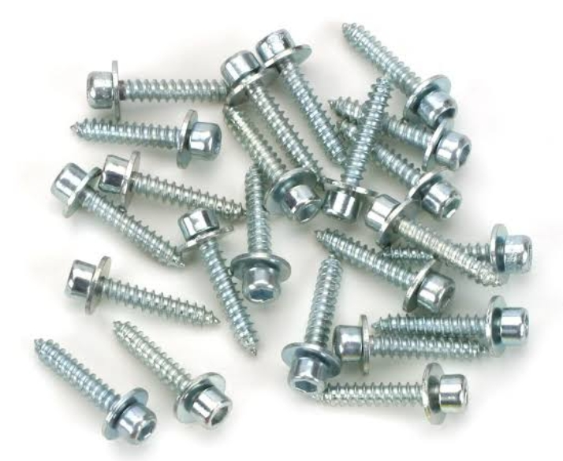

Fig. screw

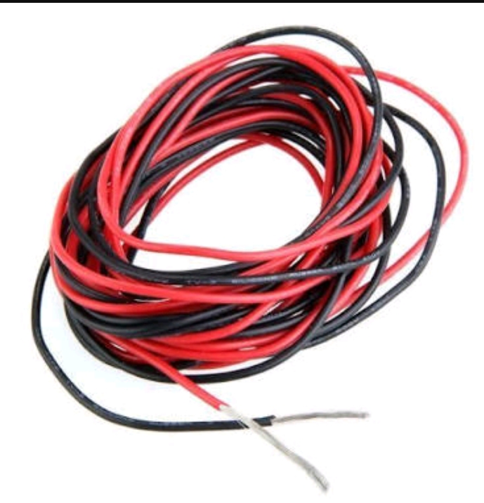

Fig. wires

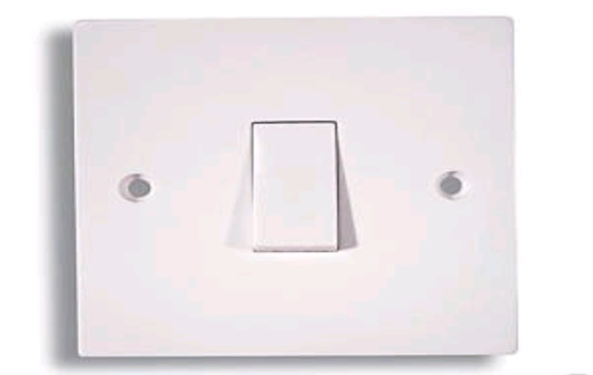

Fig. switch

* **COMPLET PROJECT**

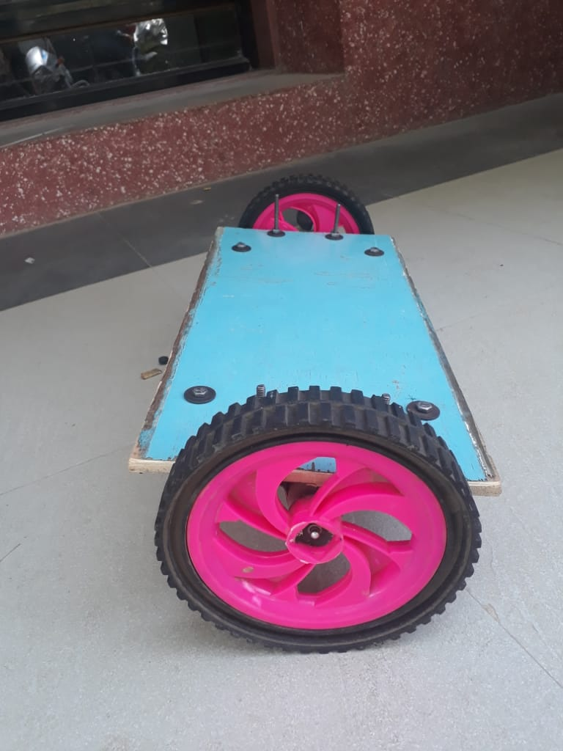

Fig.

* **ADVANTAGE**

# Less Costly

* As you all know petrol prices these days are reaching heights and costs keep on increasing and making these types of howerboard a great option of transportation.
* These electric howerboard have the ability to enable you to save a huge amount of money, as they do not consume a lot of fuel.
* When it comes, it buying them it’s actually pretty cheap compared to cars and other big vehicles.
* You can buy an electrical cycle at the lowest price from india.

# Environment friendly

* This is probably one of the best reasons to buy a self-balancing howerboard .
* As you know many industries are already destroying the nature by using tons of chemicals.
* The least you can do is take a step forword and contribute towards the nature security.
* These self-balancing howerboard are eco-friendly and produce less sound and the best thing, do not release toxic gases into the environment.
* Proving to be more beneficial towards the environment. \
* **DISADVANTAGE**
* Many are reported that hoverboards are exploding. Lithium ion batteries on hoverboard caused overheating and worst burst into flame that can destroy houses.
* Hoverboards are hard to find because markets already limited their stock because of its burning issues and because it is expensive.
* Users can get injuries for incorrect using of hoverboard .
* A lot of children and even parents are hospitalized because of accident mostly linked to falls and collisions.

* **CONCLUTION**
* Electric hoverboard is the only hoverboard available in low price with high quality when compared to other hoverboard available in a market.
* The problem of accident becomes less.
* As well as environmental problems can also be solved.
* The price of this electric hoverboard can be reached to everyone.

* **REFERENCE**

