BINDIYA KARNANI

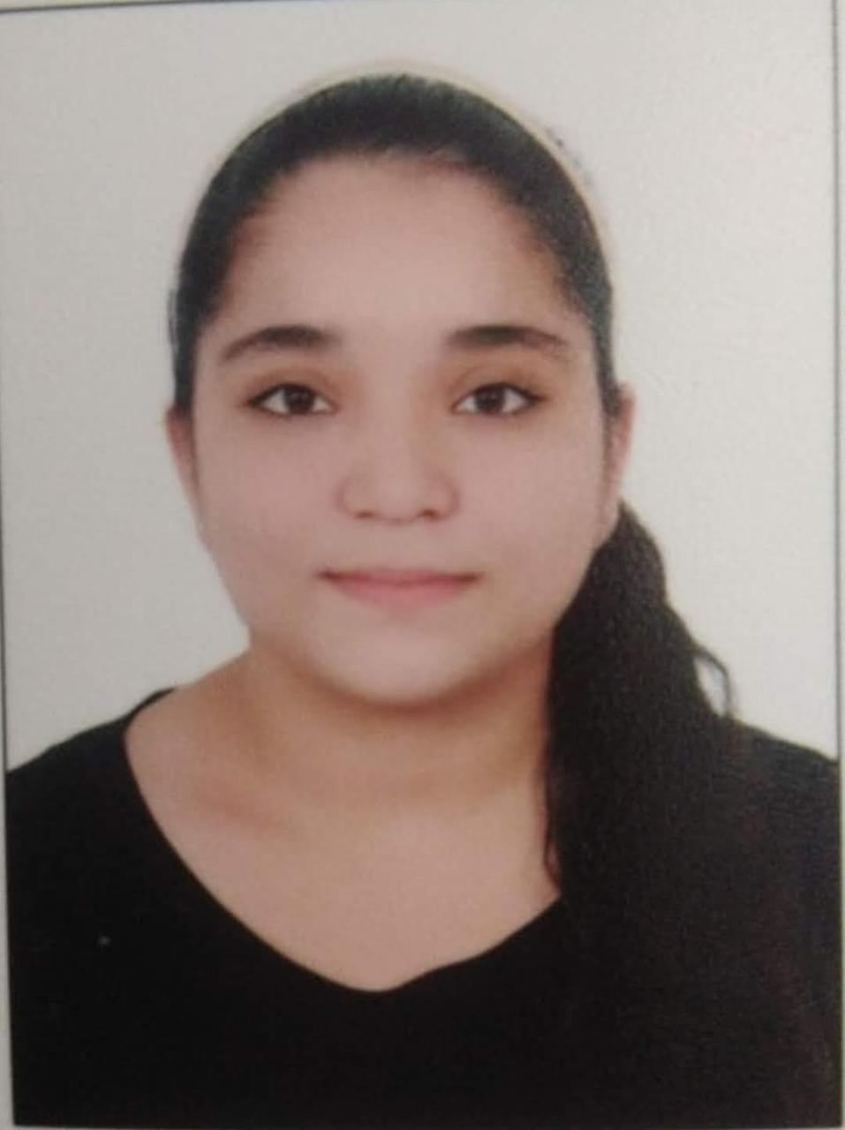

Contact

**Address:**

K-15 Nilkanthvarni Ghanshyamnagar Society,

RTO circle,

Ahmedabad

Gujarat – 380 027

**Phone:**

+91 95743 02425

**Email:**

**bindiyakarnani24**@gmail.com

Languages

English

Gujarati

Hindi

Sindhi

Personal Details

DOB: 24/01/2002

Gender: Female

Nationality: Indian

Marital Status: Unmarried

Summary

Experience in handling various tasks in annual functions organized at school and college levels. An enthusiastic person, ready to contribute for the organization with good communication ability and team management skill.

Skill Highlights

|  |  |
| --- | --- |
| * Team management * Strong decision maker * Complex problem solver * Communication |  |

Experience

**Corporate Experience** – None

Education

Bachelor of Commerce (6th Semester completed in April 2023, Result awaited ) from JG College of Commerce (GU)

H.S.C – GSEB – 70%

S.S.C – GSEB – 59%

Computer Skills

Tally Prime

MS Office