**COVER LETTER**

KOTHIYA HARDIK N.

Mail Id:-hardikkothiya93@gmail.com

Contact No:-8806512148

Dear Hiring Manager,

I'm applying for a engineering position at your company. Based on the posted description, I'm confident that I am fully qualified for the position and will be a strong addition to your team. I would appreciate a job interview at your earliest convenience.

Please find my resume attached.

I can be reached at the number above or at my email address.

Sincerely,

KOTHIYA HARDIK N.

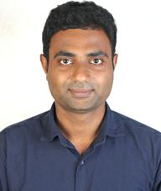**KOTHIYA HARDIK N.**

hardikkothiya93@gmail.com

263, Akshardham society, Laxmikant ashram road,Katargam, Surat 395004. Mobile : 8806512148.

**CAREER OBJECTIVE**

To obtain a challenging position in a high quality engineering environment where my resourceful experience and academic skills will add value to organizational operations.

**ACADEMIC DETAILS**

* Mechanical Engineer [2015] with aggregate of 64.33% from Pune University.
* HSC [2011] with aggregate of 71.54% from V. T. Choksi English medium school .
* SSC [2009] with aggregate of 87.69% from Gajera Vidhya Bhavan .

**WORK EXPERIENCE**

* Working as Service Engineer in Enginox Technologies from Apr 2016 to till date .
* Worked as Business Associate in Accord incorporation. from Aug 2015 to Sep 2015 .

**PROJECT DETAILS**

**• Automatic Indexing Lift**

|  |  |  |
| --- | --- | --- |
| **Description** | **:** | Aim to achieve saving of space and time through use of geneva wheel. |
| **Duration** | **:** | 6 months |
| **Role** | **:** | Design, Assembly, Research. |
| **Team Size** | **:** | 4 |
|  |  |  |

**FIELD OF INTERESTS**

* Production/manufacturing.
* Design-(Autocad / Pro-E).
* QA/QC.

**SKILLS**

* NDT Level || (UT, PT, MT, RT) .
* Autocad .
* Pro – Engineer.
* Microsoft Office.

**ACHIEVEMENTS**

* Gujarat state level, interschool/inter college volleyball Championship.
* Co-ordinator SKH's association mechanical department .

**STRENGTH & HOBBIES**

* Not to Give up too soon.
* Stay calm think and act.
* Capability to think out of box.
* Volleyball,
* Reading,
* Driving,
* Listening to News
* Movies

**DECLARATION**

I hereby declare that all the details furnished above are true to the best of my knowledge and belief.

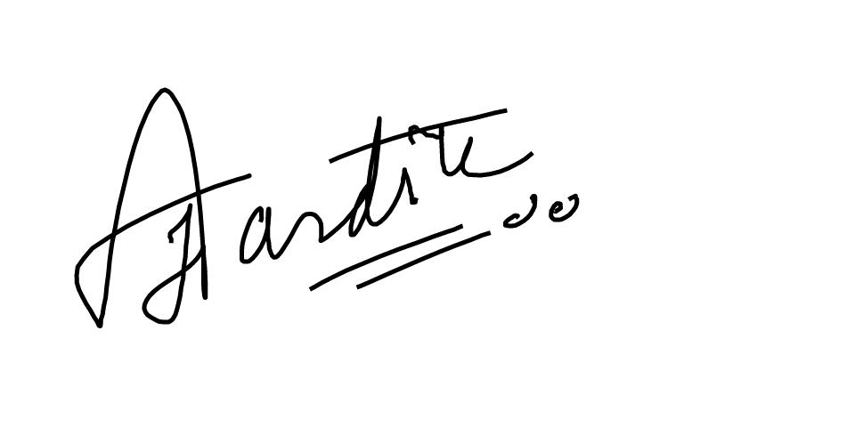

(KOTHIYA HARDIK N.)