**RESUME**

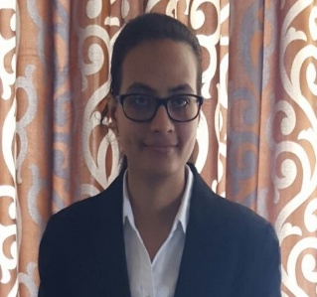

KHYATI CHAUHAN

# 8980986851

khyyaati@gmail.com

----------------------------------------------------------------------------------

**Career Objective:**

* To work for an organization this provides me the opportunity to improve my skills and knowledge to growth along with the organization objective.

**Educational Qualification:**

* Pursuing MBA (Integrated MBA) from L.J Institute of Management Studies, Gujarat Technological University
* Completed BBA (Integrated MBA) from L.J Institute of Management Studies, Gujarat Technological University with SPI – 7.88, CPI – 6.66 in year 2016
* Achieved HSC at Shiv Ashish School with 59% in year 2012,Gujarat Higher Secondary Board
* Achieved SSC at Shiv Ashish School with 67% in year 2010,Gujarat Board

**Computer Skills:**

* Knowledge of MS-Office (Word, Excel and PowerPoint)

**Internship:**

* Company Name: Gateway Technolabs Ltd.
* Designation: Management Trainee
* Description: Documentation, Filling, Appraisal, Employee Engagement, Training and Development.
* Project title: Employee Life Cycle Management
* Duration: 4 months

**Projects Undertaken:**

* In semester VI I have worked on the project of “Employee Satisfaction”
* In semester VII I have worked on the project of “Employee Life Cycle Management”
* In semester VIII I have worked on the project of “Employee Engagement”.

**Workshop Attended:**

* Workshop of Human Resource Management by college.
* Certification course of Cambridge Business English with B1 grade.

**Events:**

* Participated in LJWEDP (Lok Jagruti Women Entrepreneurship Development Programme).
* My innovative business idea was among top 5 teams also won consolidation price.
* Coordinating at college events.

**Personal Profile:**

Name : KHYATI .R. CHAUHAN

Father Name : RAJNIKANT A. CHAUHAN

Date of Birth : 04-10-1995

Marital Status : Un-Married

Languages Known : English, Hindi and Gujarati

Hobbies : Listening to music, Travelling

Address : 22, Jaldeep Bunglows part 1,

Bigddady, Opp. Tejas School, Bopal,

Ahmedabad.

**Declaration:**

I hereby declare that the above information is correct and true to the best of my knowledge and belief.

(KHYATI CHAUHAN)