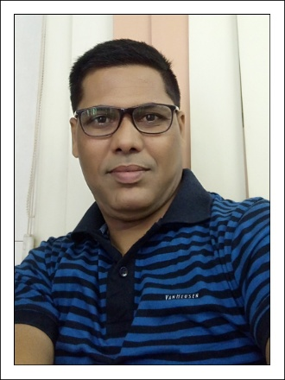

# RESUME

### **LOKESH B SHARMA**

B – 301, Akshay Residency,

B/H. Satyamev Hospital

New Chandkheda,

Ahmedabad – 382424.

**Phone:** **(M) 09099955493**

E-Mail: lokesh1970.s@gmail.com

Date of Birth: 23rd July, 1970, 49 Year,

**Experiences :-**

* My last Working Company is **Worldwide Logistic (India) Pvt. Ltd.** as a Assistant Manager - Sales ,Ahmadabad. Join from (01-01-2018 to 24-12-2019).
* Worked for One Year as a Assistant Manager - Sales in **Orchid Shipping Pvt. Ltd.** Ahmadabad. Join from (17-10-2016 to 19-10-2017).
* Worked for 2 year & Eight month as a Sr. Executive in Sales. in **Nippon Express (India) Pvt. Ltd**., Ahmadabad. Join from ( 01-01-2014 to 30-09-2016).
* Worked for 2, year & Six month as a Senior Executive in Sales. In **Dachser India Pvt. Ltd.** Ahmadabad. from ( 01-06-2010 to 10-12-2013).
* Worked for 7,Years as a Senior Executive in Sales. in **Overnite Express Ltd.** at Ahmedabad from (01-05-2003 to 30-04-2010).
* Worked for 2, Year as a Marketing Executive in **Indiacom** **Limited**. from ( 01-07-2001 to 30-04-2003).
* Worked for 4, year as a Sales Executive in **Eureka Forbs Limited** at Ahmedabad from ( 01-08-1997 to 01-06-2001).

**Educational Qualifications:**

* I.T.I. in Data preparation and Computer software from Govt. of India in 1990-91.
* B.A from Gujarat University in 1993-94.

**Experience in the job:**

* Handling Corporate Channel, in various aspects like Business booking, Payment issues, Customer service issues, etc.
* Compliance to company norms with policies & Procedures & maintenance Of TAT, various process & quality standard.
* Monitoring & Analyzing daily, Weekly & Monthly Sales Reports.
* Establish activity and sales reporting mechanisms to company standards.

**Languages Known:**

English, Hindi and Gujarati.

Date : 24-02-2020 Lokesh B. Sharma