**RESUME**

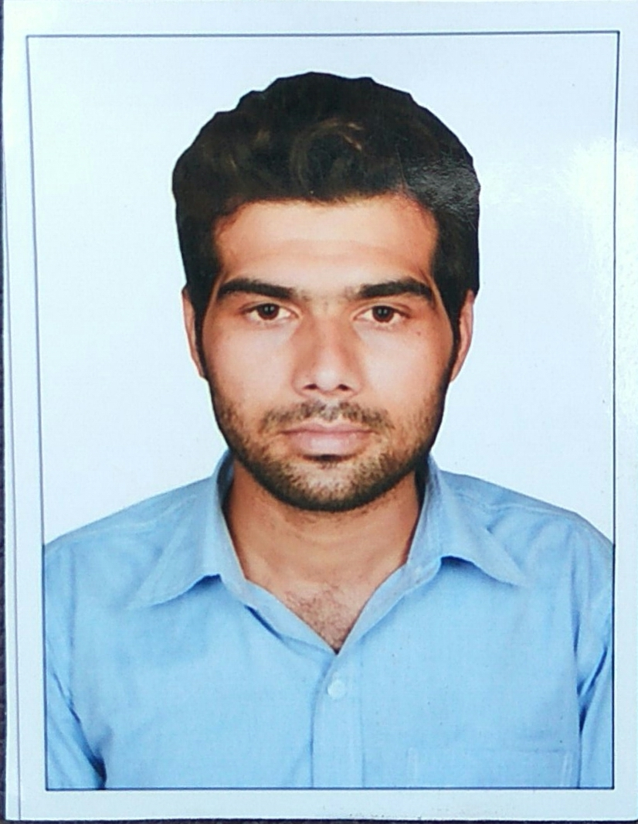

Photo

Name :MALEK SAMIRODDIN .S.

Position **: MECHANICAL SUPERVISOR**

Total Years of Experience **:** 6YEARS

Experience In Various STP Plant : ETP PLANT EXPERINCE

Any Other Certificates : Attached supporting Documents

**PERSONAL DETAILS**_______________________________________________

Name : Samiroddin Malek

Address : At & post Undhela, Ta. Matar,

Dist. Kheda - 387510

Language knowledge. : Hindi,Engliah,Gujarati

Religion : Muslim

Mo. No. : 9904658468

Email address : samiroddinmalek@gmail.com

**EDUCATIONAL QUALIFICATIONS**_______________________________________________

Degree / Diploma – Specialization **: DIPLOMA IN MECHANICAL**

College / University **:** R.H.PATEL(T.E.B. BOARD)

Attach supporting Document **: Yes**- Degree certificate is attached

**TECHNICAL KNOWLEDGE_____________________________________________________**

Professional Skills **:1)SHIFT DOCUMENT MANAGEMENT,WORK HANDLING**

**2)CENTRIFUGAL ALL TYPE RECIPROCATING AND PROGRESSIVE CAVITY PUMP**

**3)KNOWLEDGE OF CPI ,IGF,NHF,UF,SYSTEM AND CHEMICAL OUT**

**4)HANDLING DIFFERENT TYPE OF VALVE,GATE VALVE,GLOP VALVE,BUTTERFLY VALVE ,BALL VALVE,PLUG VALVE**

**CAREER OBJECTIVE_________________________________________________________**

**CAREER ACHIEVEMENTS______________________________________________________**

**WORK EXPERIENCE__________________________________________________________**

1. **COMPANY :** LARCEN AND TUBRO SURAT HAZIRA

**Designation :**  MECHANICAL SUPERVISOR

**Period :** 1 YEAR

**Roles & Responsibilities :1)I HAVE HANDLING TOTAL FABRICATION WORK**

**2)TOTAL MAINTAINANCE WORK HANDLING BY SUPERVISOR**

**3)DOCUMENT HANDLING AND MAN POWER HANDLE**

**4)I HAVE TOTAL HAND WORK HANDLING**

1. **COMPANY : SOMBANSI ENVIRO. ENGG. PVT. LTD.,ONGC**

**NAVAGAAM**

**ETP PLANT: (EFLUENT TRETMENT PLANT)**

**PLANT CAPACITY :1000M^3P/DAY**

**Designation :**  MECHANICAL SUPERVISOR

**Period :** 3 YEARS

**Roles & Responsibilities :1)KNOIWLEDGE OF UF,CPI,IGF,NHF**

**2)WORK PROCESS SYSTEM AND HAND CHEMICAL OUT SCADA OPERATRE**

**3)MAINTENANCE HANDLING AND MAN POWER HANDLING**

**4)PUMP ALLIGNMENT AND SERVICE**

**5)PUMP OIL AND GREASING**

**6)PUMP AND COMPRESSOR MAINTENANCE**

**7)IGN MAINTANANCE AND SERVICE WORK**

**8)PIPELINE FLUSHING**

**9)UF MAINTENANCE WORK AND SERVICES**

1. **COMPANY : UEM INDIA ,PVT.LTD. ONGC KALOL7,AHEMDABAD ASSETS**

**Designation :**  MECHNAICAL SUPERVISOR

**Period :** 2015-TO TILL DATE

ETP PLANT :EFLUENT TREATMENT PLANT

COMPANY TOTAL SITE :3

PLANT1 :CAPACITY1000M^3/DAY

PLANT2 ;CAPACITY2000M^3/DAY

PALNT3 :CAPACITY5000M^3/DAY

ROLE :AS A MECHANICAL SUPERVISOIR

**Responsibilities :1)SHIFT MANAGEMENT AND DOCUMENT WORK HANDLING**

**2)PREVENTIVE SCHEDULE PERIODIC AND BREAKDOWN MAINTANANCE HANDLING**

**3)WORK PROCESS AND INSTRUMENTATION OPERATE SCADA**

**4)MAN POWER HANDLING AS A SUPERVISOR**

**5)PUMM ALLIGNMENT AND SERVICE**

**6)PUMP OIL AND GREASING**

**7)PUMP AND COMPRESSOR MAINTENANCE WORK**

**8)IGN MAINTANANCE WORK AND SERVICE**

**9)PIPELINE FL;USHING AND MAINTENANCE WORK**

**10)VF MAINTENANCE AND SERVICE**

**ADDITIONAL INFORMATION____________________________________________________**

Attached all necessary information

**DECLARATION_______________________________________________________________**

I hereby declare that the above – mentioned information is correct up to my knowledge and I bear the responsibility for the correctness of the above – mentioned particulars.

Place : AHEMDABAD Signature

S.S.MALEK