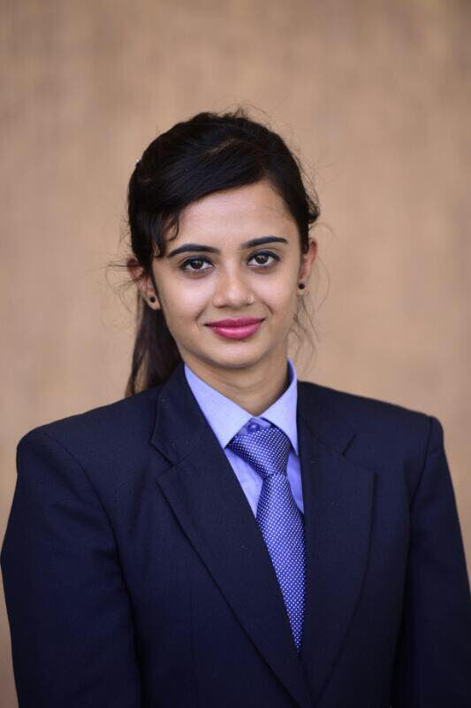**MANSI SHARDA**

271/2 SEC 13-C, Near Mahatma Mandir,

Gandhinagar, Gujarat-382016

MOBILE NO: 7043356873

EMAIL ID: [mansishardamba18@oakbrook.c.in](mailto:mansishardamba18@oakbrook.c.in)

|  |  |  |  |  |
| --- | --- | --- | --- | --- |
| EXAM/DEGREE | YEAR | NAME OF INSTITUTE | UNIVERSITY/BOARD | PERCENTAGE |
| MBA (Marketing) | 2016-2018 | OAKBROOK BUSINESS SCHOOL | GUJRAT TECHNOLOGICAL  UNIVERSITY | 8.06 CPI |
| BCOM | 2014-2016 | GOVERNMENT COMMERCE COLLEGE | GUJRAT UNIVERSITY | 70% |
| HSC | 2013-2014 | K.V.NO. 3 ARMY CANTT,CHILODA,  GUJARAT | CENTRAL BOARD OF SECONDARY EDUCATION | 50% |
| SSC | 2010-2011 | K.V.NO.1 SADAR BAZAR,  DELHI CANTT,  NEW DELHI | CENTRAL BOARD OF SECONDARY EDUCATION | 82% |

**EDUCATION QUALIFICATION:**

**Project:**

* Summer Internship Project Report on the topic A Study on Sanitary Application Acceptability and Sustainability.

**Personal Strengths:**

* Sincerity towards job and punctuality.
* Able to cope under pressure.
* Can work independently or as a part of team.

**Industrial Visit:**

* SEM 1: Harvest Pharmaceuticals Industry helps us to gain hands on experience of how industry operation are executed.
* SEM 2: Shree Bhagwati Machtech Pvt.Ltd. I bridge the gap between theoretical training and practical learning in real life environment.
* Amul: I learnt how the environment is and how the people actually work. Machinery used are shown and you can take a look at them. The lifestyle of people working there and how does they work, time of word and how the synchronization between the people is.
* Adani: I got deep understanding about the corporate world. I come to know about the functioning of company.

**Seminar:**

* A seminar by Mumbai Dabawala’s Six Sigma in Ahmedabad Management Association. In which I see a working of Mumbai Dabawala’s without any mistake. I learnt their management practices.

**Achievements:**

* Got 1st Rank in MBA SEM 2 with 8.57 SPI.
* Got 4th Rank in MBA SEM 1 with 7.57 SPI.
* Worked as a teacher in Rangoli Playschool.
* I have CIA + course in institute of Computer Accountants.
* Prepared a research paper on a topic A Study on Sanitary Application Acceptability and Sustainability.

**Personal Details:**

Name : MANSI SHARDA

Father’s Name        : Sanjay Kumar Sharda

Date of Birth           : 28thmarch1995

Sex                       : Female

Marital Status          : Single

Languages Known : English, Hindi, and Punjabi

 Permanent Address : 271/2 sec 13-c

     Near Mahatma Mandir

Gandhinagar, Gujarat-382016