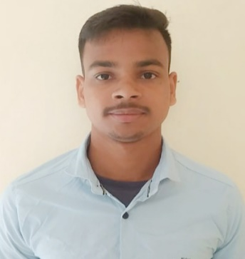 CURRICULAM VIATE

**NARENDRA DAS**

AT\PO- BARAKOLI KHALA

PS-MAHAKALPARA

DIST-KENDRAPARA

PIN-754142

MOB-8658617430

Email Id-narendradas284@gmail.com

CARRIER OBJECTIVE

*Intend to build a carrier with leading corporate of hi-tech environment with committed*

*& dedicated people, which will me to explore myself fully & realize my potential. Willing to work as*

*a key player challenging & creative environment.*

EDUCATION QUALIFICATION:

* 10th passed from gyanamayee high school in the year 2015 under **BSE,** Odisha.
* +2 Arts passed from sri sri bayababa junior college, mahakalpada in the year 2017

under **CHSE** Odisha.

* +3 BA passed from R.M.D. degree college, in the year 2021 under **Utkal University,** Odisha.
* Pursuing **MBA** from **ASBM** under **BPUT**, Odisha.

COURSE

* Complete **TALLY ERP 9.0 GST** from **NCIT**, marshaghai.

EXPERIENCE

* **Finance** internship from **ODISHA CAPITAL MARKET & ENTERPRISES LIMITED.**
* Work in **vizva** **consultancy**, **silver** **space** **technology** as a bench sale re quieter in marketing for **US** client.

STRENGTH

* Flexible & innovative.
* Goal oriented, positive & supportive.
* Hard Working & sincere.
* Self-confidence.
* Punctual.

HOBBIES

* Sports.
* Music.
* Make friends.

PERSONAL PROFILE:

Name : Narendra das

Father’s Name : Nanigopal das

Date of Birth : 12\04\1999

Gender : Male

Marital status : Unmarried

Caste : General

Nationality : Indian

Religion : Hinduism

PERMANET ADDRESS:

At\po - Barakoli khala

Po - Mahakalpada

Dist - Kendrapara

Pin - 754142

**Declaration**

I hereby declare that the above-mentioned information is correct up to my knowledge and I bear the responsibility for the correctness of the above-mentioned particulars.

Dete :- Signature of candidate

Place:-