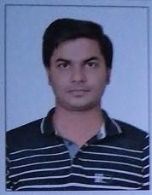

+91 8587079107 / 9410018174

[parastyagi2010@gmail.com](mailto:parastyagi2010@gmail.com) https:/[/www.linkedin.com/in/paras-](http://www.linkedin.com/in/paras-)

tyagi-4bb6b1111/

Passport Number : M8361047

475/3 Sadbhavana Park Mangal Pandey Nagar, Meerut,(U.P) India, IN

PARAS TYAGI

IB DP, MYP PHYSICS

FACILITATOR

(Personal Project Supervisor)

HRT ( IGCSE/MYP5)

UNIT WISE PLANNING

PROGRESS MONITORING

TEACHING

EVALUATIONS

# EDUCATION

## B.Tech Electronics & Communication Jun '15

**Cochin University College of Engineering Kuttanad (Kerala) Cochin University of science and technology**

### COCHIN, KERALA (INDIA)

Cochin University of Science and Technology is a government-owned autonomous science and technology university in Kochi, Kerala, India.

**MSc Physics (Singhania University) Result Awaited for second Year DEC ’22 RAJASTHAN, INDIA Singhania University was established by the Government of [6 of 2007. It is a UGC recognized private university as per Sec. 2f of the UGC Act 1956. Senior Secondary**

**B.ED- GLOBAL COLLEGE OF HIGHER EDUCATION (PURSUING CURRENTLY)**

Global College of Higher Education is an institution with quality education inquality ambience. It is affiliated **to CCS University.**

## Higher Secondary

## G T B Public School Meerut

The school is affiliated to the CBSE (Central Board of Secondary Education)

### Jun ‘10

### MEERUT (U.P) INDIA

**Secondary Education** Jun '08

**St Thomas English Medium School Meerut** MEERUT(U.P) INDIA

St. Thomas' English Medium School, also known as STEMS, is a school located in Meerut, Uttar Pradesh, India, established in 1972 by the late

K. Norhona.

# TEACHING EXPERIENCE

**A Coaching faculty for physics in OM institute** Jan '17 - Apr '18

## Om institute

IN DELHI NCR for PHYSICS.

### NOIDA, DELHI (INDIA)

**SCHOOL EXPERIENCE** May '18 - Jun '19

**SGVP international School Ahmedabad affiliated to ICSE Board** AHMEDABAD, (GUJARAT) INDIA

A secular school for boys providing quality education for the last 20 years affiliated with CISCE, New Delhi and accredited by Advanced, USA.

Responsible for teaching physics to a total of 100+ students every year from grades 9th to 12th in both school and outside coachings.

Committed to ensuring the complete emotional, social as well as cognitive development of students. Introducing innovative methods to teach physics to students such as practical demonstrations and experiments. Focussing on the use of technology such as smart classroom apps, ebooksetc

Lesson Planning

Developing new lesson plans for physics as per the updated curriculum.

Ensuring that lesson plans maintain a balance between a thorough understanding of students and the pace of learning.

**IB DP & IB MYP PHYSICS FACILITATOR** Jul '19 - July’22

**CALORX OLIVE INTERNATIONAL SCHOOL (IB BOARD)** Ahmedabad,(GUJARAT) INDIA

CALORX OLIVE INTERNATIONAL SCHOOL ACHIEVED AS THE NUMBER TWO INTERNATIONAL DAY SCHOOL BY EDUCATION SCHOOL WORLD RANKING.

Designated as the teaching assistant to the high school physics teacher. Handled multiple classrooms consisting of a total of 30+ students.

Assisted in formulating the annual lesson plans for the different grades.

Organized around the 50 class activities including field visits, guest lectures, cultural programmes etc. Gained proficiency in dealing with students with disabilities and special needs

[AS & A Level / IGCSE Physics FACILITATOR Jul ‘2022 - Present](https://www.naukri.com/job-listings-cambridge-as-a-level-physics-teacher-harvest-international-school-ludhiana-3-to-8-years-160822007534" \t "_blank)

### **[HARVEST INTERNATIONAL SCHOOL (Cambridge BOARD) Ludhiana(PUNJAB) INDIA](https://www.naukri.com/job-listings-cambridge-as-a-level-physics-teacher-harvest-international-school-ludhiana-3-to-8-years-160822007534" \t "_blank)**

# *I am working as an independent academic expert also in various international companies in order to make myself more compatible with all the digital platforms after the outburst of the Corona pandemic.*

# AWARDS & RECOGNITION

**PG DIPLOMA** Jul '16 - Sep '16

## Recognized for getting PG DIPLOMA in EMBEDDED SYSTEMS in 2016 from SMEC

*SMEC (India's Largest NSDC Approved Training Partner)*

COCHIN, KERALA (INDIA)

# CERTIFICATIONS & TRAINING

Certified as an embedded systems programmer.

Attended the various schools in Kerala (INDIA) for various automation equipment which helped students in their science projects.

My other certifications are attached below.

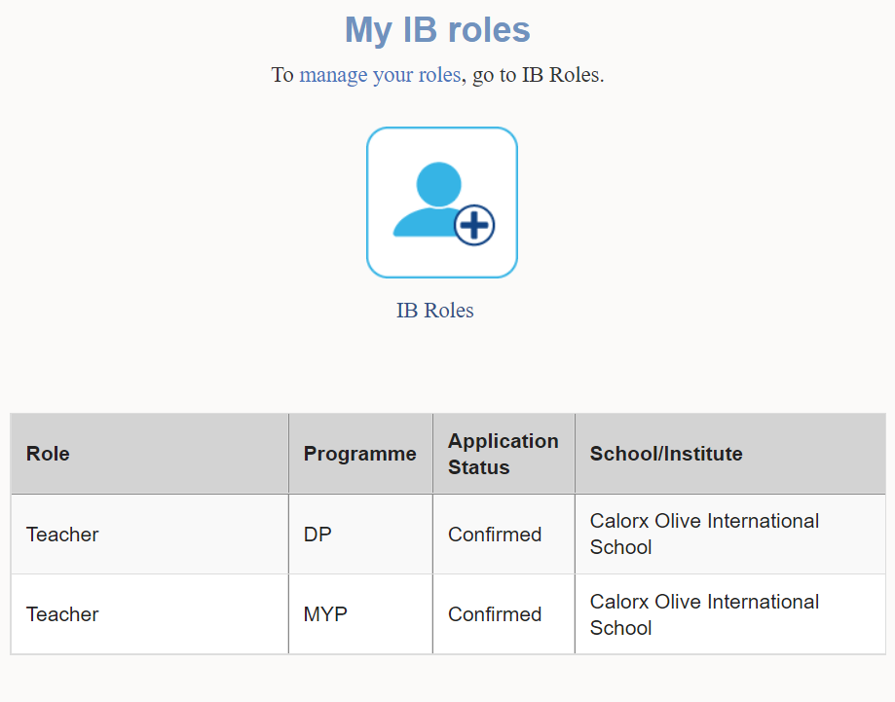

# 

# 

# 

# LANGUAGES KNOWN

ENGLISH & OFFICIAL INDIAN LANGUAGE