**RESUME**

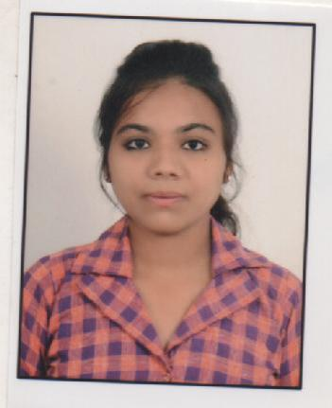

**OBJECTIVE**:

I aspire to have a Successful Career as social works field and I crave for challenging and motivating work in the field of social work.

**PERSONAL DETAILS**

NAME : POOJA N MAKWANA

DATE OF BIRTH : 26/09/1992

GENDER : FEMALE

MARITAL STATUS : UNMARRIED

NATIONALITY : INDIAN

CONTACT NO : 9974686001

E-MAIL : pooja26makwana@gmail.com

BLOOD GROUP : O+(POSTIVE)

HOBBIES : Traveling, Dancing.

**ADDRESS :**

102, Tulshinagar Society,

B/H Sorabji compound

Old Wadaj, Ahmedabad - 380013

**LANGUAGE** : Gujarati/English/Hind

**ACADEMIC RECORDS**

|  |  |  |  |
| --- | --- | --- | --- |
| Exam | Uni/Bord | Year | Percentage |
| S.S.C | G.H.S.E.B | 2009 | 55.00 % |
| H.S.C | G.H.S.E.B | 2011 | 73.00 % |
| B.A | G.U | 2014 | 69.00 % |
| M.S.W | G.U | 2016 | 71.00 % |

**OTHER QUALIFICATION : C.C. C.**

**PLACEMENT**

1 : Community Work ASARVA, 4 Month.

2 : Samaj Surksha Kacheri (APNA BAZAR) 4 Month.

3 :Samaj Kalyan Vibhag (JILLA PANCHAYT) 4 Month.

**EXPERIENCE**

* YUVA SWASTHYA PROJECT ,(SEVA NGO) 2 MONTH
* Co-Coordinator cum Counselor (KVK-Rupal) From-November-2016 to March- 2019
* DONOR Co-Coordinator (INDIRA IVF HOSPITAL) From- October-2019 to till date

DECLARATION :

I Confirm that information provided by me is true the best of my knowledge.

I shall be greatly obliged if my application is sympathetically considered and given an interview call.

POOJA N Makwana