# My Contact

 [anshuIpadhya95@gmail.com](mailto:anshuIpadhya95@gmail.com) 9510318844

A/4 Om residency, viramgam road,Patdi, 382765

# Skills

* Team work
* Leadership
* Time management
* Adaptability
* Computer literacy

# Interests

* Learn new skills
* Teaching
* Sports
* Business management

Education Background

## Ultra-vision school, Patdi

SSC BOARD, 86%

Completed in 2017

## School of Devotion

HSC BOARD, 68%

Completed in 2019

## College of Agricultural Engineering and Technology

Bachelor in Agriculture engineering, Anand Agricultural University

Present, duration 2019—2023

I am flexible, reliable and possess excellent time keeping skills. I am an enthusiastic, self-motivated, reliable, responsible and hard- working person. I am a mature team worker and adaptable to all challenging situations. I am able to work well both in a team environment as well as using own initiative.

# Trainings

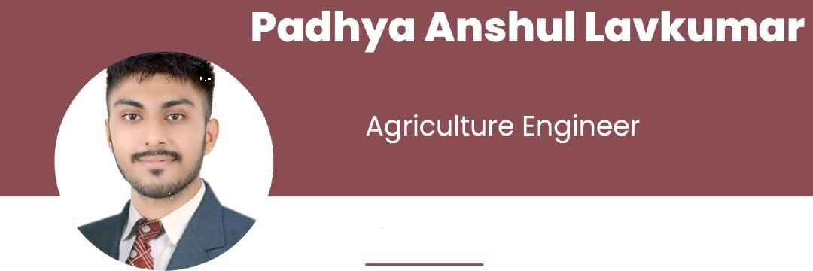

## IRRILINK IRRIGATION INDUSTRIES, Vadodara

June to July 2021

l month internship as a scope of micro irrigation engineer in irrigation sectors.

## VST TILLERS & TRACTORS Ltd., Bangalore.

June to July 2022

Summer 1 month internship in tractor industry for understandworking and driving operations of tillers and tractors.

## SARDAR PATEL RENEWABLE ENERGY RESEARCH INSTITUTE., Anand

July to November 2022

Research study on air gasification of bio-char from different agro and forestry residues

**Achievements**

2019-2021 Have been worked in NSS

2020 and selected as a University Player in

2023 Cricket in Anand Agricultural University

# Self-declaration

I hereby declare that all the details provided above aretrue to the best of my knowledge. I hereby confirm thatall the facts stated above are accurate to the best of my belief. The information stated above is true to the best of my knowledge and belief.

Padhya Anshul Lavkumar CAET, Godhra

2023

