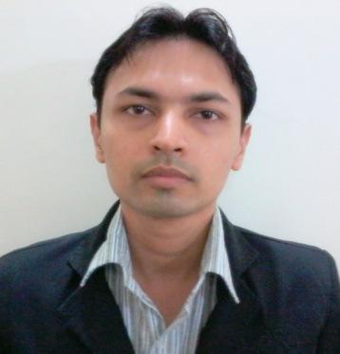

**Pankaj Naineshbhai Patel**

**Objective:**

* To be a successful Manager.
* To contribute to the growth of the organization I work

for.

**Desired job description:** Back-office administration activities, front office admin support, facility management, offline and online office data management.

I am also willing to work in the Supply chain domain (purchase, procurement, inventory, warehouse, etc.).

**Strengths:** Quick learner, flexible enough to adjust in all situations.

**Skills:** Email correspondence in MS Outlook, working on MS Word, MS Excel, online and offline office data management, telephonic follow-ups, candidate test monitoring, library administration activities.

**Total Work Experience (13 years 8 months):**

1. Worked as a Broadcaster & Concierge at **Y-Axis Solutions** from January 2019 to April 2019 (4 months).

* Performed a wide range of tasks related to immigrant visa processing, offline and online database maintenance, documents review, some correspondence with the visitors, and other general office work.
* Assisted with all kinds of work-related (administrative) tasks, such as getting materials to a printer, setting up a courier service, mailing packages, and setting up a meeting space, and much more.

1. Worked as an Office Assistant at **Atlas India** from January 2008 to October 2018 (10 years 9 months).
   * Handling inquiries through emails as well as telephone.
   * Follow-up activities.
   * Coordination & liasioning with the clients for fees, payments, etc.
   * Record-keeping.
   * Form filling and Visa filing activities.
   * Counseling the incumbents.
2. Worked as an Office Assistant with **Shiksha Coaching Institute**, from Feb. 2005 to Sept. 2007 (2 years 7 months).
   * Monitoring the CBT & paper-based tests for candidates.
   * Library administration activities.
   * Handling inquiries through emails as well as telephone.
   * Follow-up activities.
   * Coordinating & liasioning with the clients for fees, payments, etc.
   * Record-keeping.
   * Form filling and visa filing activities.
   * Counseling the incumbents.

**Languages known:**

|  |  |  |  |
| --- | --- | --- | --- |
| **Languages** | **Read** | **Write** | **Speak** |
| English | Y | Y | Y |
| Hindi | Y | Y | Y |
| Gujarati | Y | Y | Y |

**Education–Ahmedabad, Gujarat:**

|  |  |  |
| --- | --- | --- |
| **Qualification** | **School/College, University/Board** | **Year of completion** |
| B. Com | Gujarat College, Gujarat University | 2003 |
| HSC (General / Commerce) | Best Higher Secondary School, Gujarat State Education Board | 2000 |
| SSC | Best High Secondary School, Gujarat State Education Board | 1998 |

**Residential Address:** 2-A, Krishnakunj Society, Opp. Jalaram Park, Nr. BSNL Center/Arham Enclave, Pranshankar Hall-Pushpkunj Road, Kankaria, Maninagar, Ahmedabad-380008, Gujarat, India.

**Current location:** Ahmedabad, Gujarat.

**Contact:** 0-9723550878,0-6353266887, 0-9979083544.

**Email ID:** npankajpatel@gmail.com

Sincerely,

**Pankaj N. Patel**

Ahmedabad, Gujarat