|  |
| --- |
| **RADADIYA PARTHKUMAR** |

|  |
| --- |
| **Career Interest:** |
| I’m kind person I always like to interact with new people. I always like to try new things and get different new experiences. |
| **Philosophy:** |
| **“Knowledge is easy to gain but Faithfulness and self confidence need great courage and passion”** |

RADADIYA PARTHKUMAR DOB-20-03-1998

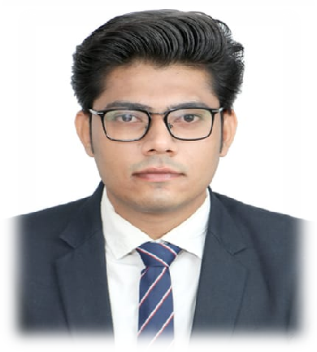

**Nationality – Indian Marital status – Unmarried Gender -** **Male**

Permanent Address

B - 503 , Casa Elite Near , Nirma University

Sarkhej - Gandhinagar High Way Chharodi

Ahmedabad 382481 Personal contacts:

Mo : 7487980425

**E-Mail:** [**parthpatel00203**@gmail.com](mailto:parthpatel00203@gmail.com) **Interests**

Reading books, Listening to Music,

Travelling

|  |
| --- |
| **Experience:**   * **Jana Small Finance Bank:- As a collection officer for settelment f om 13th June 2022 to 31st march 2023** * **Go Fashion India Pvt Ltd : - Back office from 4th October 2018 to 4th Nov 2021** * **D-mart :- Work as a cashier from 20 January 2017 to 30 September 2018** |
| **Education:**  **2012-2013 : SSC – Successfully completed** **from Board of Secondary Education, Gujarat**  **2014-2015 : HSC- Successfully completed from Board of Secondary Education, Gujarat**  **2021 :- I did ATTm (Aviation Tours & Travel**  **Management) Course from Aerostar Jet Training Academy Ahmedabad.** |
| **Language :**   * **ENGLISH** * **HINDI** * **GUJARATI** |

I hereby declare that all the information mentioned above is correct to the best of my knowledge