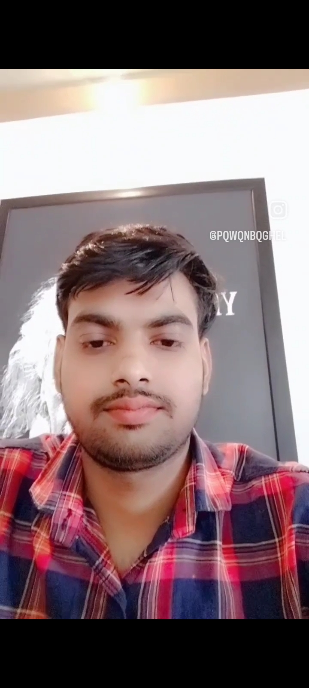

**Pavan Baghel**

**HTML DEVELOPER**

**Address:**

**10-B, PROSHOTTAM NAGAR, NEAR SAYONA CITY GHATLODIYA,**

**AHMEDABAD**

Mob. + 91 7049604869

Email Id: palayachha@gmail.com

|  |
| --- |
| **Objective:** |

Position **HTML DEVELOPER**  in progressive IT Company. To secure a position where by I can apply acquired knowledge and skills, working in a team environment, there by continuously growing and contributing to the main objectives of the organization while being resourceful, innovative and flexible.

Looking forward to an exciting and challenging career with an organization that has a congenial working environment and provides excellent opportunities for mutual growth and continuously updates my skills.

|  |
| --- |
| **Professional Experience:** |

I can convert PSD TO HTML as per all device.

I can convert Figma To HTML as per all device

I can convert XD to HTML as per all device

I have completed **PGDME Multimedia Diploma** **Explora Design School** from Gwalior and I have taken

1 Year training in Web designer.

I' m currently working in **iSquare technology Company in Ahmedabad Gujarat** as position

**HTML DEVELOPER .** I have taken 2 year Experience in **HTML DEVELOPER.**

**TOTAL EXPERIENCE 2 YEARS.**

|  |  |  |  |  |  |  |  |  |  |  |  |  |  |  |  |  |  |  |  |  |  |  |  |  |  |  |  |  |  |  |
| --- | --- | --- | --- | --- | --- | --- | --- | --- | --- | --- | --- | --- | --- | --- | --- | --- | --- | --- | --- | --- | --- | --- | --- | --- | --- | --- | --- | --- | --- | --- |
| |  | | --- | | **Education details:** |  |  |  |  |  | | --- | --- | --- | --- | | **Qualification** | **University/Board** | **Year of passing** | **Mark obtained (in %)** | | **B.A.(English)** | JIWAJI UNIVERSITY GWALIOR | 2023 | 80% | | **PGDME ( Engineering )** | EXPLORA DESIGN INT. GWALIOR | 2022 | 90% | | **12 th** | M.P. BOARD BHOPAL | 2020 | 80% |  |  | | --- | | **Technical Skills:** |  |  |  | | --- | --- | | **Operating System** | Window -7, Window-8, Window-10 | | **Programming Language** | HTML , HTML5 , SCSS, CSS , CSS3, BOOTSTRAP4,5 MEDIA QUERY CSS | | **Web Graphic** | Adobe Figma, PHOTOSHOP, PHOTOPEA , AND WORDPRESS, Shopify DESIGN | | **Email Template** | Email Template Responsive | | **Tools** | Sublime, Visual Studio Code. | | **Script** | JAVASCRIPT , JQUERY, Basic Knowledge. | |

|  |
| --- |
| **Web Pages:** |

mlcreative-demo.com/Intrepid_Applicant/?dsg=4364

https://oe-dev.cloudaccess.host/

https://coronaremediesplanner.in/home?month=jan&division=2&year=2022#sports

https://mpswealth.in/new/index.html

palayachha.epizy.com

palayachha.epizy.com/Arsha

|  |
| --- |
| **Personal Details:** |

|  |  |
| --- | --- |
| **Name:** | Mr. Pavan Baghel |
|  |  |
| **Fathers Name:** | Mr. Jawahar singh Baghel |
|  |  |
| **Date of Birth:** | 12 February 2000 |
|  |  |
| **Marital Status** | Single |
|  |  |
| **Nationality** | Indian |
|  |  |
| **Language Known** | Hindi, English |
|  |  |
| **Hobby** | Learning, Cricket |

**My Strength:**

* Eager to learn new things and progress faster.
* Problem solving ability.

**Thanks**

Pavan Baghel