**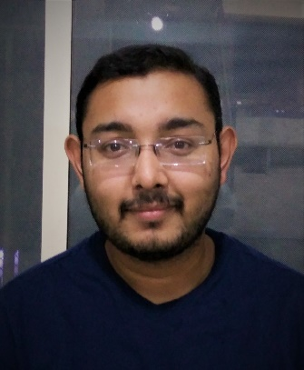*Pratik Vivek Mishra***

***+91 94092 12099***

[***Mishrapratik49@gmail.com***](mailto:Mishrapratik49@gmail.com)

***Linkedin/in/Pratik-mishra-924450152***

**Career objective**

To grasp opportunities to nurture myself and achieve my goals…

**Skills**

Sufficient knowledge in computer

Sufficient Sales skills

Understanding client’s needs

**Qualifications**

- Passed SSC from Gujarat board in 2011 with 52%

- Passed HSC from Gujarat board in 2013 with 52%

- Completed BBA (Bachelor of Business Administration) with 6.67 CGPA.

- Pursuing 5 years Integrated MBA (Final Year) from L J Institute of Management Studies (Affiliated to GTU Approved by AICTE)

**Experiences and Achievements**

Coordinated and participated in role playing activities.

I have completed internship of 5 months at Emerald Honda, Ashram road, Ahmedabad.

Got appraisal from Emerald Honda for good work and successful completion of targets given

**Projects and Case studies**

- Project report and presentation on transactional analysis.

- Case study on IRCTC reservation system.

- A study on importance of marketing in sales at Emerald Honda.

- A study on positioning of SUV with reference to Mahindra and Mahindra.

- Case study on failure of Maruti Suzuki Kizashi

- Presentation on project lifecycle

**References:-**

Prof. Sulekha Munshi (HOD of Marketing, LJIMBA)

Padmarajsinh Jadeja (DGM of sales department) Emerald Honda mobile no:-9714501027

Sumit Rajwar (ASM of sales department) Emerald Honda mobile no:-9638121133

**Personal details:-**

Date of Birth – 15th September, 1995

Languages known – English, Hindi

Nationality – Indian