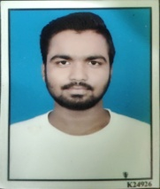**RESUME**

**RAHUL PARGHI**

+91 9773211974

Email Id – ragulparghi82@gmail.com

**OBJECTIVE**

To work with organization where can learn new skills and increase my abilities for the organizational

goals as well as myself.

**EDUCATIONAL QUALIFICATION**

* B.com Grauation from Gujrat University.
* Passed out 12th from GHSEB in 2018
* Passed out 10th from GSEB in 2016

**TECHNICAL SKILLS**

* Basic Knowledge of computer
* Tally ERP 9

**WORK EXPERIENCE**

FRESHER

**STRENGH & HOBBIES**

* Hard & Smart Working
* Honest & Punctual
* Good Communication skill
* Travelling,Driving

**PERSONAL DETAILS**

Father’s Name : Manubhai Parghi

Date of Birth : 25-08-2001

Address : 150-6, Ranjit solanki chawl, Sukhram nagar,

Ahmedabad – 380021.

Marital Status : Single

( Rahul Parghi )