**RATHOD PRIYANKA M.**

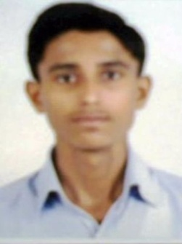**C /82 sector 3 Nandigram so.**

**Nobalnagar**

**Ahmedabad (Gujarat)**

**Pin code : 382340**

**Cont. No. :- (+ 91) 9904293906**

**E-mail ID :- priyankarathod1211@gmail.com**

**Career Objective:**

**My aim is to work with a progressive organization that will fully utilize my talent & skills, where I can work under highly motivating environment & explore, enhance my potential.**

**Personal Information:**

**Name :- Rathod Priyanka Manubhai**

**Address :- As per shown above**

**Date of birth :- 12th Nov., 1993**

**Marital status :- Unmarried**

**Nationality :- Indian**

**Languages skill :- Gujarati, Hindi, English**

**Expected salary :- As per rules**

**Academic Qualification**

|  |  |  |  |  |
| --- | --- | --- | --- | --- |
| Sr. No. | Exam passed | Board | Year | Per. (%) |
| 1. | **S.S.C** | **G.S.E.B** | **March-2009** | 50.30% |
| 2. | **H.S.C** | **G.H.S.E.B** | **March-2011** | 55.71% |
| 3. | **B.Com** | **Gujarat Uni.** | **April-2014** | 56.30% |
| 4. | CCC | B.A.O.U. | 2015 | 74.00 |

**Technical Knowledge:**

* **Knowledge about All Types Data Entry.**
* **Basic knowledge Computer & M.S.Office.**
* **Knowledge about Gujarati Typing and Basic Knowledge about Internet.**

**Work Experience Detail:**

* **I have one year as a Reseptionist in OPD Radiology billing department, Karnavati Superspeciality Hospital, Saijpur Tower, Ahmedabad.**
* **Declaration**

**I have by Declare that the above stated particulars are true to the Best of My knowledge and Belief.**

**Hope for positive reply.**

**Thanking you with warm regard.**

***( PRIYANKA RATHOD)***