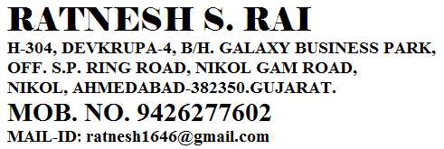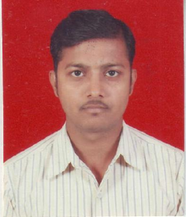_______________________________________________________________________________________________________________

**PROFESSIONAL EXPERIENCE**

**Montecarlo Ltd. Ahmedabad, April 2014 to Till Date**

**Asst. officer (Audit)**

**WORK PROFILE:**

Working as an Asst. Officer wherein following are the activities in (SAP) which I am involved:

* Handling routine account audit, Ledger scrutiny, Bank reconciliation, & other bank etc.
* Checking Cash & Bank Book, Sales Register Purchase Register, J.V. Register, Debit Note, Credit Note, and Purchase Order.
* **Statutory :** Verified of VAT, T.D.S, Service Tax, Entry tax, Royalty, PF, PT, and ESI.
* **Finance :** Verified B.G., Bank LC, Machinery Loan Repayment.
* **Quarterly site visit and physical audit at site.**

**Vimal Crop Care Pvt. Ltd., Gandhinagar April 2010 to March 2014**

**Account Executive.**

**WORK PROFILE:**

Working as an Account Executive wherein following are the activities in which I am involved:

* Handling routine accounting work, Ledger scrutiny, Inventory management,
* Bank reconciliation, Correspondence with creditors / debtors & bank etc.
* Checking Cash & Bank Book, Sales Register, Purchase Register, J.V. Register, Debit Note , Credit Note, Purchase Order.
* **Statutory :** Preparation of VAT, Income Tax T.D.S. Challan and return filling work with synchronization of C.A.
* **Finance :** Preparation of monthly book debt and stock statement for bank hypothecation.
* Preparation of outstanding & due statement for debtors and creditors.
* **Inventory :**  Handling Raw material stock, procedure set up of inward / outward, Various reports check like inward / outward to production, Batch wise consumption details, Short materials for production, Indenting of materials.
* Physical stock verification at all plans.
* Attending internal as well as statutory auditors& audit of ISO 9000 :2008

**Neha Ply & Laminate, Ahmedabad Jul 2008 – April 2010**

**Account Asst.**

**WORK PROFILE:**

Working as an Account Assistant wherein following activities had been done:

* Handling routine accounting work, Ledger scrutiny, Inventory management, Bank reconciliation, Correspondence with creditors / debtors & bank etc.
* Checking Cash & Bank Book, Sales Register, Purchase Register, J.V. Register, Debit Note , Credit Note, Purchase Order.
* Actively coordinated with the Bank Authorities and prepare Bank Reconciliation Statements for reconciling Cash & Bank balances.
* Involved in monitoring statutory books of accounts, bank reconciliation as well as financial statements including Accounts Payables and Receivables Statements

**Balaji Corporation,Ahmedabad Apr 2006 – Jun 2008**

**Accountant**

**WORK PROFILE:**

Working as an Account Assistant wherein following activities had been done:

* Maintenance stock equally as per book as actual
* Deftly prepared the VAT returns on monthly & half yearly basis.
* Responsible for preparation of sales invoice & purchase invoice in computer.
* Keep a record of overall operations to assist my senior accountant to make the final account

**ACADEMIA**

**BACHELOR OF COMMERCE, 51%, 2006**

GujaratUniversity

**HIGHER SECONDARY CERTIFICATION, 57%, 2003**

G.S.E.B

**SENIOR SECONDARY CERTIFICATION, 72%, 2001**

G.S.E.B

**COMPUTER PROFICIENCY**

Basic, FAS, PROSYS, PROFIT, Tally 4.5 to ERP 9.0, SAP

Windows XP/2003/2000/98/95,

MS Word, MS Excel, MS PowerPoint and Internet

**Additional Qualification:-**

* Completed***Certificate Course In Office Automation & Financial Accounting* From ITCT**

**(Information Technology and Computer Training)Ahmedabad.**

**Personal Profile:**

Full name- RatneshkumarSachchidanad Rai

Date of Birth - 01st January, 1985

Nationality - Indian

Languages known - English, Hindi & Gujarati

Marital Status - Married

Hobbies - Playing Chess & Listen Music

* References – Will be submitted as and when required