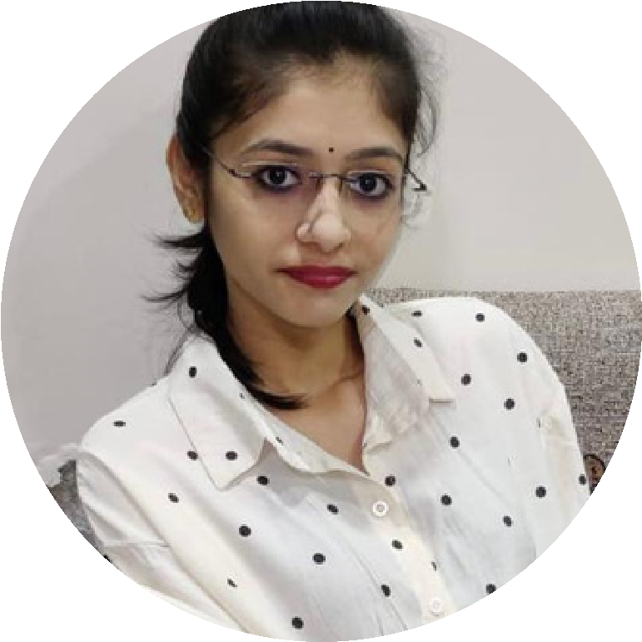

**Profile**

I am Riya Modi

completed my BBA from

GLS University.

Ahmedabad looking for

opportunity to start my

carrier in filed of finance

& Marking I m

Passionate about my

work and good to

coordinate with clients

as I was part of finance

& marketing projects in

my Institution.

*Contact me*

8320226399

rmodi0470@gmail.com

Kesar

1203/-

Heritage ,108

Emergency Centre

near, Katawada road,

New Naroda .

*Education*

*SSC Board Exam*

69

%

HSC Board Exam

70

%

Bachelor of Business Administration (BBA)

70

%

*Language*

English

Hindi

Gujarati

*Computer skills*

power point

**RIYA MODI**

word

Excel



*Profile*

I am Riya Modi

completed my BBA from

GLS University.

Ahmedabad looking for

opportunity to start my

carrier in filed of finance

& Marking I m

Passionate about my

work and good to

coordinate with clients

as I was part of finance

& marketing projects in

my Institution.

*Contact me*

8320226399

rmodi0470@gmail.com

Kesar

1203/-

Heritage ,108

Emergency Centre

near, Katawada road,

New Naroda .

*Education*

*SSC Board Exam*

69

%

HSC Board Exam

70

%

Bachelor of Business Administration (BBA)

70

%

*Language*

English

Hindi

Gujarati

*Computer skills*

power point

**RIYA MODI**

word

Excel