*RESUME*

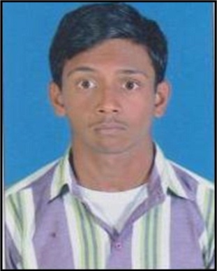

**SATHVARA**

**PIYUSH**

**DAYABHAI**

**Dodiya Mohsin Mahebub To :**- **chandlodia, vishvkarma, Soc**

**House No :**- **13, Ahmedabad**

**Pin Code :**- **382481**

**Mo :**- **8758894274, 9725089824**

**E-mail :**- **sathvarapiyushcopa72@Gmail**

**Educational Qualification :-**

|  |  |  |  |  |
| --- | --- | --- | --- | --- |
| **Exam Passed** | **School/Collage** | **Board/Uni/Course** | **Passing Year** | **Percentage** |
| EMPOWER | GANDHINAGAR | B.C.C | AUG -(2012) | A GRADE |
| S.S.C. | ANDH APANG  HIGH SECONDERY | G.S.E.B. | MARCH- 2013 | 52% |
| H.S.C | BHAVIN VIDHYALAY |  | MARCH- 2017 |  |
| BASIC COMPUTER | INTEL EDUCTION | INTEL (COMPANY) | AUG - (2013) | A GRADE |
| MS.OFFICE | K.V.K GHATLODIA | K.V.K (GHATLODIA) | MARCH(2013) | F.C |
| I.T.I | SIDDHPUR | COPA (SEM – 1) | APR-2015 | 78.05% |
| I.T.I | SIDDHPUR | COPA (SEM – 2) | AUG-2015 | 77.05% |
| I.T SMART | VISHNAGAR | COMPUTER CENTER | MAY-(2016) | 70% DIS |
| D.T.P | K.V.K GHATLODIA | K.V.K (GHATLODIA) | MARCH(2014) | F.C |
| RETAIL | AHMEDABAD | PANKH | MAY-(2016) | SUCCESS |

**_________________________________________________________________________________________________________________________________________________________________________________________________**

**Personal Information:-**

* Full Name **:** SATHVARA PIYUSH DAYABHAI
* Father Name **:** SATHVARA DAYABHAI TRIBHOVANDAS
* Mother Name **:** SATHVARA VARSHABEN D
* Birth Date **:** 18-02-1996
* Gender **:** Male
* Marital Status **:** Unmarried
* Nationality **:** Indian
* Religion/Cast **:** HINDU/KADIYA
* Category **:** OBC
* Blood Group **:** B+  Positive
* Language Known **:** Gujarati, Hindi, English
* Hobbies **:** Reading, COMPUTER WORK, TALLY ERP 9, Online Work
* E-MAIL ID **:** [sathvarapiyush1996@Gmail.com](mailto:sathvarapiyush1996@Gmail.com) Signature