RESUME

PERSONAL DETAILS

NAME : SOLANKI AJAY ANILBHAI

DOB : 03/02/1998

GENDER : MALE

MARITAL STATUS : UNMARRIED

LANGUGES KNOWN : GUJARATI,HINDI,ENGLISH

HOBBIES : READING,LISTENING MUSIC,TRAVELLING

NATIONALITY : INDIAN

ADDRESS : AMBEDKAR NAGAR LINE NO.1,B/H OMKAR TEXTILE

MEMKO CROSS ROAD,NARODA ROAD,

AHMEDABAD-382345

MOBILE : 9106388644

E MAIL : [ajaysolanki8360@gmail.com](mailto:ajaysolanki8360@gmail.com)

**CAREER OBJECTIVE**

TO ENHANCE MY PROFESSIONAL SKILL BY WORKING WITH CHANGING AND CHALLEGING ENVIRNMENT AND PUTTING THE BEST EFFORT IN MY WORK.

TO BECOME A HIGHLY SKILLED PROFESSIONAL WHO IS DEDICATADE TO ACHIVE TARGETS AND CONTINUETO DEVELOP MY KNOWLEDGE AND LEADERSHIP SKILL.

**QUALIFICATION**

|  |  |  |  |
| --- | --- | --- | --- |
| DEGREE | INSTITUTION | PERCENTAGE | YEAR |
| S.S.C. | GSEB | 57% | 2013 |
| H.S.C. | GHSEB | 51% | 2015 |
| B.A.  M.A. | GUJARAT UNIVERCITY  Gujarat  University | 68.16%  2nd year  Running | 2021 |

**PROFESSIONAL EXPERIENCE**

OPPO MOBILE INDIA PVT LTD,AHMEDABAD-1.5 YEARS

AS A SALES EXECUTIVE MOBILE SELLING

**FROM : 16/09/2020 TO 01/07/2022**

KOTAK MAHINDRA BANK LTD – 7 MONTH EXEPERIENCE AS A SALES OFFICER OF CUNSUMER DURABLE LOAN

FROM : 13/06/2022 TO 13/02/2023

**COMPUTER SKILL**

BASIC COMPUTER KNOWLEDGE & TALLY

**DECLARATION**

I HEREBY DECLARE THAT ALL THE STATEMENT MADE ABOVE IS TRUE, COMPLETE AND AUTHENTIC TO THE BEST OF MY KNOWLEDGE AND BELIEF.

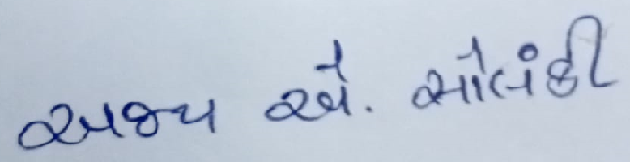

**AJAY SOLANKI**