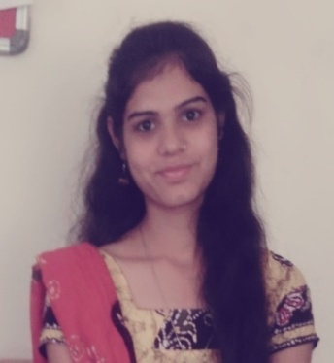**SANJU SINGH**

B.Tech (Renewable Energy and Environmental Engineering)

Address: 304 Block-D, Vrundavan residency-II,

Near infocity, Sargasan chock,

Dist: Gandhinagar

State: Gujarat

Pin Code: 382421

Contact No : 9157670659

Email ID : [sanjumsingh22@gmail.com](mailto:sanjumsingh22@gmail.com)

|  |
| --- |
| Objectives |

To obtain a position where I can utilize my technical and organizing skills for achieving the target and delivering the best performance in an esteemed organization.

|  |
| --- |
| Personal particulate |

Name : Sanju Singh

Date of Birth : 12 Feburary, 1996

Gender : Female

Religion : Hindu

Nationality : Indian

Marital Status : Single

Language Known : English,Hindi, Gujarati& Bhojpuri

Hobbies : Dancing, Teaching and study

Catogory : General

Parmanent Address : At Naghar, Ballia

State: Uttar Pradesh

|  |  |  |  |
| --- | --- | --- | --- |
| Educational Qualification | | | |
| Year | Qualification | University / Board | % / CGPA |
| 2017 | B.Tech  (Environment Engineer) | Sardarkrushinagar Dantiwada Agricultural University,Palanpur | 7.91 (CGPA) |
| 2013 | XII | Kendriya Vidyalaya BSF Dantiwada, Palanpur, Gujarat | 70.2 % |

|  |  |  |  |
| --- | --- | --- | --- |
| 2011 | X | Kendriya Vidyalaya BSF Dantiwada, Palanpur, Gujarat | 8.2 (CGPA) |

|  |
| --- |
| Area of Interest |

* Environment –Effluent Treatment Plant (ETP), Sewage Treatment Plant (STP)
* Renewable Energy – Solar Energy, Wind Energy
* Chemical Analysis of Water Waste Water, Air, Soil

|  |
| --- |
| Project / Thesis |

* B.Tech dissertation Project on “Performance Evaluation of the UASB (Up flow Anaerobic Sludge Blanket-Digester) Plant in Banas Dairy”.

|  |
| --- |
| **Internship / Training** |

* Training at Gujarat Environment Management Institute **(GEMI)** Gandhinagar, on the project topic “Climate Change Indicators: A study of Gulf of Kutch” for two month.
* Training at Gujarat Cleaner Production Centre (GCPC) Udhyog Bhawan,Gandhinagar on “Industrial Symbiosis at Nandesari Industrial Estate”for two month.

|  |
| --- |
| **Job Experiences** |

* **J.M.Enviro Studies Pvt.Ltd.**

**Sector 26 GIDC, Gandhinagar**

Started as Trainee Analyst and working as Laboratory Analyst since **September 2017 to September 2018.**

My work profile includes the following:

* Chemical Analysis of Water and Waste Water, Hazardous waste, Soil and Analysis of Air (Ambient and Stationary Sources) Samples.
* Currently working as a PRT Teacher in Kameshwar international school.