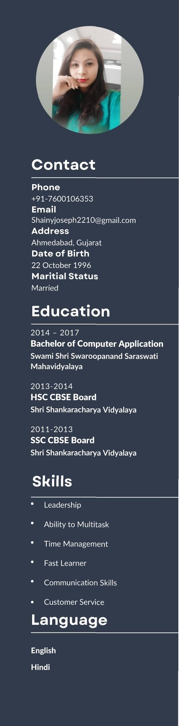Shainy Joseph

Customer Service Professional

An unwavering commitment to customer service with the ability to build productive relationships, and resolve complex issues with customer loyalty. Strategic Relationship/partnership-building skills-listen attentively, solve problems and use logic and diplomacy to find common ground and achieve win-win outcomes.

Experience

January 2021 - Present

IDP Education Pvt. Ltd. | Ahmedabad

# Customer Care Executive

* Get Calls from the students and assigned them to their respective counsellors.
* Having good interpersonal communication skills to convince the candidate to visit our office and get counselling done.

August 2019- December 2020

# Vodafone India Services Pvt. Ltd. | Ahmedabad Senior Technical Representative

* Successful working in a team environment, as well as independently.
* Adaptability, teamwork and self-motivated.
* Referred difficult issues to upper management while maintaining positive rapport with customers.
* Displayed courtesy and strong interpersonal skills with all customer intersections.

June 2017-August 2019

TTEC India Pvt. Ltd. | Ahmedabad

Fraud Prevention Analyst

* Complete research, analysis and documentation of account activity and used personal judgment to determine appropriate actions that removed or minimized fraud exposure.
* Handle confidential information in accordance with the

privacy policy.

* Determine existing fraud trends and assist in the prevention of future trends.

Achivements

* Working as a Fraud Analyst in Trust and Safety department of

Airbnb

* Handling recovery of the Hacked accounts, Refunds, Validating

rental properties and customer issues

* Mentored new batches and provided floor support
* Preparing quizzes for the team for knowledge checks and daily

reports

* Discover new fraud trends and come up with a proficient tools for

fraud prevention

* Awarded best Mentor.