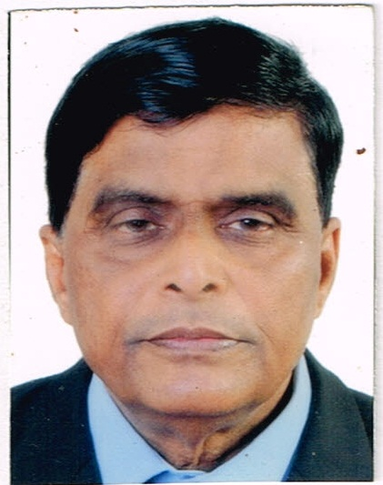

Dr. Shanker K.Iyer

Am a qualified medical professional with a rich experience of over 40 years spanning reputed industries, hospitals and family practice.

**PERSONAL DETAILS**

* NAME: Dr. SHANKER KRISHNASWAMY IYER
* DATE OF BIRTH: 30/05/1949
* MOBILE PHONE NO: -+91 7005753490(WhatsApp)
* EMAIL: shank[erk.iyer@yahoo.co.in](mailto:iyer@yahoo.co.in)

skiyer1949@gmail.com

* PASSPORT DETAILS: PASSPORT NO- P 8534778

DATE OF ISSUE- 08/03/2017

DATE OF EXPIRY- 07/03/2027

**Work Experience:**

Present Position. Working as a Physician in a specialized hospital..Dr S S Patel Paralyric and Gen Hospital since 28/02/×020 to date.A 100 bed hospital manage the opd and IPD treating all cases across the spectrum trum of age gender.Managing medicakenergencies.

**Last Position Sept 2018 to Feb 2020**

Medical Doctor In charge of OHC

Seamtek Middle East Dubai - Benghazi Libya, Since Oct.2018 up to date.

* Coordinate the setting up of a functional Medical Center in a large cement unit from ground level and day to day management of the Medical center as per industrial norms.

**Previous Experience:-**

1. **In charge of a multispecialty hospital in Rajasthan India**

Jeevan Arogya Multispecialty Hospital, Kotputli Jaipur Rajasthan India - Jaipur, Rajasthan, Feb.2018 to Aug.2018.

* In charge of a running The Multispecialty Hospital with all facilities for total treatment. Day to day administration and management of the hospital and functioning as head of the medical unit.

1. **Medical Adviser Lafarge Umaim Mining Pvt. Ltd. A business unit of Lafarge Holcim.**

LUMPL Lafarge – Shillong, Meghalaya, Oct.2013 to Feb.2018

* Responsibilities:-

Medical Advisor of the company & In charge of The OHC. Management of all OPD cases & emergencies both medical and accident injuries, Iaisoning with local health authorities, hospitals and maintenance of health and hygiene at site and living area. Management of all aspects of health and safety.

* Accomplishments

Set up the Trauma care center and the medical facility in mining site.

1. **Medical Officer in charge of Medical facility**

ETA Star International Dubai - Sumbe , Angola , S.W. Africa, May,2011 to Jan,2013

* Medical Officer in charge of the medical centre of Sumbe Cement Project a 4200 TDP cement plant under erection with over 2000 Employees. Responsible for the total medical care of the employees.
* Management of all aspects of health and safety, daily OPD Treatment & Management of all Medical & Industrial emergencies.

1. **Medical officer in charge, Meghalaya cements, Meghalaya**

Meghalaya cements lLTd. Meghalaya, India.May.2009 to April 201.

* Medical officer in charge of the medical centre of a very large cement unit with over

4000 employees and families medical care of the population and dealing with accidents

And medical emergencies.

* I have co ordinated the setting up of a hospital with complete facilities for treatment

Of day to day patients and emergencies and accidents.

1. **Chief medical officer**

Sparta cements lLtd. - Lakhpat Kutch Gujarat India, Sep.2008 to April 2009

* Medical officer in charge of a very large cement unit under erection with over

2000 employees, responsible for complete medical care and treating accidents and

emergencies. Co ordinated the complete setting up of the medical facility.

1. **RIG MEDICAL OFFICER**

Essar oil ltd.Mehsana india - Mehsana Gujarat India ,April 2007 to Aug.2008

* In charge of three operational oil rigs, maintenance of Health & safety at Rig sites.
* Responsible for complete medical care and treating accidents and emergencies.

1. **Resident Medical officer**

KMG General Hospital, Balasinor Gujarat India,Sep.2004 to March 2007.

* A 700 bed multispecialty hospital catering to over 1200 patients a day. independent OPD,IPD and dealing with medical emergencies.
* Independently handled the medical wards.

1. **Medical Officer**

Lakshmi Cements Ltd,Sep.1993 to Dec.1995.

* In charge of Company Medical Facility, Catering to the employees of Factory and Mines and their families.
* Management of Daily OPD patients, Medical and Accident emergencies.

1. **Medical Officer**

Udaipur Cement Works.Sep.1989 to Sep.1991.

* In charge of Company Medical Facility, Catering to the employees of Factory and Mines and their families.
* Management of Daily OPD patients, Medical and accident emergencies.

1. **Medical Officer In charge**

Rajasthan Medical and Health Services, Sep.1984 to July 1985.

* Complete charge of Govt. Dispensary, Chandarwara, Dist. Banswara, Rajasthan. Salary as per rules II class Gazetted Officer.

1. **Medical Officer**

SHRI BRIJ SEWA SAMITITB SANATORIUM - Vrindavan, Uttar Pradesh,

Sep.1983 to Aug.1984

* Independent charge of 160 beds in 600 bed hospital with complete care of Emergencies and independent O.P.D. Functioned from Feb. '83 to Apr. '83 and Nov. '83 to Aug. '84.

1. **Private Practice**

* Over 16 years experience in Rajasthan and Gujarat.

Education

St..Xavier high school, Jaipur, Rajasthan, India.

* **Indian School Certificate Exam. ISCE. with English Language, Literature, Physics, Biology and Chemistry**

.

SMS MEDICAL COLLEGE, JAIPUR, INDIA

* M.B,B.S. Bachelor in Medicine and Surgery

**Certifications/Licenses**

* **MBBS Degree**
* **Registration with Gujarat Medical council India.**

Signature

**Dr.Shanker K.Iyer**