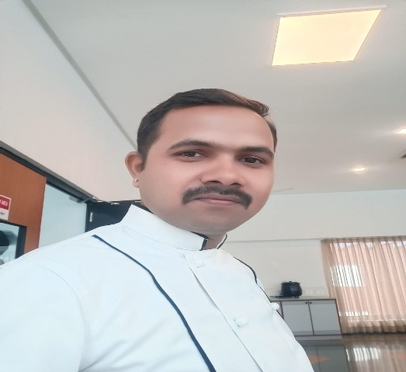

**Shiv Kumar Gupta**

**Mobile No -918800287857**

**Email Address: shiva.gupta0000@gmail.com**

**CAREER OBJECTIVE:**

Considering success not a destination but a journey and believing, learning as an un-ending process, want to be a part of an organization, offering challenging position that provides great opportunities for learning self-development, personal growth , want to be a part of a dynamic organization, recognizing and rewarding talent and natural growth.

**Working Experience**

1. Presently working as a sous chef with cadila pharmaceuticals from 24/10/2017 to till date.
2. Worked as junior sous chef in Indian Accent from January 2016 to October 2017
3. Worked as a C.D.P. in Indian Accent form January 2015 to September 2016
4. Worked as a demi chef in Indian Accent from 2013 to 2016
5. Worked as a 1st commis in Lavasa pune from 2010 to 2012
6. Worked as a commis in comfort in Lucknow from 2009 t0 2010.

**ACADEMIC EXPERIENCE:**

**10th passed From Allahabad Uttar Pardesh**

Done Diploma in food Safety from Gujrat

Certification in Basic Computer Course.

**LANGUAGE KNOWN:**

English, Hindi,

**STRENGHTS**

Capability to work under stressful condition potential to achieve targets and meet deadlines.

HOBBIES: Travelling, Cooking & Music.

**PERSONAL PROFILE**:

Name: Shiv Kumar Gupta

Father Name: Ram Prasad Gupta

Date of birth: **15.06. 1989**

Marital Status: Married

Permanent Address: barnapur Teh-tarabganj

District-Gonda. Pin code 271124 (up)

DATE:

PLACE: