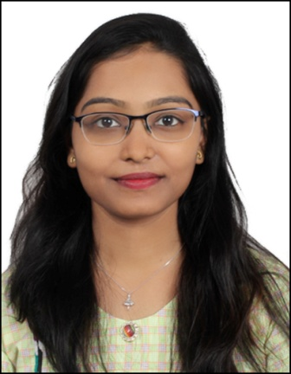

Plot no:194, Siripur, Bhubaneswar 751003

E-mail: [snigdha.sweta1@gmail.com](mailto:snigdha.sweta1@gmail.com)

Mob: 7205104648

SnigdhaSweta

Date of Birth: 31-10-1995

|  |
| --- |
| Career objective |
| To acquire sound professional knowledge, expertise and creativity through sincerity and hard work and to apply these skills to meet the challenges and need of the organization for which I am working so as to enable its upliftment along with self-development . |

|  |
| --- |
| Educational qualification |
| |  |  |  |  |  | | --- | --- | --- | --- | --- | | **Degree** | **Institute** | **Board/university** | **Year** | **%Marks/CGPA** | | **MBA**  **(TTM)** | Indian Institute of Tourism and Travel Management | Ministry of tourism | 2017-19 | - | | **Bsc**  **(Zoology)** | Rajdhani college | Utkal university | 2013-16 | 60% | | **12th Board**  **(Science)** | Kamala Neheru Women’s college | CHSE | 2013 | 63% | | **10th Board** | Saraswati Sishu Vidya Mandir, unit-8 | HSE | 2011 | 77% | |

|  |
| --- |
| Systems used |
| * MS OFFICE- Word, Excel, Access, Power point * Tally * C programming * AMADEUS for Air Ticketing |

|  |
| --- |
| Training and certification |
| * Office Assistant course (IT) * 45 days of training under RIYA TRAVEL & TOURS INDIA PVT. LTD * Working as Sales Executive in XENIUM HOLIDAYS PVT. LTD. |

|  |
| --- |
| Extra-Curricular |
| * Professional Odissi Dancer. * Worked as a Dance Teacher at Jaydev Sishu Vidya Mandir. * Participated in National and State Dance festivals. * 1stRunnersU p in a Dance Reality show of Odia channel Prarthana (2017). * Learned swimming at Kalinga Stadium Bhubaneswar (2017). * Participated in 33rd IATO Annual Convention in Bhubaneswar (2017). * Went for an Adventure Trip to Manali under IITTM (2017). * Trained on self-defence at Rajdhani College (2014). * Got training on Taekwondo (2014). * Learned Horse riding at OUAT (2013). * Participated National Scout & Guide camp held in Ahmedabad (2010). |

|  |
| --- |
| Personal Details |
| * Language: English, Hindi, Odia * Nationality: Indian * Address: Plot No. -194, Near Radha Krishna lane, Siripur, Bhubaneswar, Odisha |

|  |
| --- |
| Declaration |
| I hereby declare that above information is correct to the best of my knowledge and belief.  Date: Yours Sincerely,  Place: Snigdha Sweta |