**CARRICULUM–VITAE.** 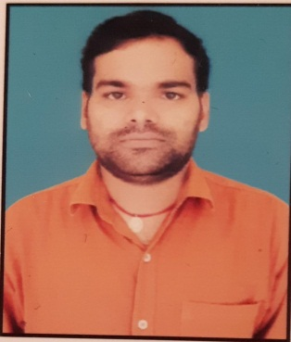

**VIJAY KUMAR**

**Mobile no- 7004189749, 9430997052.**

[**vs223609@gmail.com**](mailto:vs223609@gmail.com)

**OBJECTIVES:-** Looking for position in an organization that utilizes my technical skills and practical knowledge mutually benefitting both the organization and myself.

**PERSONAL DETAILS:-**

**NAME : VIJAY KUMAR**

Father name **:**  SHANTI PRASAD SINGH.

Permanent Address **:**  Village-Singuhi, Post –Sikariya,

P.S -Darigaon, Sasaram Dist- Rohtas,

(Bihar) Pin code-821115.

Date of Birth **:** 11/11/1993.

Nationality **:**  Indian

Marital Status **:** Married.

Languages **:** Hindi & English.

QUALIFICATION:-

* **Diploma in Mechanical Engineering (2013) (IASE Deemed University Rajsthan)**
* 12th – Sher Sah Suri Inter School Sasaram, (2010) (Bihar Board)
* 10th – Sher Sah Suri U M V Sasaram (2008) (Bihar Board)

**SOFTWARE KNOWLEDGE:-**

* Knowledge of Excel ,Power point ,Ms words and Auto CAD Drowing

**WORKING EXPERIANCE IN INDIA :-**

**Engineer- Electrical** with excellent experience in **Shirdi Sai Electricals Limited**, Hyderabad, BRGF,DDUGJY AGRI,SOUBHAGYA Project, SBPDCL,Kaimur Bihar.(**From 01st Dec 2017 to Till Date**).

**JOB RESPONSIBILITIES:-**

* Preparing of Bills and Reconciliation, SLD and BOQ etc. and commissioned all work related to

Rural Electrification with Quality control.

* Installation of APL Electronic Meter Erection Installation Under Saubhagya Project & Infra work in DDUGJY & BRGF Project.
* Practical experience of field leading and managing projects coordination with team .
* Check drawings, surveys and Single line diagrams according to site conditions and modifications in existing plans.
* Responsible for all day to day site operations.
* Monitoring and prepare daily progress report & report to project management, including supervision & site work.
* Regulate all the safety during work process according to safety procedure.
* Handing over procedure to client SBPDCL (South Bihar Power Distribution Company Limited)
* Preparing & planning schedules, shut down schedules, client and

Management.

**DECLARATION DETAILS:-**

I Vijay Kumar **,** hereby declare that all the above mentioned information and statements in this application are true to the best of my knowledge and belief .I assure that if I am given an opportunity I will prove myself worth enough and efficient to the organization and I will do my work very honestly and sincerely.

**VIJAY KUMAR**

**DATE :- 13/12/2022 SASARSM**