**RESUME**

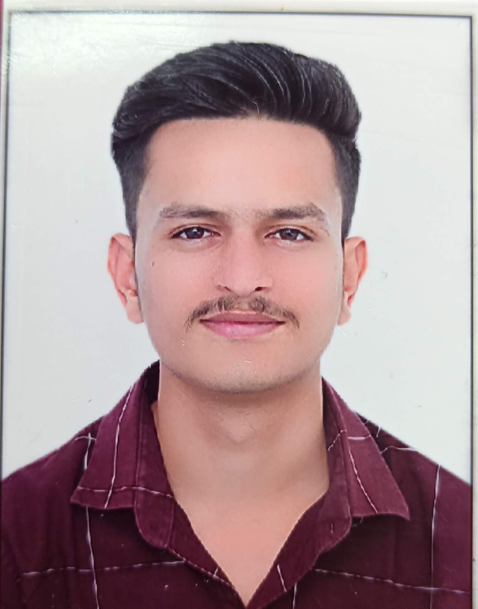

**VIPUL KUMAR**

106,MEGHWALO KA VAS ,VISHWAKARMA GALI , TIMBER MARKET , SUMERPUR , PALI, RAJ.

Pincode- 306902

Mobile No: - +917073556093

Email Id: - vpulkumar15@gmail.com

**OBJECTIVE**:

To work on a challenging job profile which could provide me an opportunity to enhance my skills and knowledge. This could provide me an insight into new aspects so that it would be helpful for growth of organization as well as mine.

**PERSONAL DETAILS:**

# Father’s Name: Mr. BHARAT KUMAR

Date of birth : 15th.JULY, 2000

Gender: Male

Nationality: Indian

Languages Known : Gujarati and Hindi.

Hobbies: Photography, and Listening to music.

## ACADEMIC QUALIFICATION:

* Has Completed Bachelor’s in MADICAL LABORATORY TECHNICIAN From SSARDAR PATEL UNIVERSITY VALLABH VIDHYANAGAR 388001
* 12th in Science Stream from SHREE MAHESHWARI SR.SEC. SCHOOL, Jodhpur (RAJ.) (RBSE) 2017
* 10th from SHREE MAHESHWARI SR.SEC SCHOOL (RBSE) 2015

### EXPERIENCE:

* Has done Work in jassi de parathe Anand in 2019
* Has worked full time as a Manager in One N Only Food Junction Cafe, Anand (Nov-2021 to Fab-2023)

**DECLARATION:**

I hereby declare that the above - mentioned information is correct upto my knowledge and I bear the responsibility for the correctness of the above mentioned particulars.

Yours truly,

**(Vipul Kumar)**