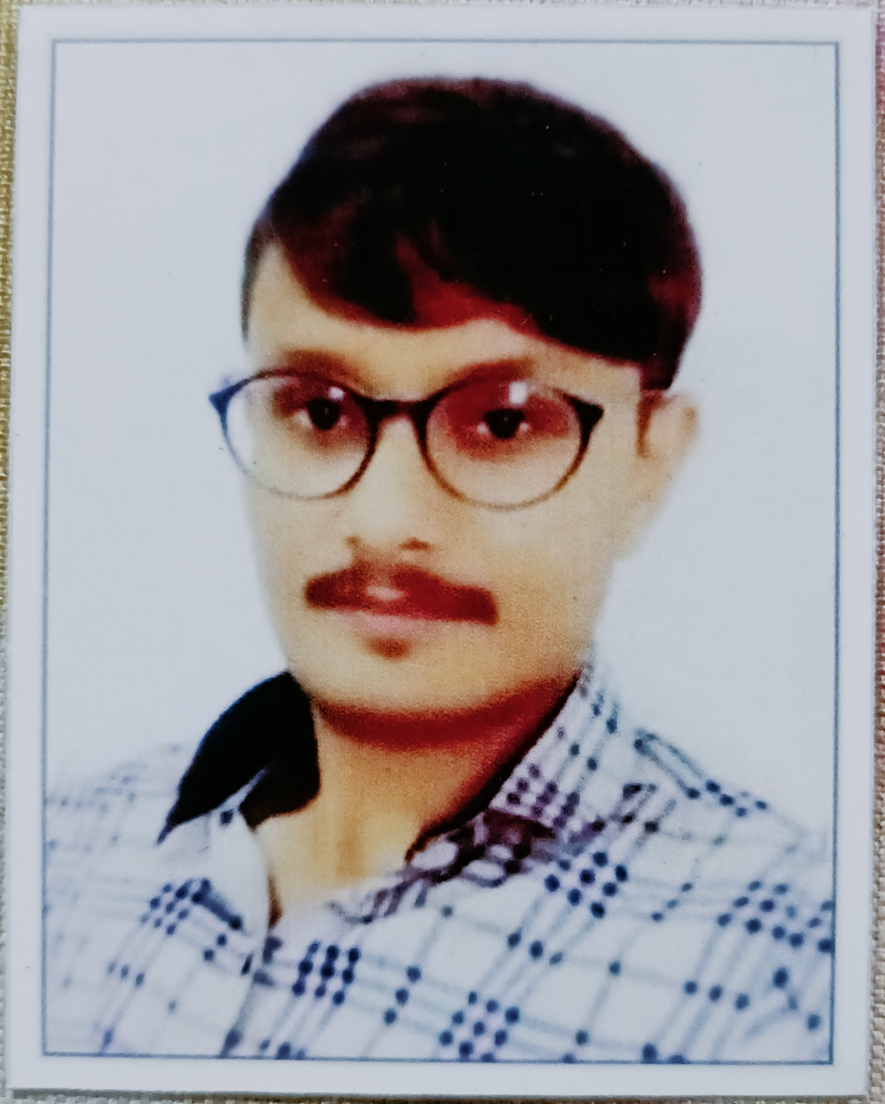

*A self-Motivated person with high ambitions and steely determination, a good understanding of the theoretical aspects with strong practical skills.*

*A team player with an effective communication, leadership, analytical & relation management skills. Proven ability to meet deadlines and work under pressure situations.*

**PARMAR VISHAL N.**

+91- 8200105513

Parmarvishaln6@gmail.com

**ACADEMICS**

|  |  |  |  |  |  |  |
| --- | --- | --- | --- | --- | --- | --- |
| Course | Board / University | | Year Of Passing | Class | Percentage | |
| S.S.C | G.S.E.B. | | 2010 | First Class | 60.92% | |
| 12 ARTS | GSHEB | | 2012 | Second class | 56 % | |
| ITI FITTER | G.C.V.T | | 2014 | Distinction | 72% | |
| ITI FITTER | N.C.V.T | | 2016 | First Class | 66.14 % | |
| BACHRAL OF ARTS | DR Baba Saheb Ambedkar Open University | 2019 | | Second classs | | 57.75% |
| BE.D | H.N.G.U | Running 4th sam | | _ | | _ |
|  |  |  | |  | |  |
|  |  |  | |  | |  |

**WORK EXPERIENCE**

|  |  |  |  |
| --- | --- | --- | --- |
| Sr. No | Organization Name | Designation | Experience  (In Years) |
| 1. | Schindler India Pvt Itd | Technician | 3 Years |
| 2. | Thyssenkrupp India Pvt Itd  (Contract work) | Technical (contract) | 1Years |
| 3. | Express ltd  (Contract job) | Technician | 4 MONTH |

**ACHIEVEMENTS & EXTRA-CURRICULAR**

* Acquired Ccc National Nigital Literacy Mission.
* Acquired Prdhan Mantri Gramin Digital Sakshrta Abhiyan.
* Acquired Abhinav Education Information Technology Institute.
* Successfully Complete General knowledge IQ Competition 4 Saptember 2011 Gk test.

**WORK PROFILE**

**Thyissumkrupp India**   
 (1 yerss contract job)

**Express Ltd.**  
(December 2021 /4Month work )

**Schindler indiaPvt. Ltd.**  
(july/2017 to Aug/2020)

|  |  |  |  |
| --- | --- | --- | --- |
| Operation And Maintenance | Operation And Maintenance | Installation work | |
| New Insallation work | Installation Work truballshoting | Look After Raw Materials Planning, Handling, And Storage As Well As Finish Goods. | |
| All Ahemdabad Areas lift Installation Work | Ahemdabad Sardar Dham Projects | Assist The Department Head In Administration & Production Planning. | |
| New Installation Department | Ahemdabad Navratn Projects | Filld work | |
| Work In Lift All Parts Fitting Maintenance Department | Adani Shantigraam work | | Work in Installation ,opretion | |
| Work in lift parts fitting maintenance department. | Look After Raw Materials Planning, Handling, And Storage As Well As Finish Goods. | Solved Running Machine Probleam | |

**PROFESSIONAL TRAINNING**

**New Installation Work**

**Implementation of Good Skil  
Activities On The Production Floor**

**First Aid & Industrial Safety**

**Trainee A Product no 3100 5100 3300**

**Elevator Instollation hghghhhhinstallation**

**Maintenance Customer Hendal**

**REFERENCE**

|  |  |
| --- | --- |
| **MR.KETAN UPADHYAY**  **Gujrat Branch Manager**  **Ahemdabad Bopal** | **MR. ISON GREGORY SIR**  Manager  New Installation Department  Ahemdabad Bopal |

**PERSONAL DETAILS & DECLARATION**

**Date of Birth:**24 july 1995; **Sex:** Male; **Languages:** English, Hindi and Gujarati.

I hereby declare that the above-mentioned information is correct up to my knowledge and I bear the responsibility for the correctness of the above-mentioned particulars.

Date:

Place:

PARMAR VISHAL NARESHBHAI