**CURRICULUM VITAE**

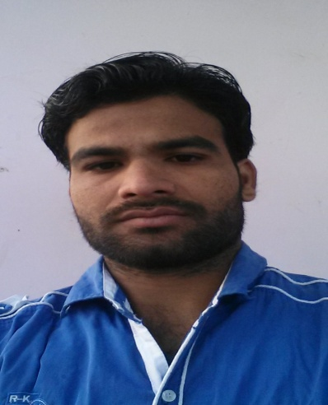

**ZIA ULRAB MANZAR IMAM QUADRI**

Village:-At, Post- Dahegaon (Rangari) Ward no-04, house no-825

District: Nagpur (MAHARASHTRA) PIN:-441113

Email : quadri78668@gmail.com

Voice : +919665652845 & 7048490438

**CAREER OBJECTIVE:**

To pursue a career in a Non-destructive testing (NDT) industry as an efficient and dependable multi-technician employee, being resourceful to the organization and affable towards my colleagues.

**ACADEMIC PROFILE:**

* HSC MCVC (12th standard), Anjuman high school sadar nagpur 2009.
* SSC (10th Standard), Anjuman high school sadar nagpur 2007.

|  |  |  |
| --- | --- | --- |
|  | | |
| **Total Experience:  More Then 3 Year**s **& Two Shutdowns** | | |
| **PROFESSIONAL EDUCATION :**   * ASNT Level II in Rediography Testing. * ASNT Level II in Magnetic Particle Testing. * ASNT Level II in Dye Penetrant Testing. * ASNT Level II in Ultrasonic Testing.   **ADDITIONAL SKILLS:**  MS-Office and Internet usage (MSCIT) | | |
| **EXPERIENCE IN INDIA:**   |  |  |  |  |  | | --- | --- | --- | --- | --- | | Sr. No. | YEAR | PROJECT/ SITE | COMPANY | DESIGNATION | | 1 | November 2012 Still  Continue… | Reliance Industries Limited Refinery Division Jamnagar Gujarat. | NDT Systems Private Limited. Borivali Mumbai. | RT Technician  DPT,THIKNESS  (Thikness gauging)  Technichian | | 2 | 01 /05/2016 to 25/05/2016 | Reliance Industries  Limited Refinery  Division Jamnagar  Gujarat | NDT Systems  Private Limited  Borivali Mumbai | RT Technician  DPT,THIKNESS  (Thikness gauging)  Technician | | 3 | 22/03/2015 to 22/04/2015 | Reliance Industries  Limited Refinery  Division Jamnagar  Gujarat | NDT Systems  Private Limited  Borivali Mumbai | RT Technician  DPT,THIKNESS  (Thikness gauging)  Technician | | | |
|  |  |  |

|  |  |  |  |
| --- | --- | --- | --- |
| |  | | --- | |  | | **EXPERIENCE IN DETAIL:**   * Carried out Ultrasonic Flaw detector and thickness measurement (modsonic- panametric) of piping (flow of fluid, gas and vapors) and Static equipments, as, Pressure Vessels, Tank, Exchangers, Column etc., and Lamination check of materials. Also I know about isometric drawing of piping and static equipment’s (P&ID). | | * Carried out penetrant inspection on weld joints, equipments, components such as in heat exchanger tubes using Visible and Fluorescent method. * Radiography of tanks, vessels, pressure parts, prefabricated weld joints of pipes also profile radiography using Gamma ray. * Familiar with the technique of single wall single image (Panoramic), Double wall-Double Image (Elliptical), & Super Impose. (Diameter range from1/2 inch to 48 inch piping job). * Carried out Radiography method of inspection to find out internal flaws in welds using all techniques viz. DWDI, DWSI, Panoramic and SWSI. * Experience in film processing and interpretation of Radiography films. * Carried out Hardness Testing of Alloy piping, equipment welded joint and components..   **RELOCATION**: Yes – Anywhere in India including International job opportunity. | |
|  |

**PERSONAL PROFILE:**

Name : Zia Ulrab Quadri

Father’s Name : Manzar Imam Quadri

Mother’s name :Shafaqqat Parveen

Nationality : Indian

Gender : Male

Marital Status : Single

Date of Birth : 14th, April, 1993

Passport No : N0398415, **Date of issue 22/07/2015 and Valid up to 21/07/2025.**

Languages Known : English, Hindi, Marathi, Urdu, (Read, write and speak)

**Declaration:**

I declare that the information and facts stated above are true and correct to the best of my knowledge and belief.

Place:- India

Date :-

(ZIA ULRAB MANZAR IMAM QUADRI)