**RESUME**

**HETVI DOMADIYA**

+91 95378 18968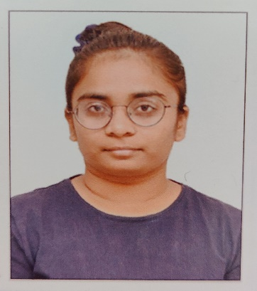

Email id. : [hkdomadiya123@gmail.com](mailto:hkdomadiya123@gmail.com)

**OBJECTIVE**

To work with an organization where can learn new skills and increase my abilities for the organizational goals as well as myself.

**EDUCATIONAL QUALIFICATION**

* Pursuing **MSCIT** 4th year from K.S.SCHOOL OF BUSINESS MANAGEMENT in Gujarat university.
* Passed out 12th in 2019

Marks pr.89.10

* Passed out 10th in 2017

Marks pr. 96.72

**TECHNICAL SKILLS**

* Basic knowledge of computer, C, C++, JAVA………etc.

**WORK EXPERIENCE**

* Fresher

**STRENGTH AND HOBBIES**

* Hard & Smart Working
* Honest & Punctual
* Good Communication Skill
* Reading Books

**PERSONAL DETAILS**

* Father’s name : Kalpeshbhai Domadiya
* Date of birth : 24 march,2002
* Address : 16, Sanskar tenement, Nr. Ghanshyam villa

society, nikol naroda road, Ahmedabad.

* Marital status : single