**CURRICULUM VITAE**

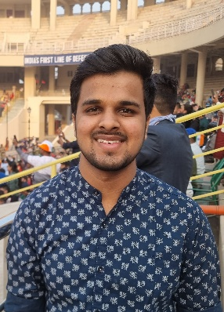

Vivek Saboo, **Email:** ic201287@nirmauni.ac.in

Royal town hostel and PG, **Contact:** +91 72298 16669

Vandematram crossroad,

Gota, Ahmedabad,

Gujrat.

**ABOUT MYSELF:** I am a very creative person and like to do Drawing and

Painting, Editing, and Travelling. Other than that, I am also

fond of Dancing and cooking.

**CAREER OBJECTIVE:** To pursue a highly challenging and creative career,

where I can apply my knowledge and contribute in

such a way, that will acquire me better skills and

training.

**ACADEMIC PROFILE:** 1. HSC- 77%

2. SSC- 85%

3. GRADUATION- 7 CGPA till now.

**SKILLS:** 1. Hard and efficient working.

2. Creative mind and thinking.

3. Can speak Hindi and English well.