**COVER LETTER**

**From: Afsar Iman**

**Mob:** +91-9074257152 / +91-8825244934

**E-mail**: [afsarce98@gmail.com](mailto:afsarce98@gmail.com)

________________________________________________________________________

To,

The Senior HR/ Admin Manager,

Respected Sir/ Madam,

**I, Afsar Imam** would like to get your kind attention to the fact that I am a **BE CIVIL ENGINEER** with more than **2 years’** Experience.

I am keenly interested in your esteemed organization and it will be a great honor for me if I get an opportunity to demonstrate my aptitude and ability.

Herewith, I enclose my CV for your kind consideration and perusal.

I hereby declare that the information given by me is true to the best of my knowledge and belief.

Thanking You,

Yours Sincerely,

(**AFSAR IMAM**)

**CURRICULUM VITAE**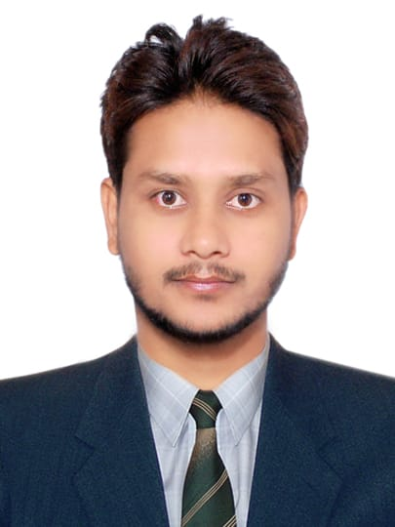

**Afsar Imam**

Mob No.- +**91-9074257152**

**+91-8825244934**

**Email id: -** [**afsarce98@gmail.com**](mailto:afsarce98@gmail.com)

**Total Experience approx. 2 years.**

# **AFSAR IMAM CIVIL ENGINEER**

**CAREER OBJECTIVE: -**

To work with an organization where I can create a new curve to enhance and update my qualification and skills. Also where I can get the environment to add feather to my experience by utilizing my knowledge.

**STRENGTH: -**

* High Confidence Level.
* Good Communication Skill.
* Extrovert.
* Takes Initiative.

**ACADEMIC DETAILS: -**

* **B. Tech** in **Civil Engineering** (04 Years Course) with 1st Division in July 2017 from **Millennium Institute of technology & science College, Bhopal**.
* Passed Intermediate Science Examination from BSEB Patna with Second division.
* Passed Matriculation Examination from BSEB Patna with Second Division.

**COMPUTER PROFICIENCY: -**

* Basic Knowledge of MS Offices word, Auto Cad, net surfing.

**PROJECT PROFILE: -**

* **Project title: -** Building construction and management.
* **Overview of the project: -** It is a Civil Engg. Based project which facilitates the better use of materials required for construction of a Building.

**WORK EXPERIENCE: -**

* Worked in **National Construction Company** as a CIVIL Site Engineer From 30th July 2017 to 05th Sep. 2018.

**JOB RESPONSIBILITY: -**

* Cube test in the field workability.
* Slump test in the field.
* BBS (Bar Binding Schedule)
* Excavation of all civil works as per the standard specification which includes the layout of the site as per drawing, supervising all kinds of activities related to job.
* Maintenance of work.
* Inspection of the building layouts and levels from the approved submittal drawings.
* Check slump test & Temperature, before pouring the concrete. Preparing all material submittals (as per the BOQ & Specifications) for approval of consultant or client.
* Preparing Daily, Weekly & Monthly progress report for submitting to the Consultant or Client.

**AREAS OF EXPERTISE / ESPOSURE: -**

* Expertise in Structural work like Foundation, Grade Beam, Grade Slab, Roof Slab, Block works, Tanks etc.
* Planning for project activities, team mentoring, deployment, Maintenance and monitoring.
* Good listening skills to work along with Architects, Contractors, Govt. Agencies etc.

**PASSPORT DETAILS: -**

* Passport No. : **S 2067283**

* Date of Issue : 19.07.2018 * Date of Expiry : 18.07.2028

**PERSONAL DETAILS: -**

* Name- Afsar Imam
* Father’s Name Junaid Alam
* Date of birth 07th July 1995
* Nationality Indian
* Sex Male
* Marital Status Unmarried
* Religion Islam
* Languages known English, Hindi, Urdu

**PRESET ADD: -** House no H-93 Indranagar Gali vassi Naka. Mahul Road Chembur **Mumbai.** **74.**

**PERMANENT ADD: -** At+Po - Sabeyah, PS- Ramnagar West Champaran, Bihar (India) 845103

**DECLEARATION: -**

I do hereby that all information’s are true, to the best of my knowledge. I hope you will consider my C.V.’s favorable and call me for an interview with the delegate and prove my worthiness and capabilities. I shall be able grateful to you at any time.

Yours’s faithful,

Date: -

Place: - **(Afsar Imam)**