*HARSH PATEL* 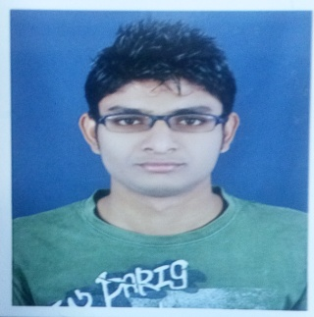

**Personal Information**

**Name :- HARSH PATEL**

**Date of Birth :- 25/02/1994**

**Place of Birth :- AHMEDABAD-INDIA**

**Marital Status :- UNMARRIED**

**Contact Information**

**Address :- B/105,vishvascity-3,opp vandemataratownship,Gota. Ahmadabad - 382481.**

**Mobile :- +917069281737**

**E-Mail :-** [**Harshpatel2502@gmail.com**](mailto:Harshpatel2502@gmail.com)

**Work Experience**

* **I have a 2yr Experience in Aegis BPO (As CCE)**
* **I have a 1yr Experience in Management one Placement Consultancy (As HR Executive)**
* **I have a 3 yr experience in tradebull security pvt ltd as a (rELATIONSHIPmANAGER)**

**Currant company: - AMERICAN EXPRESS**

**Designation: - Business development manager**

**Duration:- 10h Feb 2018to till**

**Job Profile:-**

**Finding client data base**

**Give the all product information to client**

**Solve the all client inquiry and query**

**Archives the daily sales target**

**Reporting team manager**

**Education**

**2008– 2009 :- Gujarat secondary (10th)**

**2009-2012 :- Gujarat technical university in (E.C. engineering)**

**2011-2012 :- Gujarat higher secondary (12th)(external)**

**2016 to till :- B.com 5th Sam Running**

**Seminars and Courses**

**Computer :- Microsoft Office (Word, Excel, PowerPoint)**

**PHP, Java, C,**

**Certificates :- Microsoft Office**

**Associations :- A1 ASSOCIATION**

**Projects**

**2009 to 2010 :- clapping light,**

**Sensor security system,**

**Water controller**

**2015 :- ACPC Adjuration helpline project**

**Languages**

**HINDI, ENGLISH, GUJARATI**

Skills

**Interpersonal communication. ...**

**Good writing ability. ...**

**Analytical knowledge. ...**

**Creativity and expression. ...**

**Influencing and negotiation skills. ...**

**Team playing. ...**

**Computer skills. ...**

**Commercial knows.**

**Other**

**Hobbies :- WATCHING MOVIE,BIKE RIDING,READING**

***Harsh Patel***