**RESUME**

**Subject - FOR THE POST OF PRINCIPAL/DIRECTOR**

Have 10 years of experience in teaching, administration and management of school activities. I have vast experience and expertise in heandling a big team. As a head of managing the school I manage around 45 teaching staffs, 30 non-teaching staffs, and students of various ages from 1st grade to 12th grade. I have helped the management by my dynamic professional work which helped in profitable budgeting without losing the safe and healthy environment of school. My greatest strengths which helped me to achieve a successful head position are my logical and critical thinking, ability to solve the problem quickly and efficiently, excellent communication skills and management ability.

**Carrier objective**

To work in a challenging and dynamic environment, and use my expertise and rich for the growth of the working environment and students.

**Accadamic qualification**

* High school passed from U.P. board.{2001}
* Intermediate passed from U.P. board.[2003]
* B.sc. passed from C.S.J.M. Kanpur University.
* M.sc. passed from V.M. University Tamilnadu.[zoology]
* M.A. passed from C.S.J.M. Kanpur University.[pol- science]

**Professional qualification**

* I have passed print and electronic Journalism from M.S.M.E. development organization government of India Kanpur.
* I have passed B.Ed. from Kanpur University in the year 2006-2007.
* Persuing Med from Kanpur University.

**Skills:**

* Have excellent communication and written skills in English to deliver points in precise
* Have expertise using computers and well versed with the usage of Microsoft office tools namely Microsoft Word. Also have mastered to operate internet and email efficiently.

**Strengths:**

* Leadership and efficient management ability
* Appropriate and exact delegation of responsibilities to staffs
* Have learnt and used different techniques and tools of educating students for effective and efficient teaching

**Professional Member:**

* Kanpur Sahodya

**Work Experience:**

**Principal April 2008 - Till Date**

* I worked as a science teacher and adminstrater for one year in St. Xavier’s boarding school.2007 to 2008 [CBSE]
* I worked as a principal for three years in St.xaviers High School .2008 to 2011 [CBSE]
* Worked as a Principal for one and half year in Manik Chand Group Pune Maharastra.[CBSE]
* Worked as a Principal /Director in us International School unnao 2014 to 2016 [CBSE]
* Now working as Principal in CBSE SCHOOL Bhuj – Gujarat

**SHIVAM BHATT**

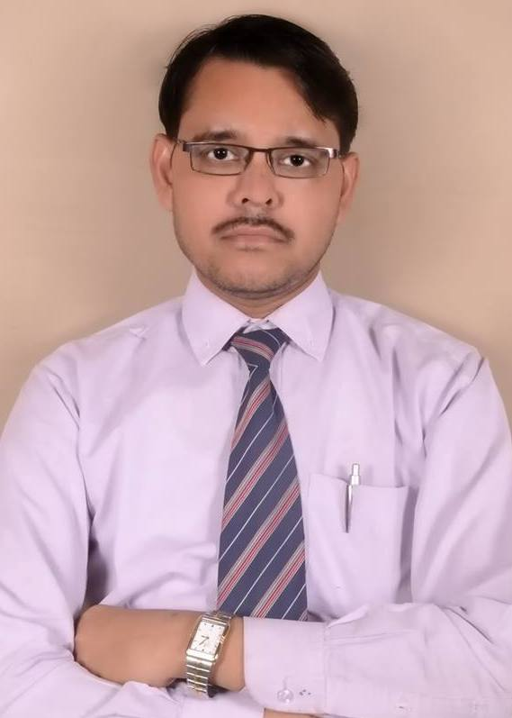

**D.O.B. - 01-01-1985 (82)**

**CONTCAT NO.**

09454387689,9924119776

**E-mail**

[sshivam7777@gmail.com](mailto:sshivam7777@gmail.com)

principal640536@gmail.com

**HOBBIES**

Reading Books

Listening Music

**Responsibilities:**

As a Principal of this school I took all the responsibility of managing the students, staffs and all the activities related to school. I took up the task of teacher’s recruitment whenever needed, maintaining discipline and decorum in school campus, getting feedback from students, teachers and parents and taking appropriate actions on it at appropriate time. I am in charge of monitoring and maintaining safe, healthy, peaceful environment in school. I also monitor the attendance of students and teachers. In this area I introduced the concept of awarding students with no leave and for students maintaining punctuality which encouraged the students to come on time to school. I also reviewed the text books and notes followed by students and give my feedback to teachers for improvement. I was responsible for launching the computer program compulsory for all students in school free of cost which helped to keep students in current with technolo**gy.**

**Administrator Apr 2007 - Apr 2008**

St. Xavier’s Boarding School (CBSE)

**Responsibilities:**

I assisted Principal of the school in various management and monitoring activities and helped to maintain discipline inside school campus. I attended various programs for Student management representing the school. I imparted and trained teachers the techniques of various teaching methodologies learnt and experienced by me. In the absence of principal I took the responsibility of administrating the various operations of the school. I observed, evaluated and recorded my observations of teaching staff, non-teaching staff and students and give it for further actions to the Principal.

**Responsibilities:**

I assisted the principal of the school in various activities. I maintained a record sheet for recording feedback from students, staffs to receive their complaints and votes on improvement and present it to principal for his further actions. I took the task of going rounds at regular intervals to ensure that all activities in school are carried out well. I also make arrangements by sending circulars, seat arrangement needed at times like parents meeting which help the management to carry out the event efficiently and smoothly**.**

**High School Teacher, Science, April 2006 – April 2007**

St. Xavier’s Boarding School (CBSE)

**Responsibilities:**

I handled Science classes for classes’ 8th , 9th and 10th grade. My style of teaching is to make students learn science in a fun-filled way which made many students to learn science interestingly. I got a letter of appreciation from management for creating a Practical interest for activating young students mind.

Middle School Teacher, Science, April 2004 – April 2005

Jalpa Devi Inter College Kanpur

**Responsibilities:**

I handled Science classes for classes’ 7th, 8th and 9th grade. I took the responsibility of coordinating interested students to participate in inter-school Science competitions and helped them in their activities to win prizes. I also took the task of recording each students activities and proving feedback to management and parents at appropriate times to take necessary actions for improvement if needed from their side.

**Self assessment:**

**Nature Strength**

* Dynamic Hard Working
* Adaptable Cool
* Creative Self Motivated
* Perseverance Goal Oriented
* Influential Handling of Problem

**Personal details**

* Father’s Name : D.R. Bhatt
* Permanent Address : 127/268 U-BLOCK NIRALA NAGAR KANPUR UP
* Language proficiency : English & Hindi
* Marital Status : Married
* Nationality : Indian
* Passport no. N3958842
* Correspondence Address:E-79 HOUSE NO.404 SWAMINARYAN PARK AHEMDABAD GUJARAT

**Declaration:**

I hereby declare that the information stated above is true & correct to the best my knowledge and belief.

Date :

Place : Shivam Bhatt