***Resume***

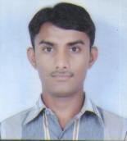

Name:- solanki devchandbhai babubhai

Birth date:-25/07/1990

Address:- to-dedarda ta-palitana district:-bhavnagar pin cod:-364265

Father name:- solanki babubhai laxmanbhai

Mother name:- solanki vasantben babubhai

Hobbies :- reading writing

Mo:- 9998677982

Mail id :- solankidevchand999@gmail.com

Education:-

|  |  |  |  |  |
| --- | --- | --- | --- | --- |
| Edu per board | | | | |
| 10th pass | 56% | Gandhinagar board |  |  |
| 12th pass | 43% | Gandhinagar board |  |  |
| Copa ITI Bhavnagar | 66% | Gandhinagar board |  |  |
| Basic computer ccc | 77% | Palitana |  |  |

Experience:- palitana megestrit of gujrat office adhaar card 3 year supervisor

hedling

|  |
| --- |
|  |