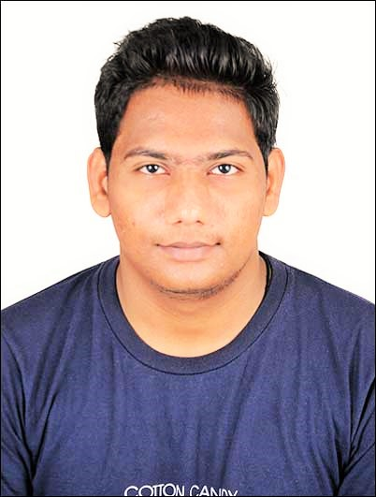

* **Curriculum Vitae**

**NAME**  **:** Vishal Satishchandra Bhatiya

**ADDRESS** **:** 53, Ratndeep Society, Malpur Road , Modasa.

**PIN CODE**  **:** 383315

**DIST**  **:** Aravalli

**E-MAIL ID** **:** vishalbhatiya74@gmail.com

**MOBILE NO:** +91-9601158557

* **Career Objective**

Seeking a position to utilize my skills and abilities in the Industry or Organization that offers Professional growth while being resourceful, innovative and flexible.

* **Personal Information**

**Date of Birth :** 14 January,1995

**Sex** **:** Male

**Marital Status** **:** unmerried

**Nationality**  **:** Indian

**Father’s Name** **:** Satishchandra Bhikhalal Bhatiya

**Languages Known :** English, Hindi, and Gujarati.

* **Strength**
* Adaptive to any atmosphere.
* Hard working, Sincere, Accept Challenges.
* Having great personality & positive attitude towards work.
* **Educational Qualifications**  Have displayed a consistent track record throughout my academic life

.

|  |  |  |  |
| --- | --- | --- | --- |
| **Examination** | **Board / University** | **Month-Year** | **Result (SPI)** |
| B**.**e (civil) | **G.T.U,** Ahmadabad | Final year | Sem 8:  **7.5 SPI**  **7.58 CGPA** |
| B**.**e (civil) | **G.T.U,** Ahmadabad | Final year  (sem-7) | Sem 7:  **7.80 SPI** |
| B**.**e (civil) | **G.T.U,** Ahmadabad | Third year  (sem-6) | Sem 6:  **7.53 SPI** |
| B**.**e (civil) | **G.T.U,** Ahmadabad | Third year  (sem-5) | Sem 5:  **7.50 SPI** |
| HSC | **Gujarat board** **Examination** Gandhinagar (Gujarat) GSHEB | March-2012 | 64.4% |
| SSC | **Gujarat board** **Examination** Gandhinagar (Gujarat) GSHEB | March-2010 | 85.38% |

* **Computer Literacy**
* Basic Knowledge of Computer.
* Proficient in Microsoft office: Word, Excel, PowerPoint
* Operating System: Windows XP/Vista/Seven/8.0/8.1/10
* Internet Knowledge
* Knowledge of **AutoCAD , Staad.Pro** etc.
* **Areas of Interest**
* Reading News Paper,
* Surfing Internet,
* Interest to work in any innovative projects,
* Feasibility analysis of the study,
* Working hard with patience and positive attitude,
* Work with time management.
* **Study visit**
* L&T Ahmadabad
* construction site pavansity near modasa
* cold storage near modasa
* **Intitute of Sismological Reserch Gandhinagar**
* **Sant Sarovar, Indroda Barrage Gandhinagar**
* Attend the seminar at IITRAM AHEMDABAD FOR **BANTLEY STAAD.PRO.**
* **Declaration**
* I consider myself familiar with civil Engineering Aspects. I am also confident of my ability to work in a team.
* I hereby declare that the above written particulars are true to the best of my knowledge and belief.

**Place: -**

**Date : -**

**Yours Sincerely**

**vishal bhatiya**