Real world project - Market Research

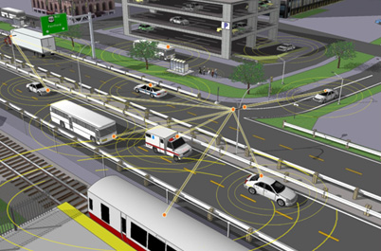

**Connected vehicles**

A connected vehicles is a vehicle that connects with the

World around it whether that other cars or any other

Electronic system, giving and receiving feedback.

Most vehicles in fact are already connected to some extent to either a gps system or mobile phone. At the moment this connection is mainly based on cellular connection.

The National Highway Transportation Safety Administration has proposed a rule mandating the inclusion of 5.9 GHz-based equipment in all new vehicles to make them CV ready.

Largest market for connected vehicles is in Asia.

**Real world Connected vehicle projects**

The United States Department of Transportation

The USDOT awarded three agreements which collectively were worth more than 45m in order to initialise a Design/Build/Test phase of the connected vehicles pilot deployment Program. This is a whole national test in the pursuit and advancement of connected vehicles. The main advantages of these are thought to be saving lives, improving mobility and enhance economic productivity to name a few.

Tata motors and Microsoft

First vehicle will be showcased on the 7th march 2017.

The two companies aim to incorporate technologies such as ***cloud computing, analytics, geo-spatial & mapping and increased human-machine interface***. Data gathered by these two companies can be used for minimising accidents and smart city development.

According to research endorsed by Microsoft by 2020 90% of all new cars will be connected.

Volkswagen car-net apps

A current technology which is already commercially available and expanding. Carnet refers to in-car internet connectivity. Turns your car into a smart phone-adapts to the graphical user interface of either your android or IOS device; using apple CarPlay, Android Auto and MirrorLink depending on the users device. Up-to-date information using the internet. In conjunction with composition media discovery navigation and discovery navigation pro.

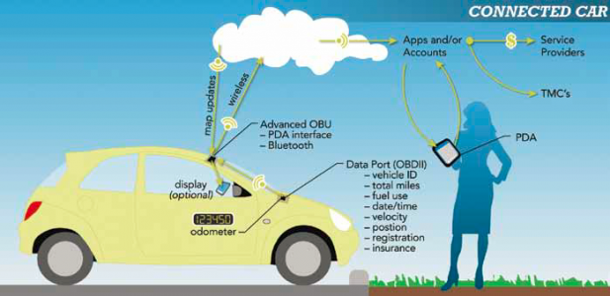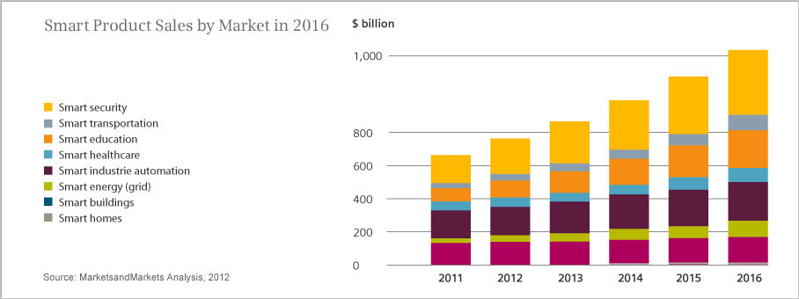

<http://www.its.dot.gov/pilots/>

<http://www.atkinsglobal.com/en-gb/angles/all-angles/autonomous-vs-connected-vehicles-whats-the-difference>

<https://ipcarrier.blogspot.co.uk/2013/10/internet-of-things-forecasts-vary-by.html>

[https://news.microsoft.com/en-in/tata-motors-and-microsoft-india-collaborate-to-redefine-the-connected-experience-for-automobile-users/#sm.00000gx5simjr1fcuzlkc270zcmg5#YLpmFc4ugtlqheg4.97](https://news.microsoft.com/en-in/tata-motors-and-microsoft-india-collaborate-to-redefine-the-connected-experience-for-automobile-users/#sm.00000gx5simjr1fcuzlkc270zcmg5)