Question 2:

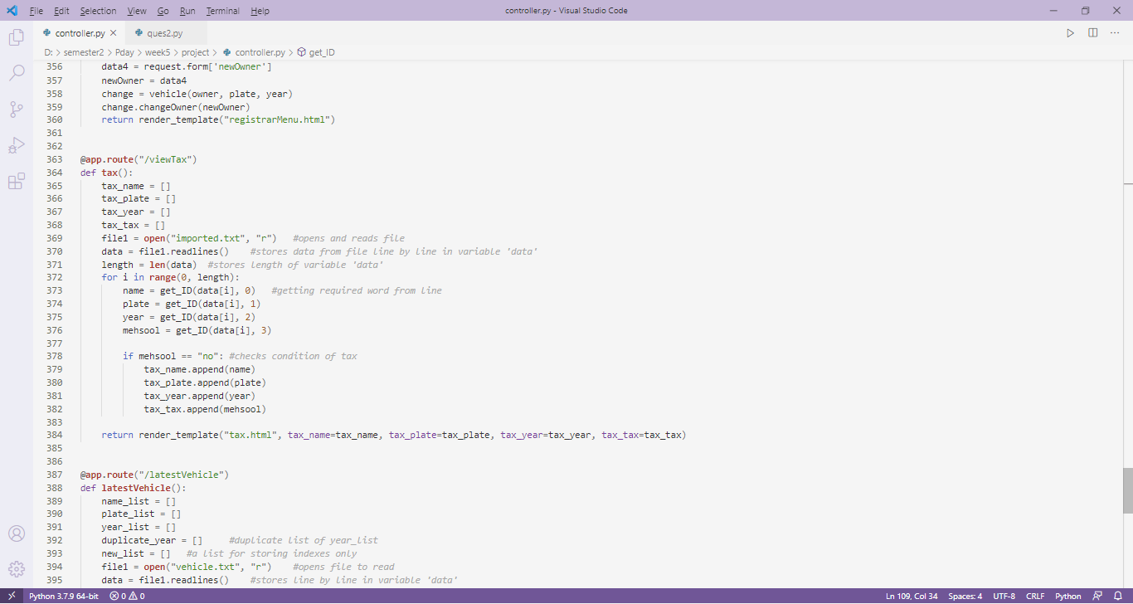Old :

New:

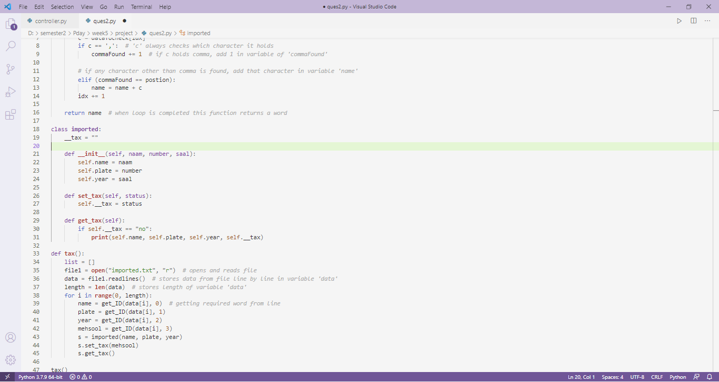

In this updated case, tax attribute is made private and can only be accesed by class and its functions.

Therefore, security is increased. Moreover, this function of class can be called at any place and it increases the maintainability of code.