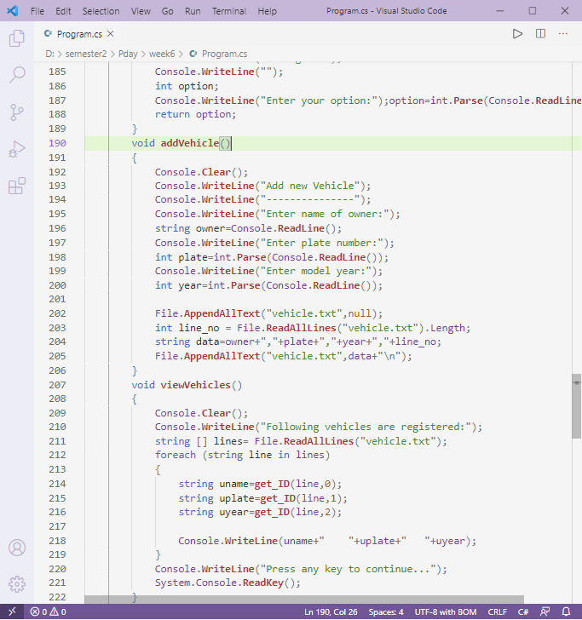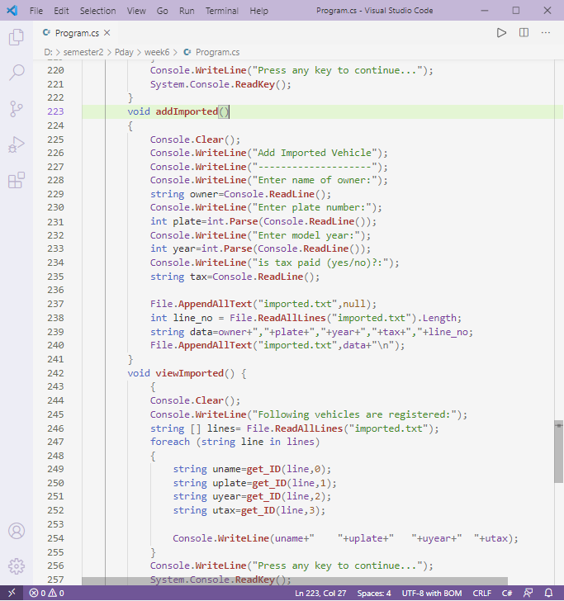in above scenarios, the functionality is same: to add vehicles. In first case, owner name, plate number and model year. In second case, 4 parameters are used: owner name, plate number, model year and tax status.

So instead of using different functions, we can use same name function name and overload it.