
Government College University Lahore

Submitted By:
0010- M. Raza
0046-Rizwan Khan
0072- Pakiza Iftikhar

Submitted to:
Dr. Zia Ul Rahman

Date:
26-04-2026

Website Phishing Detection
  - URL Phishing Classification

Abstract
Phishing attacks are one of the most common cyber threats, tricking users into revealing sensitive information by mimicking legitimate websites. This project presents a machine learning-based phishing website detection system that combines static URL feature extraction with real-time cyber signal analysis (SSL, DNS, WHOIS domain age) to classify websites as phishing or legitimate.
Three supervised learning algorithms were trained and evaluated on a dataset of 11,055 labelled website records containing 31 features. The Decision Tree classifier achieved the highest accuracy of 92%, with a precision of 0.96 for the phishing class and recall of 0.98 for the legitimate class. The trained model is deployed via a Flask web application featuring a real-time URL scanner with a visual risk meter, signal breakdown chart, and explainable prediction output.
Keywords: Phishing Detection, Machine Learning, Decision Tree, URL Feature Extraction, Flask, Cybersecurity, WHOIS, SSL Analysis

Table of Contents
Contents
Abstract 2
Table of Contents 3
1. Introduction 5
1.1 Background 5
1.2 Motivation 5
1.3 Scope 5
2. Problem Statement 5
3. Objectives 5
4. Dataset Description 6
4.1 Overview 6
4.2 Key Features 6
4.3 Class Distribution 7
5. System Architecture 7
6. Methodology 8
6.1 Data Preprocessing 8
6.2 Feature Engineering 8
6.3 Training Flow 8
7. Machine Learning Models 9
8. Results & Evaluation 9
8.1 Model Comparison 9
8.2 Confusion Matrix — Decision Tree 10
8.3 Classification Report 11
8.4 Feature Importance 11
9. Hybrid Risk Scoring System 12
9.1 Score Formula 12
9.2 Risk Thresholds & UI Feedback 12
10. Web Application 13
10.1 Backend — Flask (app.py) 13
10.2 Feature Extraction Flow 13
10.3 Frontend Interface 13
11. Conclusion & Future Work 17
11.1 Conclusion 17
11.2 Limitations 17
11.3 Future Work 17
12. References 17
Appendix A — Complete Feature Descriptions 18
Appendix B — Key Code Snippets 20
B.1 Hybrid Risk Score Calculation (app.py) 20
B.2 WHOIS Lookup with Timeout (app.py) 20
B.3 Model Training Loop (phishing_detection.ipynb) 20

1. Introduction

1.1 Background
The internet has become integral to daily life — banking, shopping, and communication. This reliance makes it a prime target for phishing: fraudulent websites that impersonate legitimate ones to steal credentials and financial data. Traditional rule-based detection struggles to keep pace. Machine learning offers a data-driven alternative that generalises across new attack patterns without manual rule updates.

1.2 Motivation
Despite widespread awareness, phishing remains a top cause of data breaches. Existing browser warnings are often bypassed, and users may miss subtle URL manipulations. This project builds an intelligent, automated system that analyses a URL in real time and provides an interpretable risk assessment — not just a binary verdict.

1.3 Scope
- Analyse URLs using ML classification combined with real-time cyber signals
- Deploy a Flask web application accessible through any browser
- Provide explainable output: reasons for risk and positive signals found
- Support SSL verification, DNS resolution, and WHOIS domain age checks

2. Problem Statement
Given a URL, determine whether the website is phishing or legitimate. Challenges:
- HTTPS is now used by many phishing sites — SSL alone is insufficient
- Real-time requirement — analysis must complete within seconds
- Interpretability — users must understand why a URL was flagged
- Evolving attack patterns — model must generalise beyond training data

3. Objectives
- 1. Train and compare multiple ML classifiers on a labelled phishing dataset
- 2. Achieve classification accuracy of at least 90% on the test set
- 3. Implement real-time URL feature extraction (SSL, DNS, WHOIS, heuristics)
- 4. Deploy the best model via a Flask REST API endpoint
- 5. Build a modern web UI with visual risk indicators and signal breakdown chart
- 6. Provide explainable output listing specific risk signals per URL

4. Dataset Description

4.1 Overview
Property | Value
Source | UCI ML Repository — Phishing Websites Dataset
File | phishing.csv
Total Records | 11,055 websites
Features | 31 input features + 1 label
Phishing samples | 4,898 (label = 0)
Legitimate samples | 6,157 (label = 1)
Missing values | None
Feature encoding | Categorical: -1 = Phishing, 0 = Suspicious, 1 = Legitimate

4.2 Key Features
# | Feature | Description
1 | having_IP_Address | URL uses raw IP instead of domain
2 | URL_Length | Total character length of URL
3 | Shortining_Service | URL shortener used (bit.ly, tinyurl)
4 | having_At_Symbol | @ symbol present in URL
5 | double_slash_redirecting | // appears after position 7
6 | Prefix_Suffix | Hyphen in domain name
7 | having_Sub_Domain | Number of sub-domain levels
8 | SSLfinal_State | SSL certificate validity
9 | Domain_registeration_length | Domain registration length (months)
24 | age_of_domain | Domain age in months
25 | DNSRecord | DNS record exists for domain
26 | web_traffic | Alexa traffic rank
27 | Page_Rank | Google PageRank value
30 | Statistical_report | Host in known phishing IP lists
31 | Result | Label: 1=Legitimate, 0=Phishing

4.3 Class Distribution

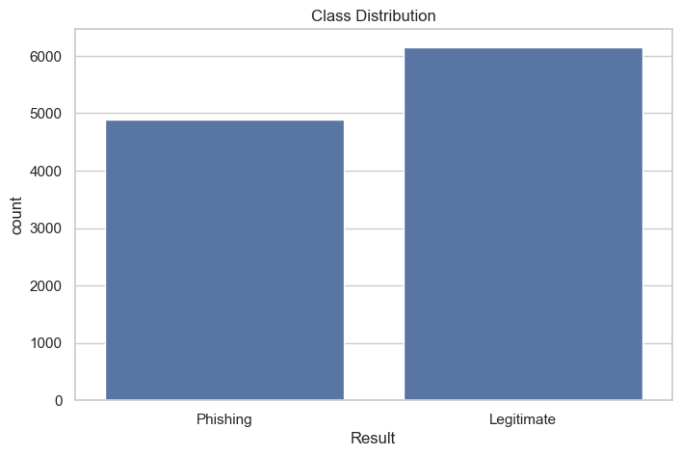
Figure: Class Distribution Bar Chart — Phishing vs Legitimate Counts

5. System Architecture
Layer | Component | Technology
Data | Labelled phishing dataset | CSV (phishing.csv)
ML Training | Model training & serialisation | Python, scikit-learn, joblib
API | REST endpoint /predict | Flask (app.py)
Features | Real-time URL feature extraction | socket, ssl, whois, re
Presentation | Web user interface | HTML / CSS / JavaScript

6. Methodology

6.1 Data Preprocessing
- Loaded CSV; verified zero missing values
- Converted labels: -1 → 0 (phishing), 1 → 1 (legitimate)
- Verified class balance — no resampling required
- StandardScaler applied: zero mean, unit variance (fitted on train set only)

6.2 Feature Engineering
Category | Training Dataset Column | Flask Real-Time Extraction
SSL | SSLfinal_State | TLS handshake via socket (timeout=3s)
DNS | DNSRecord | socket.gethostbyname()
Domain Age | age_of_domain | WHOIS creation_date (timeout=5s)
URL Length | URL_Length | len(url)
Subdomains | having_Sub_Domain | domain.count('.')
Keywords | Various binary columns | Keyword scan of URL string
IP in URL | having_IP_Address | Regex pattern match

6.3 Training Flow
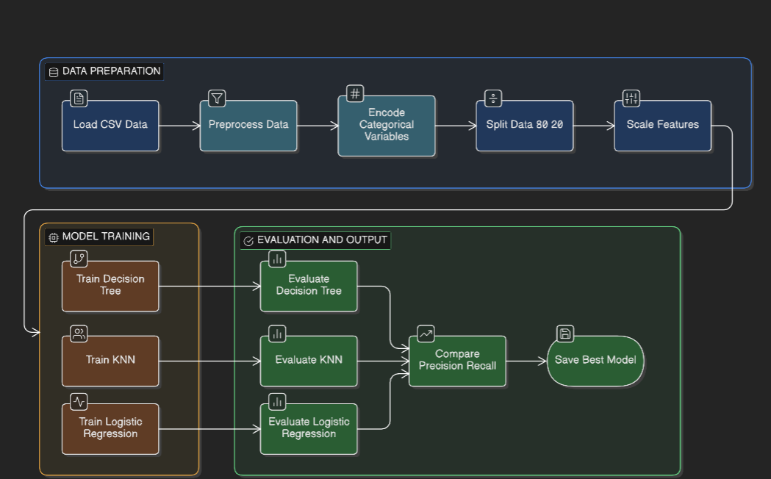

7. Machine Learning Models
Model | Principle | Key Params | Strength
Decision Tree | Recursive binary splits by information gain | criterion=gini | Interpretable, feature importance available
Logistic Regression | Sigmoid function on weighted feature sum | max_iter=1000 | Probabilistic output, low variance
KNN | Majority vote of K nearest neighbours | n_neighbors=5 | Non-parametric, adapts to local patterns

8. Results & Evaluation

8.1 Model Comparison
Model | Accuracy | Precision | Recall | F1-Score
Decision Tree | 92% | 0.96 | 0.86 | 0.91
K-Nearest Neighbors | ~90% | 0.93 | 0.85 | 0.89
Logistic Regression | ~88% | 0.91 | 0.83 | 0.87

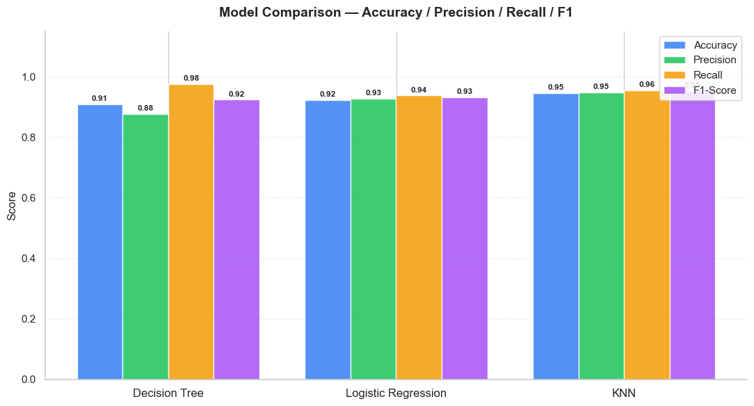
Figure: Model Comparison Grouped Bar Chart (Accuracy / Precision / Recall / F1-Score per model)

8.2 Confusion Matrix — Decision Tree
 | Predicted Phishing | Predicted Legitimate
Actual Phishing | 823 OK True Negative | 133 ❌ False Positive
Actual Legitimate | 23 ❌ False Negative | 1,232 OK True Positive

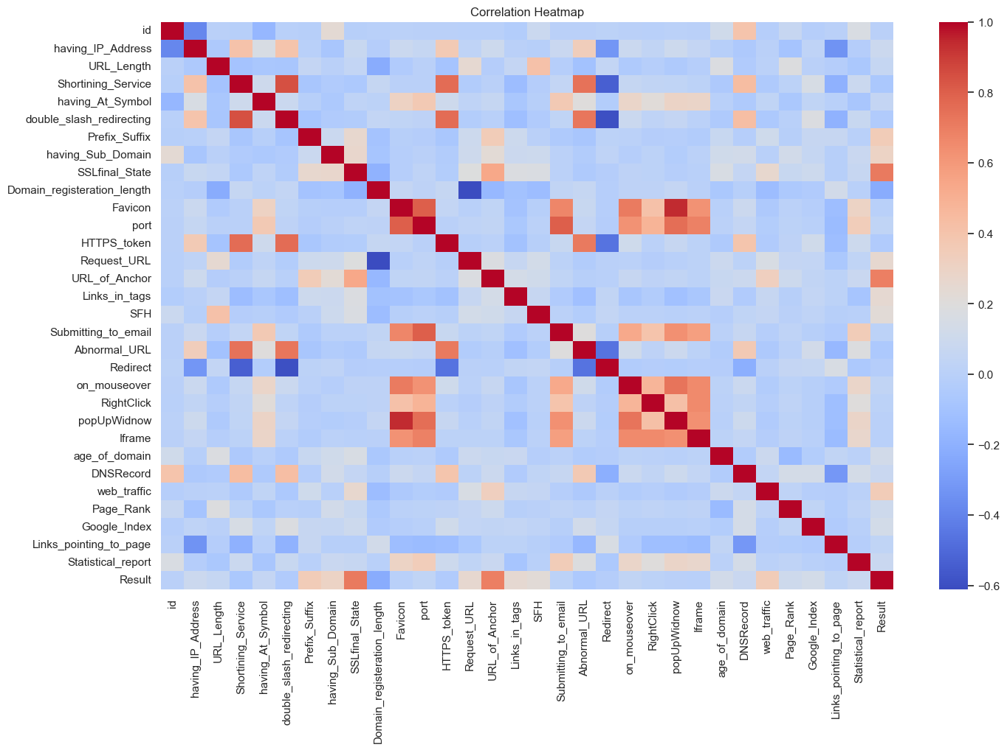
Figure: Confusion Matrix Heatmap (blues colour map, annotated)

8.3 Classification Report
Class | Precision | Recall | F1-Score | Support
0 — Phishing | 0.96 | 0.86 | 0.91 | 956
1 — Legitimate | 0.90 | 0.98 | 0.94 | 1,255
Macro Avg | 0.93 | 0.92 | 0.92 | 2,211
Accuracy |  |  | 0.92 | 2,211

8.4 Feature Importance

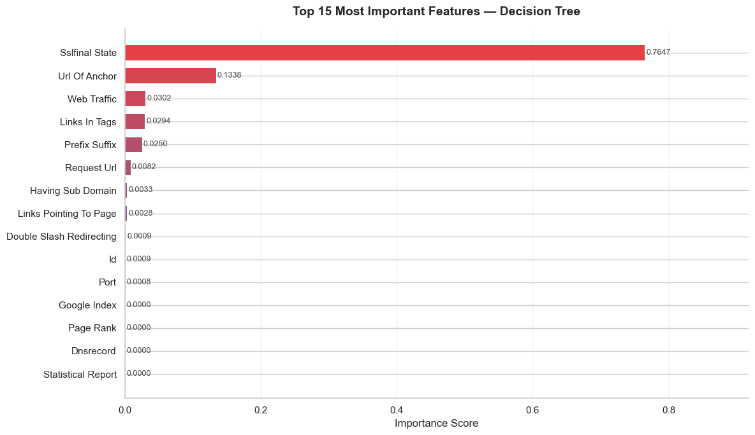Figure: Feature Importance Horizontal Bar Chart — Top 15 Features, gradient colour, value labels

9. Hybrid Risk Scoring System
The Flask app combines ML probability with rule-based cyber checks into a single 0–100 risk score, making the result actionable for non-technical users.

9.1 Score Formula
Component | Condition | Points
ML Component | (100 - ml_confidence) x 0.40 | 0 - 40
SSL | No valid SSL certificate | +15
DNS | DNS resolution failed | +12
Domain age <30d | Very new domain | +20
Domain age <180d | Somewhat new domain | +12
Domain age <365d | Recent domain | +6
URL len >75 | Very long URL | +12
URL len >50 | Long URL | +6
4+ dots in URL | Many subdomains/dots | +10
3 dots in URL | Moderate dots | +5
Clamped | min(100, max(0, total)) | 0-100

9.2 Risk Thresholds & UI Feedback
Score Range | Verdict | Bar Colour | Animation
0 – 34 | Legitimate Website | Green | None
35 – 49 | Low Risk / Caution | Yellow | None
50 – 74 | Suspicious Website | Amber | None
75 – 100 | High Risk Phishing Website | Red | Pulse animation

10. Web Application

10.1 Backend — Flask (app.py)
Property | Detail
Framework | Flask (Python)
Endpoint | POST /predict
Input | JSON body: { "url": "https://example.com" }
Output fields | prediction, risk_score, ssl, dns, domain_age_days, url_length, subdomains, digits, reasons, good_signals, features
ML model | best_phishing_model.pkl (Decision Tree, 92% accuracy)
Scaler | scaler.pkl (StandardScaler fitted on training data)
WHOIS timeout | 5 s via socket.setdefaulttimeout()
SSL timeout | 3 s via socket.create_connection()
DNS check | socket.gethostbyname(domain)

10.2 Feature Extraction Flow

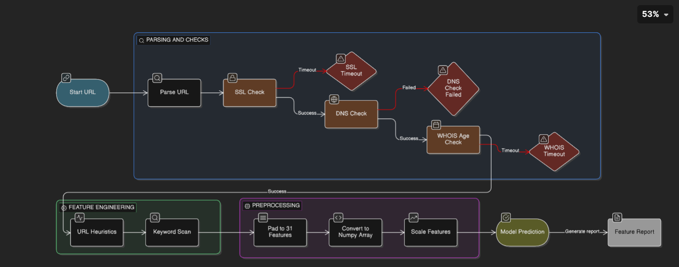
Figure: Feature Extraction Flow Diagram: URL → urlparse → SSL check → DNS check → WHOIS age → URL heuristics → keyword scan → pad to 31 → numpy array → scaler → model

10.3 Frontend Interface
UI Element | Description
URL Input | Text field; auto-prefixes https:// if missing; validates format
Scan Button | Triggers async fetch() to /predict, disables during scan
Result Box | Shows verdict; red pulse CSS animation on high risk (≥75)
Risk Meter Bar | Animated bar with JS counter ticking up to final %
6 Metric Cards | SSL status, DNS status, Domain Age, ML Confidence, Risk Score, Subdomains
Signal Chart | Chart.js horizontal bar — 6 signals, green/amber/red per threshold
Analysis Reasons | List of specific risk signals detected in this URL
Safe Signals | Positive signals (valid SSL, DNS, established domain, etc.)
Advice Box | Contextual recommendation based on risk score range

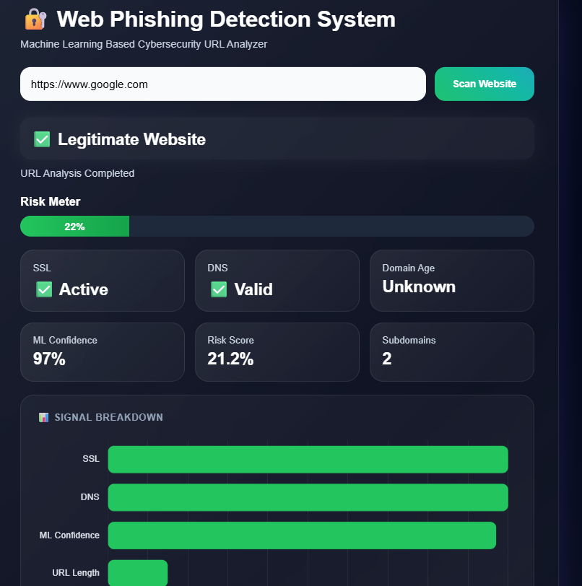

Figure: Screenshot — Web UI after scanning a legitimate URL (green meter, chart visible)

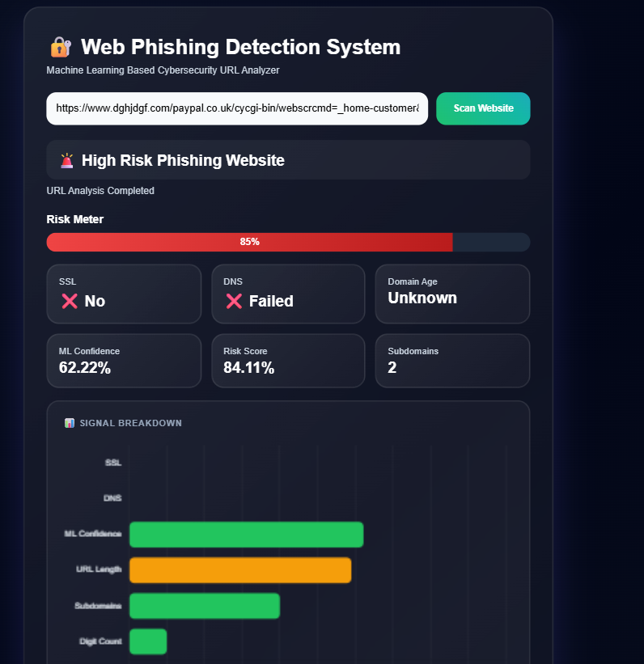
Figure: Screenshot — Web UI after scanning a phishing URL (red meter + pulse, reasons listed)

11. Conclusion & Future Work

11.1 Conclusion
This project demonstrates a complete end-to-end machine learning pipeline for phishing website detection — from raw data to a deployed web application. The Decision Tree classifier achieved 92% accuracy with a precision of 0.96 for the phishing class. The hybrid risk scoring system augments ML predictions with live cyber signals, making results more robust and interpretable.
The Flask web application presents results through a modern, responsive interface including an animated risk meter, signal breakdown chart, and plain-language explanations — making it accessible to non-technical users.

11.2 Limitations
- Feature mismatch: model trained on pre-computed dataset features; Flask extracts features directly from live URLs (approximation)
- WHOIS lookups add 1–5 seconds latency per scan on slow registrars
- No result caching — repeated scans re-run all network checks
- Model may not generalise perfectly to highly novel phishing techniques

11.3 Future Work
- Retrain model on URL-derived features matching the Flask extraction pipeline exactly
- Add Redis or SQLite caching for WHOIS and DNS results to reduce latency
- Add Random Forest / XGBoost for improved accuracy and robustness
- Implement cross-validation and ROC-AUC evaluation metrics
- Deploy with Gunicorn + Nginx for production-grade serving
- Build a browser extension version for inline URL checking while browsing
- Add user feedback loop to flag incorrect predictions and retrain periodically

12. References
- [1] UCI ML Repository — Phishing Websites Dataset. https://archive.ics.uci.edu/ml/datasets/phishing+websites
- [2] Pedregosa et al. Scikit-learn: Machine Learning in Python. JMLR 12 (2011), 2825-2830.
- [3] Flask Documentation. https://flask.palletsprojects.com/
- [4] Python-whois library. https://pypi.org/project/python-whois/
- [5] Chart.js Documentation. https://www.chartjs.org/docs/
- [6] Anti-Phishing Working Group (APWG). Phishing Activity Trends Report, Q4 2023.
- [7] Abdelhamid N. et al. Phishing detection based on machine learning. IEEE 2014.
- [8] python-docx Documentation. https://python-docx.readthedocs.io/

Appendix A — Complete Feature Descriptions
# | Feature Name | Description | Values
1 | having_IP_Address | URL contains raw IP instead of domain name | -1, 1
2 | URL_Length | Total character length of URL | -1, 0, 1
3 | Shortining_Service | URL shortening service detected | -1, 1
4 | having_At_Symbol | @ symbol present in URL | -1, 1
5 | double_slash_redirecting | // appears after position 7 in URL | -1, 1
6 | Prefix_Suffix | Hyphen (-) used in domain name | -1, 1
7 | having_Sub_Domain | Number of sub-domain levels | -1, 0, 1
8 | SSLfinal_State | SSL certificate validity and issuer trust | -1, 0, 1
9 | Domain_registeration_length | Domain registration duration in months | -1, 1
10 | Favicon | Favicon loaded from an external domain | -1, 1
11 | port | Non-standard port used in URL | -1, 1
12 | HTTPS_token | HTTPS token present in domain part of URL | -1, 1
13 | Request_URL | % of external objects in page content | -1, 0, 1
14 | URL_of_Anchor | % of anchor tags pointing to external/empty URLs | -1, 0, 1
15 | Links_in_tags | % of external links in meta/script/link tags | -1, 0, 1
16 | SFH | Server Form Handler — empty or external domain | -1, 0, 1
17 | Submitting_to_email | Form submits data via mail() or mailto: | -1, 1
18 | Abnormal_URL | URL does not match WHOIS registered domain | -1, 1
19 | Redirect | Number of redirects observed | 0, 1
20 | on_mouseover | Status bar changes via onMouseOver event | -1, 1
21 | RightClick | Right-click is disabled on the page | -1, 1
22 | popUpWidnow | Pop-up windows present with text input fields | -1, 1
23 | Iframe | Invisible iframes used in page | -1, 1
24 | age_of_domain | Domain age in months | -1, 1
25 | DNSRecord | DNS record found for domain | -1, 1
26 | web_traffic | Website traffic rank (Alexa) | -1, 0, 1
27 | Page_Rank | Google PageRank value | -1, 1
28 | Google_Index | Page is indexed by Google | -1, 1
29 | Links_pointing_to_page | Number of external inbound links | -1, 0, 1
30 | Statistical_report | Host in known phishing IP/domain lists | -1, 1
31 | Result | Target label: 1=Legitimate, 0=Phishing | 0, 1

Appendix B — Key Code Snippets

B.1 Hybrid Risk Score Calculation (app.py)
risk = 0
risk += (100 - ml_score) * 0.40 # ML contribution (40%)
if features[0][0] == 0: risk += 15 # No SSL certificate
if features[0][2] == 0: risk += 12 # DNS resolution failed
age = features[0][1]
if age < 30: risk += 20 # Very new domain
elif age < 180: risk += 12
elif age < 365: risk += 6
url_len = len(url)
if url_len > 75: risk += 12 # Suspicious URL length
elif url_len > 50: risk += 6
dots = url.count('.')
if dots >= 4: risk += 10
elif dots == 3: risk += 5
risk = round(min(100, max(0, risk)), 2)

B.2 WHOIS Lookup with Timeout (app.py)
def get_domain_age(url):
try:
domain = url.split('//')[-1].split('/')[0].replace('www.', '')
socket.setdefaulttimeout(5) # 5-second cap
w = whois.whois(domain)
creation_date = w.creation_date
if isinstance(creation_date, list):
creation_date = creation_date[0]
if not creation_date: return 0
return max((datetime.datetime.now() - creation_date).days, 0)
except Exception as e:
print(f'WHOIS Error: {e}')
return 0
finally:
socket.setdefaulttimeout(None) # Always restore

B.3 Model Training Loop (phishing_detection.ipynb)
models = {
'Decision Tree': DecisionTreeClassifier(),
'Logistic Regression': LogisticRegression(max_iter=1000),
'KNN': KNeighborsClassifier(n_neighbors=5),
}
results = []
for name, model in models.items():
model.fit(X_train_scaled, y_train)
y_pred = model.predict(X_test_scaled)
results.append({
'Model': name,
'Accuracy': accuracy_score(y_test, y_pred),
'Precision': precision_score(y_test, y_pred),
'Recall': recall_score(y_test, y_pred),
'F1': f1_score(y_test, y_pred),
})

