**What is an API?**

An Application Programming Interface, commonly shortened to API, is a set of rules which determines how one software program can access the data or functionality provided by another software program.

APIs are an essential part of modern software development. They allow different systems and applications to communicate with each other and share functionality in a flexible and efficient way. They're used in a wide variety of contexts, including web development, mobile apps, and Internet of Things (IoT) applications.

## How do APIs work?

APIs often come in the form of a library that a software developer can include in their code. This library provides a set of functions that can be called upon to perform various tasks. The API specifies the function calls, the inputs they accept, and the outputs they return.

Here's a simplified overview of how APIs work:

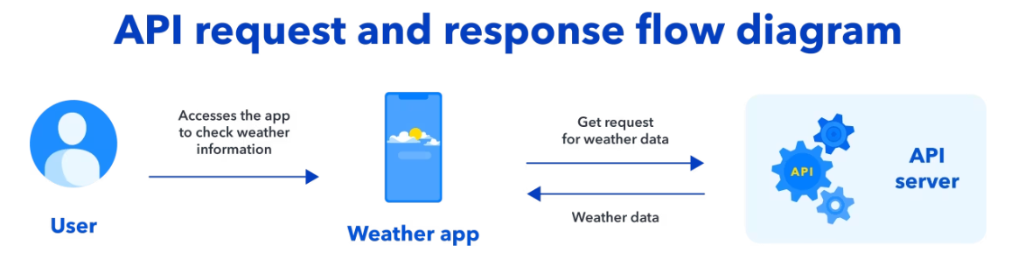

* A client sends a request to the API server, usually over the internet or a local network. The request is made using a specific protocol (such as HTTP) and includes information about the operation the client wants to perform, e.g., retrieving data or updating a resource.
* The API server receives the request and processes it. It may validate the request, authenticate the client, authorize the request, or perform other necessary operations.
* The API server sends a response back to the client, which may include data, an error message, or a status code indicating the result of the operation.
* The client receives the response and processes it.

**How do I use an API?**

Using an API typically involves the following steps:

| **Step** | **Description** |
| --- | --- |
| **1. Find an API** | The first step in using an API is to find an API that provides the functionality you need. There are many APIs available on the internet, and you can search for APIs using search engines, developer portals, or API marketplaces. |
| **2. Read the documentation** | Once you have found an API that you want to use, the next step is to read the API documentation. The documentation should provide information on the API's capabilities, the structure of the requests and responses, and any authentication or authorization requirements. |
| **3. Understand the API's terms of use** | Before you begin using an API, it's important to understand its terms of use. These terms will specify limitations on how you can use the API, and how you can use and share the API's data. It may also explain whether the API is free or requires a paid subscription. |
| **4. Obtain an API key** | Many APIs require you to obtain an API key before you can start using it. The API key is a unique identifier used to authenticate your API requests. You're given one after you sign up for the API or after you agree to the API's terms of use. |
| **5. Make API requests** | Once you have an API key and have read the API documentation, you can start making API requests. The API request usually contains a URI that identifies the resource you want to access. It'll also have an HTTP verb (such as GET or POST) to specify the operation you want to perform. You can make API requests using a tool such as a command-line utility or a library in your programming language of choice. |
| **6. Process the API response** | When you make an API request, the API server will send a response back to you. The response may include data, an error message, or a status code indicating the result of the operation. It's important to process the API response and handle any errors or exceptions that may occur. |
| **7. Follow best practices** | Cache data to reduce the number of API requests, handle errors and exceptions gracefully, and respect the API's terms of use. By following best practices like these, you'll make sure that your use of the API is efficient, reliable and compliant. |

## What is an API call?

An [API call](https://www.contentful.com/blog/api-call/) is a request made to an API to access data or functionality. A client makes an API call and sends a request to the API server, and the server sends back a response. The request and response use a specific format and structure, and are transmitted using a specific protocol (such as HTTP).

To make an API call, you should have access to the API documentation. This documentation provides information on the API's capabilities, the structure of the requests and responses, and any authentication or authorization requirements. You may also need to obtain an API key or other credentials before you can make API calls.

## What is an API key?

An [API key](https://www.contentful.com/blog/api-key/) is a unique identifier used to authenticate API requests. API keys will typically track and control how you can use an API. They can also provide access to an API's data and functionality.

API keys guide the correct operation of an API as per the terms of use. They can limit the number of API requests that a client can make, for example. An API key can also track the usage of an API, or make sure that the data provided by an API is being used appropriately.

API keys are usually provided by the API provider and are required to make API requests. They can be generated and managed through the API provider's developer portal, and are often specific to a particular API or application.

API keys are typically present in the header of an API request, and are used to authenticate the request. Other authentication and authorization credentials, such as an OAuth token or a JSON Web Token (JWT), may also be used in tandem.

## What is an API endpoint?

An [API endpoint](https://www.contentful.com/blog/api-endpoint/) is a specific location on a server which can receive and respond to API requests. An API endpoint is identified by a URI (Uniform Resource Identifier) and is typically associated with a particular API or service.