Computer Vision & Natural Language Processing  Diploma in IT  2025/26 Semester 4 | Week 12/ 13
 | 1 hour
Week 12/13 Activity
More about RNNs

OBJECTIVES

At the end of this exercise, you will learn more about:

- Sequences
- RNN Architectures

IMPORTANT

- Submit the following notebook files via Brightspace submission link by the specified due date.

- Completed Week 13 Activity – More about RNNs.docx

- Understanding basics of RNNs

- What is the primary difference between a Recurrent Neural Network (RNN) and a traditional feedforward neural network?

- Describe how the hidden state in an RNN helps in processing sequential data. Provide an example.

- What is meant by "weight sharing" in the context of RNNs? Why is it beneficial?

- Explain how weight sharing allows RNNs to generalize across sequences of different lengths.

- What is the purpose of embedding layers in RNNs?

- What is the purpose of padding sequences in RNNs, and how is it typically done?

- Explain the concept of packed sequences in PyTorch and how it helps improve the efficiency of training RNNs.

- Weight Sharing computations in RNNs

- Consider a vanilla RNN with input sequence {x₁, x₂, x₃}, where each x_{i} is a 2-dimensional vector. X₁ = [1, 2], x₂ = [0, 1], x₃ = [2, 0]. The RNN has a hidden state size of 3. Given the following parameters:
Input-to-hidden weight matrix:
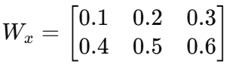
Hidden-to-hidden weight matrix
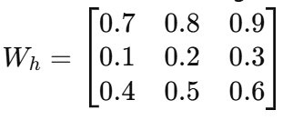
Bias for hidden states
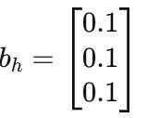

Let the initial hidden state h₀ = [0,0,0], compute the hidden states h₁​, h₂​, and h₃​ using the ReLU activation function. Show each step of the computation. State assumptions if any.

- Applications and possible considerations of RNNs

- Provide two real-world applications of RNNs. Briefly explain how RNNs are utilized in each.

