Artificial Intelligence Concepts & Techniques  Diploma in IT  2025/26 Semester 4 | Week 7
 | 2 hours
Week 7 Activity
Uncertainty I

OBJECTIVES

At the end of this exercise, you will:
- Gain an understanding of Bayesian Network
- Use a python package (pgmpy) to implement Inference from Bayesian Network

IMPORTANT

- Submit the following via Brightspace submission link by the specified due date
- completed .py files
- completed Week 7 Activity – Uncertainty I.docx

- There is no need to compress your files in a zip.

- Bayesian Network (Practical)
Refer to the following conditional probability table:

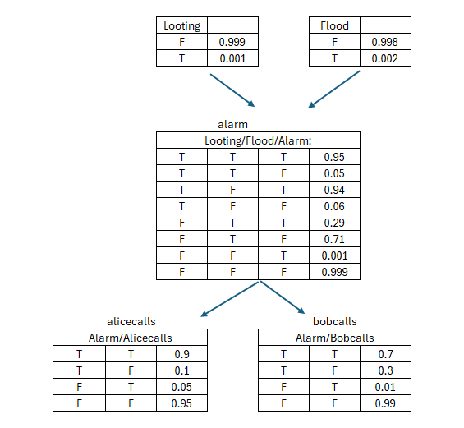

- You are required to model this using the pgmpy package in python.
- Assuming that both Alice and Bob made phone calls, predict what the new probability distributions will look like.

- If both Looting and Flood occurred, predict the new probability distributions.

