K-2

**Started Means:**

[[182 119 88]

[245 241 242]]

**Trained Means:**

[[144.76829268 106.26689383 78.77643472]

[197.58451925 177.14689044 164.62237053]]

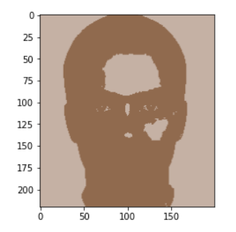

**Comment:**

Here k=2, all pixels are replaced by only 2 (RGB) values. That’s why image is looking dark and white almost.

K-3

**Started Means:**

[[187 116 86]

[239 239 237]

[ 38 19 2]]

**Trained Means:**

[[187.65295189 140.35776278 112.56375228]

[214.35410881 198.86954746 190.00951642]

[124.00905387 90.76630954 64.02977717]]

**Comment:**

Here k=3, all pixels are replaced by only 3 (RGB) values. That’s why image is looking better than the value of k=2

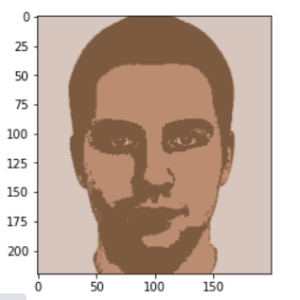

K-5

**Started Means:**

[[248 240 221]

[221 222 217]

[ 13 19 5]

[ 28 26 3]

[194 134 98]]

**Trained Means:**

[[222.10616256 208.65942093 201.32937843]

[197.29354654 168.96207881 150.69891491]

[151.4751791 116.37671971 90.66043238]

[127.61951017 91.98664948 63.87597827]

[196.77775135 145.76458928 118.82643514]]

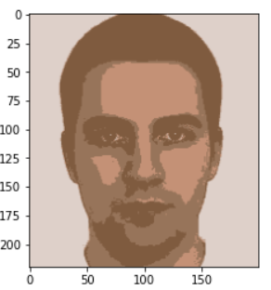

**Comment:**

Here k=5, all pixels are replaced by only 5 (RGB) values. That’s why image is looking better than the value of k=3

K-10

**Started Means:**

[[231 229 230]

[231 226 230]

[223 147 113]

[236 234 235]

[173 109 73]

[ 29 27 12]

[229 228 226]

[231 229 230]

[245 241 242]

[141 98 63]]

**Trained Means:**

[[196.31778357 163.80653564 145.51030073]

[195.16789809 134.47630573 102.78509554]

[165.89314248 114.91500222 82.37427874]

[206.94367405 188.90979271 178.05046462]

[156.7493494 107.08615258 72.57622244]

[ 74.05946776 54.17737973 31.54032753]

[193.46368039 153.40124524 131.31943964]

[179.04981818 151.24497727 132.83184091]

[227.49757002 219.86146601 216.35688161]

[129.0401354 89.23855577 58.63749194]]

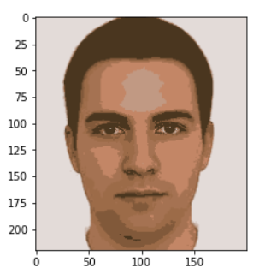

**Comment:**

Here k=10, all pixels are replaced by only 10 (RGB) values. That’s why image is looking better than the value of k=5, and contains better representation.

K-15

**Started Means:**

[[246 242 243]

[151 109 69]

[169 114 75]

[227 226 224]

[ 36 29 3]

[238 238 230]

[138 115 97]

[243 242 240]

[ 24 26 2]

[229 229 231]

[172 113 73]

[107 72 40]

[179 111 74]

[171 117 81]

[242 241 239]]

**Trained Means:**

[[232.626627 226.93901078 225.12670669]

[148.86001918 103.02684564 67.62160435]

[159.48947198 109.11467444 73.26368643]

[202.76872964 159.30841762 136.7354706 ]

[113.05884889 75.89545161 47.82194438]

[210.89530355 193.30973654 182.48957617]

[150.94985898 96.26324036 66.15888436]

[205.4812398 184.47047308 172.50375204]

[ 54.03852684 40.36868225 20.07953507]

[208.85843965 188.16486752 177.69406281]

[153.32901834 114.94138799 84.16936354]

[136.58783121 98.01799149 66.62839385]

[186.25162541 125.01528459 90.35850348]

[170.43312757 114.8063786 78.98251029]

[216.65169903 202.70485437 194.91966019]]

**Comment:**

Here k=15, all pixels are replaced by only 15 (RGB) values. That’s why image is looking better than the value of k=10, and contains better representation.

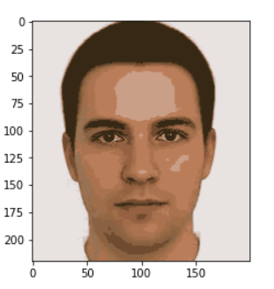

K-20

**Started Means:**

[[ 33 42 13]

[ 25 27 6]

[123 89 52]

[242 238 237]

[107 72 40]

[234 232 233]

[158 95 62]

[ 66 40 15]

[237 232 226]

[157 104 70]

[ 11 20 1]

[243 241 242]

[202 136 104]

[230 228 231]

[235 235 233]

[245 241 242]

[220 217 208]

[186 121 81]

[169 105 67]

[206 136 100]]

**Trained Means:**

[[142.91353172 106.03144301 76.59067939]

[ 80.73893572 57.32191781 32.01975764]

[154.35288066 114.58744856 82.4994856 ]

[219.05211268 202.55774648 193.13014085]

[129.37388818 86.08449809 53.87198221]

[208.5333935 189.41110108 179.07897112]

[159.80842607 122.11327504 94.32988871]

[145.66194487 97.16117917 63.24540582]

[210.87941889 147.1559322 117.25544794]

[150.09390863 107.01573604 72.18781726]

[ 42.33287399 33.45796968 14.59592712]

[223.43768601 214.33816964 209.5390625 ]

[161.60977903 111.57310766 78.82933709]

[213.42525313 199.86658725 193.01042287]

[212.56963428 194.1023273 182.99224233]

[235.24482967 229.65132481 228.21142136]

[176.51971748 147.95055915 126.7898764 ]

[175.6406746 117.96349206 81.49900794]

[159.8369906 106.5984326 71.12664577]

[194.49913345 128.79618718 94.95979203]]

**Comment:**

Here k=20, all pixels are replaced by only 20 (RGB) values. That’s why image is looking better than the value of k=15, and contains better representation. Image is almost looking great.

