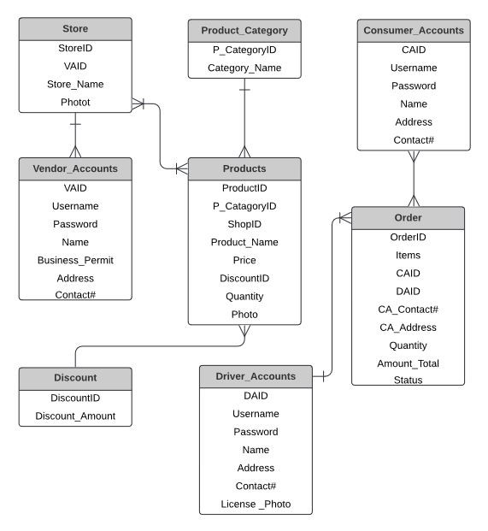**E-BUYan: WEB-BASED E-COMMERCE OF TUY PUBLIC MARKET AMIDST COVID-19**

The 30 % of the system will focus on the consumer’s modules such as:

* Account Registration
* Add/Modify order
* Manage order