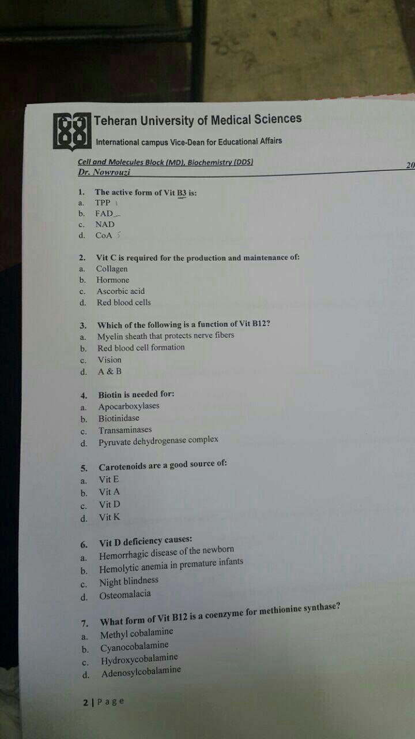
- C\
- A\
- D\
- A\
- B\
- D\
- A\

8\ Methotrexate interferes with activation of:
A\calcitriol B\folic acid C\pyridoxine D\ riboflavin
9\ night blindness is due to deficiency of:
A\ retinal B\ retinoic acid C\ tretinoin D\ isotretinoin
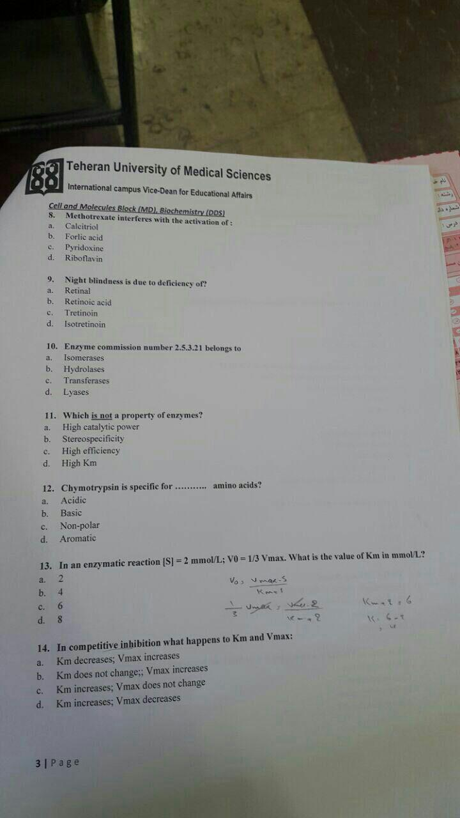
- B\
- A\
- C\
- ALL OF THEM ARE PROPERTY -_- MAYBE D\
- B\
- B\
- C\
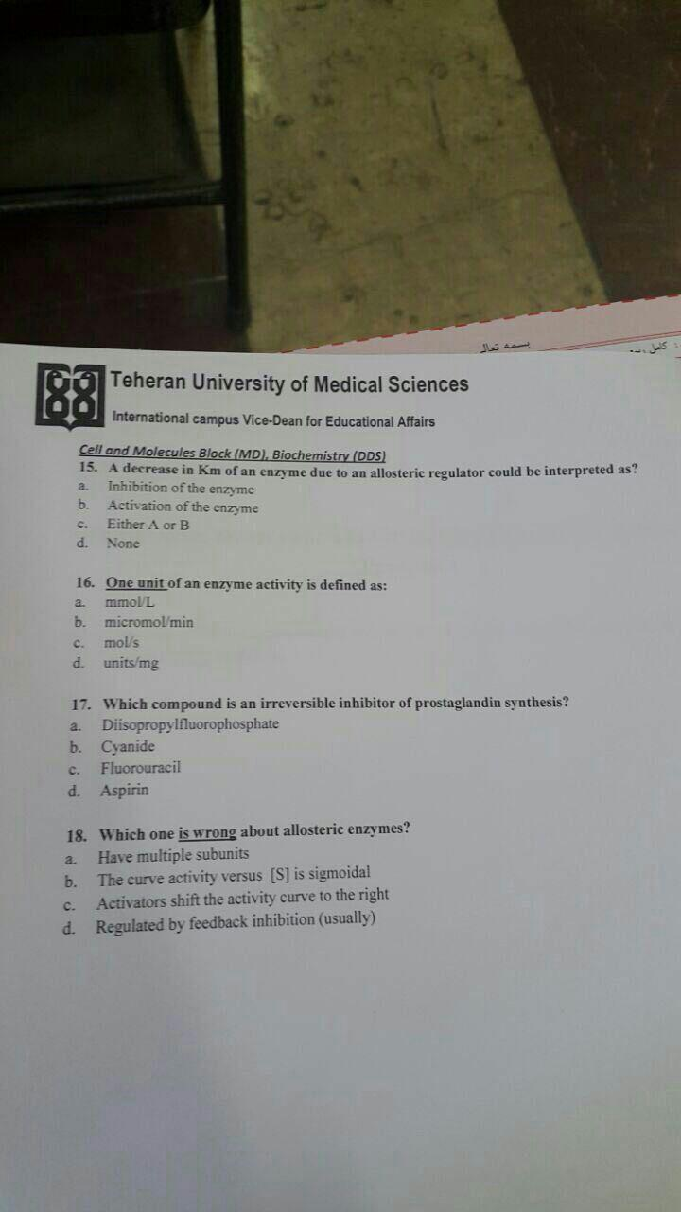
- C\
- B\
- D\
- C\

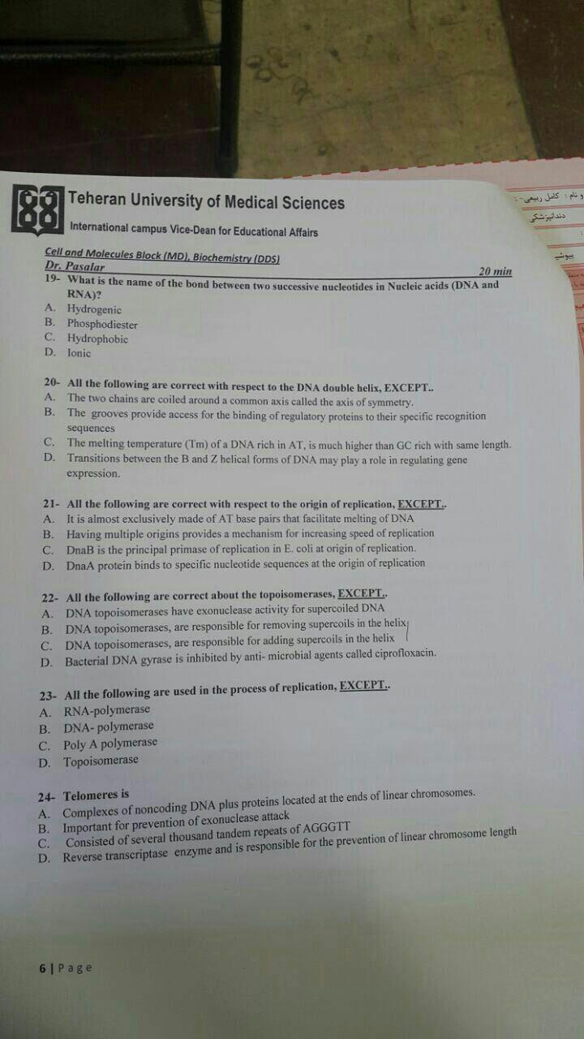
DNA page 7
19 B\ phosphodiester bond
20 C\ Tm in AT is higher than GC rich base pairing
21 C\ Dna B is the principle primase
22 A\ has exonuclease activity
23 A\ RNA polymerase
24 A\

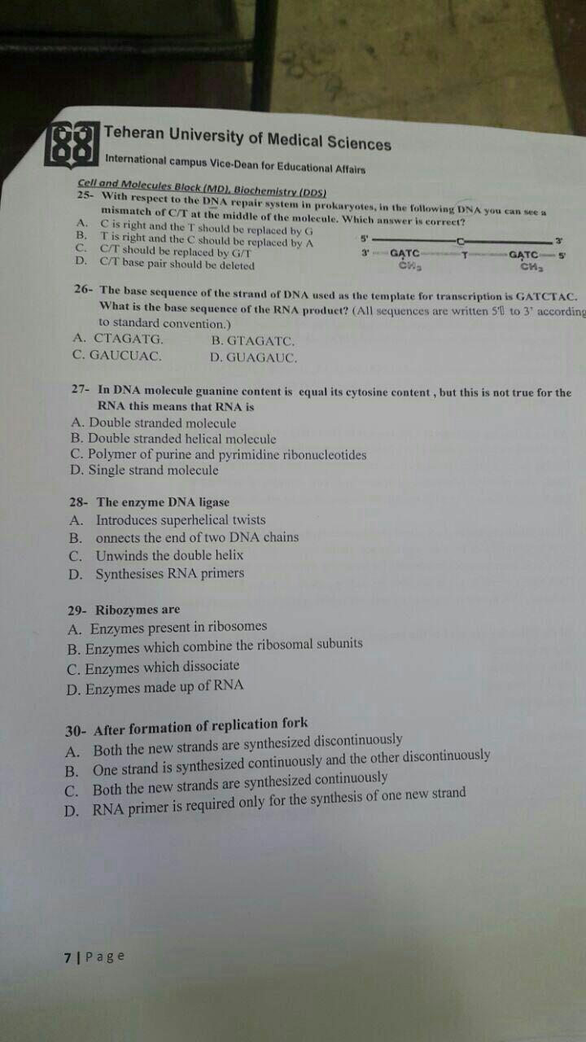
25 B\ T is right and C should be replaced by A
26 D\ GUAGAUC
27 D\ single strand molecule
28 B\ connects the end of two DNA chains
29 D\
30 B\ one enzyme discontinuously and the other strand is continuously

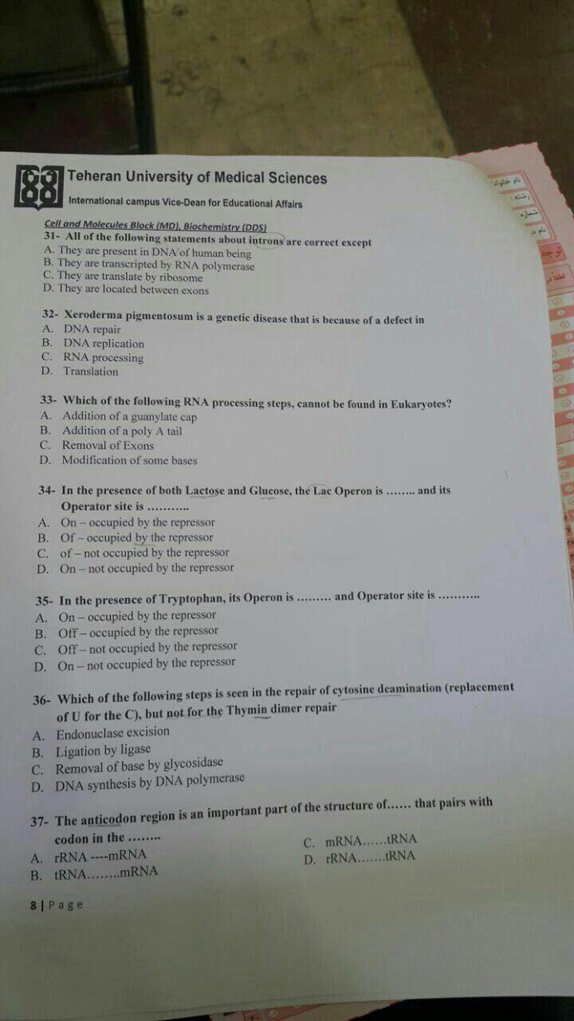

31 C\
32 A\
33 C\
34

XTRA NOTES

B1 thimine
Structure
A substituted pyrimidine and a thiazole coupled by a methylene bridge. + sulfidic group
Active form
thymine pyrophosphate TPP
deficiency
beriberi weak weak
cuz raw fish tea
alcohol cuz lots of calorie but low nutrition such B1 Wernicke-Korsakoff syndrome
anti-thymine diuretic wet beriberi
B5
Function
Transfer acetyl group

Sample \Which of the following is the cofactor for ?

