Data Scientist Role Play: Profiling and Analyzing the Yelp Dataset Worksheet

Question:
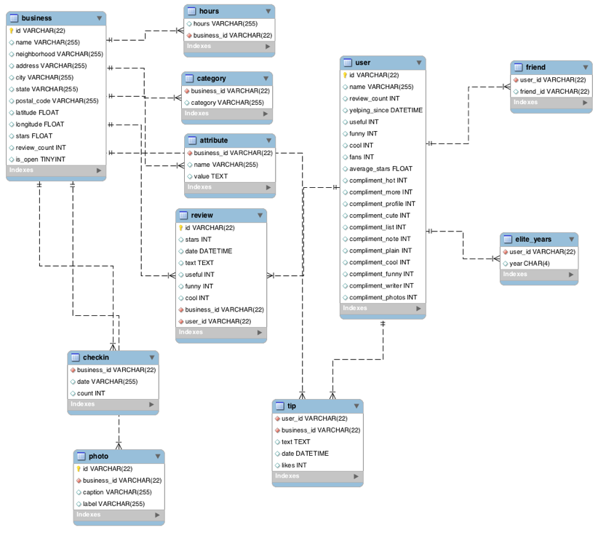
Part 1: Yelp Dataset Profiling and Understanding

1. Profile the data by finding the total number of records for each of the tables below:

i. Attribute table =
ii. Business table =
iii. Category table =
iv. Checkin table =
v. elite_years table =
vi. friend table =
vii. hours table =
viii. photo table =
ix. review table =
x. tip table =
xi. user table =

2. Find the total distinct records by either the foreign key or primary key for each table. If two foreign keys are listed in the table, please specify which foreign key.

i. Business =
ii. Hours =
iii. Category =
iv. Attribute =
v. Review =
vi. Checkin =
vii. Photo =
viii. Tip =
ix. User =
x. Friend =
xi. Elite_years =

Note: Primary Keys are denoted in the ER-Diagram with a yellow key icon.

3. Are there any columns with null values in the Users table? Indicate "yes," or "no."

Answer:

SQL code used to arrive at answer:

4. For each table and column listed below, display the smallest (minimum), largest (maximum), and average (mean) value for the following fields:

i. Table: Review, Column: Stars

min: max: avg:

ii. Table: Business, Column: Stars

min: max: avg:

iii. Table: Tip, Column: Likes

min: max: avg:

iv. Table: Checkin, Column: Count

min: max: avg:

v. Table: User, Column: Review_count

min: max: avg:

5. List the cities with the most reviews in descending order:

SQL code used to arrive at answer:

Copy and Paste the Result Below:

6. Find the distribution of star ratings to the business in the following cities:

i. Avon

SQL code used to arrive at answer:

Copy and Paste the Resulting Table Below (2 columns â€“ star rating and count):

ii. Beachwood

SQL code used to arrive at answer:

Copy and Paste the Resulting Table Below (2 columns â€“ star rating and count):

7. Find the top 3 users based on their total number of reviews:

SQL code used to arrive at answer:

Copy and Paste the Result Below:

8. Does posing more reviews correlate with more fans?

Please explain your findings and interpretation of the results:

9. Are there more reviews with the word "love" or with the word "hate" in them?

Answer:

SQL code used to arrive at answer:

10. Find the top 10 users with the most fans:

SQL code used to arrive at answer:

Copy and Paste the Result Below:

Part 2: Inferences and Analysis

1. Pick one city and category of your choice and group the businesses in that city or category by their overall star rating. Compare the businesses with 2-3 stars to the businesses with 4-5 stars and answer the following questions. Include your code.

i. Do the two groups you chose to analyze have a different distribution of hours?

ii. Do the two groups you chose to analyze have a different number of reviews?

iii. Are you able to infer anything from the location data provided between these two groups? Explain.

SQL code used for analysis:

2. Group business based on the ones that are open and the ones that are closed. What differences can you find between the ones that are still open and the ones that are closed? List at least two differences and the SQL code you used to arrive at your answer.

i. Difference 1:

ii. Difference 2:

SQL code used for analysis:

3. For this last part of your analysis, you are going to choose the type of analysis you want to conduct on the Yelp dataset and are going to prepare the data for analysis.

Ideas for analysis include: Parsing out keywords and business attributes for sentiment analysis, clustering businesses to find commonalities or anomalies between them, predicting the overall star rating for a business, predicting the number of fans a user will have, and so on. These are just a few examples to get you started, so feel free to be creative and come up with your own problem you want to solve. Provide answers, in-line, to all of the following:

i. Indicate the type of analysis you chose to do:

ii. Write 1-2 brief paragraphs on the type of data you will need for your analysis and why you chose that data:

iii. Output of your finished dataset:

iv. Provide the SQL code you used to create your final dataset:

Answers-:
Part 1: Yelp Dataset Profiling and Understanding

1. Profile the data by finding the total number of records for each of the tables below:

i. Attribute table = 10000
ii. Business table = 10000
iii. Category table = 10000
iv. Checkin table = 10000
v. elite_years table = 10000
vi. friend table = 10000
vii. hours table =10000
viii. photo table =10000
ix. review table = 10000
x. tip table = 10000
xi. user table =10000

SQL CODE-:
SELECT COUNT(*)
FROM table

2. Find the total number of distinct records for each of the keys listed below:

i. Business = id: 10000
ii. Hours = business_id: 1562
iii. Category = business_id: 2643
iv. Attribute = business_id: 1115
v. Review = id: 10000, business_id: 8090, user_id: 9581
vi. Checkin = business_id: 493
vii. Photo = id: 10000, photo: 6493
viii. Tip = user_id: 537, business_id: 3979
ix. User = id: 10000
x. Friend = user_id: 11
xi. Elite_years = user_id: 2780

SQL CODE-:
SELECT COUNT(DISTINCT Keys)
FROM table

3. Are there any columns with null values in the Users table? Indicate "yes," or "no."

Answer: No

SQL code used to arrive at answer:
SELECT COUNT(*)
FROM user
WHERE id IS NULL
OR name IS NULL
OR review_count IS NULL
OR yelping_since IS NULL
OR useful IS NULL
OR funny IS NULL
OR cool IS NULL
OR fans IS NULL
OR average_stars IS NULL
OR compliment_hot IS NULL
OR compliment_more IS NULL
OR compliment_profile IS NULL
OR compliment_cute IS NULL
OR compliment_list IS NULL
OR compliment_note IS NULL
OR compliment_plain IS NULL
OR compliment_cool IS NULL
OR compliment_funny IS NULL
OR compliment_writer IS NULL
OR compliment_photos IS NULL

4. Find the minimum, maximum, and average value for the following fields:

i. Table: Review, Column: Stars
min: 1 max: 5 avg: 3.7082

ii. Table: Business, Column: Stars
min: 1.0 max: 5.0 avg: 3.6549

iii. Table: Tip, Column: Likes
min: 0 max: 2 avg: 0.0144

iv. Table: Checkin, Column: Count
min: 1 max: 53 avg: 1.9414

v. Table: User, Column: Review_count
min: 0 max: 2000 avg: 24.2995

SQL CODE-:
SELECT MIN(Column),MAX(Column),AVG(Column)
FROM table

5. List the cities with the most reviews in descending order:

SQL code used to arrive at answer:
select city, sum(review_count)
from business
group by city
order by sum(review_count) desc

Copy and Paste the Result Below:
+-----------------+-------------------+
| city | sum(review_count) |
+-----------------+-------------------+
| Las Vegas | 82854 |
| Phoenix | 34503 |
| Toronto | 24113 |
| Scottsdale | 20614 |
| Charlotte | 12523 |
| Henderson | 10871 |
| Tempe | 10504 |
| Pittsburgh | 9798 |
| Montreal | 9448 |
| Chandler | 8112 |
| Mesa | 6875 |
| Gilbert | 6380 |
| Cleveland | 5593 |
| Madison | 5265 |
| Glendale | 4406 |
| Mississauga | 3814 |
| Edinburgh | 2792 |
| Peoria | 2624 |
| North Las Vegas | 2438 |
| Markham | 2352 |
| Champaign | 2029 |
| Stuttgart | 1849 |
| Surprise | 1520 |
| Lakewood | 1465 |
| Goodyear | 1155 |
+-----------------+-------------------+

6. Find the distribution of star ratings to the business in the following cities:

i. Avon

SQL code used to arrive at answer:
select stars as [Star Rating], count(stars) as [Count]
from business b
where city = 'Avon'
group by stars

Copy and Paste the Resulting Table Below (2 columns - star rating and count):
+-------------+-------+
| Star Rating | Count |
+-------------+-------+
| 1.5 | 1 |
| 2.5 | 2 |
| 3.5 | 3 |
| 4.0 | 2 |
| 4.5 | 1 |
| 5.0 | 1 |
+-------------+-------+

ii. Beachwood

SQL code used to arrive at answer:
select stars as [Star Rating], count(stars) as [Count]
from business b
where city = 'Beachwood'
group by stars

Copy and Paste the Resulting Table Below (2 columns - star rating and count):
+-------------+-------+
| Star Rating | Count |
+-------------+-------+
| 2.0 | 1 |
| 2.5 | 1 |
| 3.0 | 2 |
| 3.5 | 2 |
| 4.0 | 1 |
| 4.5 | 2 |
| 5.0 | 5 |
+-------------+-------+

7. Find the top 3 users based on their total number of reviews:

SQL code used to arrive at answer:
select name, review_count
from user
order by review_count desc
limit 3

Copy and Paste the Result Below:
+--------+--------------+
| name | review_count |
+--------+--------------+
| Gerald | 2000 |
| Sara | 1629 |
| Yuri | 1339 |
+--------+--------------+

8. Does posing more reviews correlate with more fans?
- No

Please explain your findings and interpretation of the results:
- Not necessarily. Amy who has the most
fans, only has 609 reviews. Gerald has 253 fans, but has the
2000 reviews. Some other factors should also be
considered.

SQL code:
select name, review_count, fans
from user
order by fans desc
limit 10

Results:
+-----------+--------------+------+
| name | review_count | fans |
+-----------+--------------+------+
| Amy | 609 | 503 |
| Mimi | 968 | 497 |
| Harald | 1153 | 311 |
| Gerald | 2000 | 253 |
| Christine | 930 | 173 |
| Lisa | 813 | 159 |
| Cat | 377 | 133 |
| William | 1215 | 126 |
| Fran | 862 | 124 |
| Lissa | 834 | 120 |
+-----------+--------------+------+

9. Are there more reviews with the word "love" or with the word "hate" in them?

Answer: Yes. There are 1780 reviews with love and 232 reviews with hate

SQL code used to arrive at answer:
SELECT COUNT(*)
FROM review
WHERE text LIKE '%love%'

SELECT COUNT(*)
FROM review
WHERE text LIKE '%hate%'

10. Find the top 10 users with the most fans:

SQL code used to arrive at answer:
select name, fans
from user
order by fans desc
limit 10

Copy and Paste the Result Below:
+-----------+------+
| name | fans |
+-----------+------+
| Amy | 503 |
| Mimi | 497 |
| Harald | 311 |
| Gerald | 253 |
| Christine | 173 |
| Lisa | 159 |
| Cat | 133 |
| William | 126 |
| Fran | 124 |
| Lissa | 120 |
+-----------+------+

Part 2: Inferences and Analysis

1. Pick one city and category of your choice and group the
businesses in that city or category by their overall star
rating. Compare the businesses with 2-3 stars to the businesses
with 4-5 stars and answer the following questions. Include your code.

i. Do the two groups you chose to analyze have a different distribution of hours?

I picked Las Vegas and Food for this question.
Yes, the restaurants with only 2.5 stars open from 8:00-22:00 on
Saturday. The places with higher rating stars open late on Saturday.

The results from SQL is shown below:
+-----------------------------+-----------+----------+-------+----------------------+
| name | city | category | stars | hours
+-----------------------------+-----------+----------+-------+----------------------+
| Walgreens | Las Vegas | Food | 2.5 | Saturday|8:00-22:00 |
| Sweet Ruby Jane Confections | Las Vegas | Food | 4.0 | Saturday|10:00-19:00 |
+-----------------------------+-----------+----------+-------+----------------------+--------------+

ii. Do the two groups you chose to analyze have a different number of reviews?

Yes. The group with 2.5 stars has less review (06) compared with the group with higher rating stars.

The results from SQL is shown below:
+-----------------------------+-----------+----------+-------+----------------------+--------------+
| name | city | category | stars | hours | review_count +-----------------------------+-----------+----------+-------+----------------------+-------------- +---------+
| Walgreens | Las Vegas | Food | 2.5 | Saturday | 8:00-22:00 | 6| Sweet Ruby Jane Confections | Las Vegas | Food | 4.0 | Saturday | 10:00-19:00 | 30|+-----------------------------+-----------+----------+-------+----------------------+-----------------------

iii. Are you able to infer anything from the location data provided between these two groups? Explain.

Not really. They have different locations.

The results from SQL is shown below:
| name | city | category | stars | hours | review_count | address | postal_code |
+-----------------------------+-----------+----------+-------+----------------------+--------------
| Walgreens| Las Vegas | Food| 2.5 | Saturday|8:00-22:00| 6 | 3808 E Tropicana Ave| 89121 |

Sweet Ruby Jane Confections| Las Vegas| Food|4.0 | Saturday|10:00-19:00 |30| 8975 S Eastern Ave, Ste 3-B| 89123|
+-----------------------------+-----------+----------+-------+----------------------+--------------

2. Group business based on the ones that are open and the ones
that are closed. What differences can you find between the ones
that are still open and the ones that are closed? List at least
two differences and the SQL code you used to arrive at your answer.

i. Difference 1: The ones that are still open have more reviews on average than ones that are closed and the total reviews of the open
ones are more as well compared to the closed ones.
ii. Difference 2: There are more business that are still open listed as useful or funny or cool.

SQL code used for analysis:
SELECT AVG(b.stars) AS AverageStarRating,SUM(b.review_count) AS TotalReviews,AVG(b.review_count) as AverageReviews,COUNT(r.useful)+COUNT(r.funny)+COUNT(r.cool),is_open as OpenorClosed
FROM business b INNER JOIN review r ON b.id = r.id
GROUP BY b.is_open

| AverageStarRating | TotalReviews | AverageReviews | COUNT(r.useful)+COUNT(r.funny)+COUNT(r.cool) | OpenorClosed |
+-------------------+--------------+----------------+----------------------------------------------+--------------+ | 2.0 | 4 | 4.0 | 3 | 0 |
| 2.96153846154 | 504 | 38.7692307692 | 39 | 1 |
+-------------------+--------------+----------------+----------------------------------------------+--------------+

3 For this last part of your analysis, you are going to choose the type of analysis you want to conduct on the Yelp dataset and
are going to prepare the data for analysis.Ideas for analysis include: Parsing out keywords and business
attributes for sentiment analysis, clustering businesses to find commonalities or anomalies between them, predicting the overall
star rating for a business, predicting the number of fans a user will have, and so on. These are just a few examples to get you
started, so feel free to be creative and come up with your own problem you want to solve. Provide answers, in-line, to all of the following:

i. Indicate the type of analysis you chose to do:

We will study the preference among different types of food that people have using the yelp dataset.

ii. Write 1-2 brief paragraphs on the type of data you will need for your analysis and why you chose that data:

I will pick different types of food including Chinese ,Mexican,Italian,Japanese and Indian.
Then I will do analysis on their timings,average star ratings,number of reviews that it gets so that I can get some information
on which type of food is famous among people on yelp.

iii. Output of your finished data
+----------+----------------------+---------------+-------------------+-----------+----------------------+
| category | No_Of_Resturants|AverageStars| AverageReview | city | timings |
+----------+----------------------+---------------+-------------------+-----------+----------------------+
| Chinese | 13 | 3.76923076923 | 423.230769231 | Las Vegas | Saturday|10:00-23:00 |
|Mexican | 28 | 3.625 | 73.0 | Edinburgh | Saturday|12:00-22:30 |
| Italian | 13 | 3.53846153846 | 78.2307692308 | MontrÃ©al | Saturday|11:30-0:00 |
| Indian | 6 | 3.5 | 32.0 | Aurora | Saturday|11:30-14:00 |
| Japanese | 20 | 3.475 | 22.85 | Toronto | Saturday|11:00-23:00 |
+----------+----------------------+---------------+-------------------+-----------+----------------------+

iv. Provide the SQL code you used to create your final dataset:

SELECT c.category,COUNT(b.name) AS No_Of_Resturants,AVG(stars) AS AverageStars,AVG(review_count) AS AverageReviews,
b.city,h.hours as timings
FROM business b INNER JOIN hours h ON b.id = h.business_id
INNER JOIN category c ON c.business_id = b.id
WHERE c.category IN ("Chinese","Mexican","Indian","Japanese","Italian")
GROUP BY c.category
ORDER BY AVG(stars) DESC

