RP INSTITUTE
Affiliated to the University of Mumbai
FIELD PROJECT REPORT
ANALYSIS OF SEASONAL DISEASE PATTERNS USING GOVERNMENT HEALTH DATA
An Epidemiological Surveillance Study of Outbreak Reports in Maharashtra, with Field Evidence from Nallasopara West
Submitted in partial fulfilment of the requirements of the B.Sc. Data Science programme (Semester III), University of Mumbai
Name of Student: | Khan Umar
Roll No.: | [Enter Roll No.]
Programme: | B.Sc. Data Science, Semester III
Mentor / Project Guide: | [Enter name of Project Guide]
Institution: | RP Institute
University: | University of Mumbai
Academic Year: | 2026–27

CERTIFICATE
This is to certify that the Field Project report entitled "Analysis of Seasonal Disease Patterns Using Government Health Data" is the bonafide work of Khan Umar, Roll No. [Enter Roll No.], a student of B.Sc. Data Science, Semester III, RP Institute, affiliated to the University of Mumbai, carried out during the academic year 2026–27 under my guidance, in partial fulfilment of the requirements of the programme.
The work embodied in this report is original to the best of my knowledge and has not been submitted elsewhere for any other degree or diploma.

Project Guide / Mentor: [Enter name] Head of Department / Principal: [Enter name]
Signature: ____________________ Signature: ____________________
Date: ____ / ____ / 2026 Place: ____________________
Internal Examiner: ____________________ External Examiner: ____________________

DECLARATION
I, Khan Umar, a student of B.Sc. Data Science, Semester III, RP Institute, affiliated to the University of Mumbai, hereby declare that this Field Project report entitled "Analysis of Seasonal Disease Patterns Using Government Health Data" is my original work, carried out under the guidance of [Enter name of Project Guide].
The data used in the analysis were obtained from the publicly available weekly outbreak reports of the National Centre for Disease Control (NCDC) under the Integrated Disease Surveillance Programme. The field evidence was collected during a visit on 2 October 2026 with the consent of the facility's Medical Officer In-Charge. No data were fabricated, and no personal or patient-identifiable information was collected or stored. All sources consulted have been acknowledged in the References.

Signature: ____________________
Name: Khan Umar
Roll No.: [Enter Roll No.]
Date: ____ / ____ / 2026
Place: ____________________

ACKNOWLEDGEMENT
I would like to express my sincere gratitude to my Project Guide, [Enter name], for the guidance, encouragement and constructive feedback given throughout this project. I am thankful to the Head of the Department and the faculty of the Department of Data Science at RP Institute for giving me the opportunity to carry out this Field Project and for the instructions that shaped its structure.
I thank the Medical Officer In-Charge and the staff of the Vasai-Virar Municipal Corporation health post at Nallasopara West for their time, openness and permission to observe the facility and to learn how disease reports begin at the local level.
I also acknowledge the National Centre for Disease Control and the Integrated Disease Surveillance Programme of the Government of India for making weekly outbreak reports publicly available, and the authors of the studies cited in this report, whose work informed my own.
Finally, I thank my family and friends for their constant support and patience.

Khan Umar

ABSTRACT
Disease is seasonal, but each disease follows its own calendar, and officials need to know when to prepare for which illness. This field project analyses seasonal patterns in government-reported disease outbreaks in Maharashtra. Using 237 weekly outbreak bulletins of the National Centre for Disease Control (Integrated Disease Surveillance Programme), 809 outbreak records were extracted, validated against the source documents and harmonised. Five disease families were studied: Dengue, Acute Diarrheal Disease (ADD), Malaria, Food Poisoning and Chikungunya, comprising 539 outbreak records, 20,955 reported cases and 266 reported deaths in 2022–2025, with weeks 1–32 of 2026 used as an out-of-sample check.
Dengue events concentrate in June–October and peak in September–October; ADD stays elevated from June to August with a second rise in October; Malaria clusters in May–July, with 61.4% of events in Gadchiroli and Chandrapur; Food Poisoning shows two non-monsoon windows, January–February and April–May; and Chikungunya is diffuse. Only ADD shows significant year-to-year repeatability (Kendall's W = 0.530, p = 0.016). A handful of very large outbreaks, three of which supply 74.7% of February food-poisoning cases, distort case-based peaks, so outbreak counts are used to describe timing.
A visit to a municipal health post in Nallasopara West on 2 October 2026, with a Medical Officer interview, gave context that broadly matched the data and showed how many cases never reach the bulletins. The report recommends calendar-informed preparedness, test-kit logistics, household water-storage campaigns, better data standards and digital reporting. The findings describe reported outbreaks, not population incidence, and imply no climate causation.
Keywords: seasonality, outbreak surveillance, IDSP, NCDC, Maharashtra, Dengue, Malaria, Kendall's W.

TABLE OF CONTENTS
CHAPTER 1: INTRODUCTION 10
1.1 Purpose of the Study 10
1.2 Background 10
Problem Statement 11
1.3 Research Question and Objectives 11
1.4 Scope of the Study 12
1.5 Significance of the Study 12
1.6 Key Terms Used in this Report 12
1.7 The Project Website: Presentation Layer of the Research 13
1.8 Organisation of the Report 14
Problems Faced 15
CHAPTER 2: LITERATURE REVIEW 15
2.1 Seasonality of Infectious Diseases 15
2.2 Surveillance Data Used in Seasonal Studies in India 15
2.3 Seasonal Variation of Outbreaks in India 15
2.4 State and District Level Studies 16
2.5 Current Reporting and Media Evidence 16
2.6 Statistical Methods for Seasonality in Short Series 16
2.7 Qualitative Evidence and Thematic Analysis 17
2.8 Summary of Reviewed Studies and the Research Gap 17
CHAPTER 3: METHODOLOGY 18
3.1 Research Design 18
3.2 Data Source and Acquisition 18
3.3 Extraction, Provenance and Validation 18
3.4 Data Cleaning and Harmonisation 19
3.5 Analytical Framework 19
3.6 Tools and Technology 20
3.7 Field Work Design 21
3.8 Ethical Considerations 22
3.9 Methodological Limitations 22
CHAPTER 4: OBSERVATION AND ANALYSIS 23
4.1 Dataset Overview 23
4.2 Profile of the Five Disease Families 24
4.3 Seasonal Patterns by Disease 24
4.4 Temporal Concentration 27
4.5 Inter-Annual Stability of Seasonal Patterns 28
4.6 Tests for Non-Uniform Timing 29
4.7 Event Frequency versus Case Volume 29
4.8 Outlier Sensitivity 29
4.9 Geographic Patterns 31
4.10 The 2026 Partial-Year Comparison (Weeks 1–32) 31
4.11 Field Observations: PHC Nallasopara West 32
4.12 Comparing the Surveillance Data with the Field Evidence 36
4.13 Evidence Strength and Overall Discussion 37
CHAPTER 5: CONCLUSION AND RECOMMENDATIONS 39
5.1 Summary of Findings 39
5.2 What I Learned 39
5.3 Recommendations 40
5.4 Scope for Future Work 41
REFERENCES 42
APPENDICES 43
Appendix A: Monthly Outbreak Events and Cases by Disease (2022–2025) 43
Appendix B: Short Field Questionnaire (Planned Instrument) 44
Appendix C: Interview Guide Modules 44
Appendix D: Observation Checklist Items Used During the Visit 44
Appendix E: Photographs and Field Documents 45
Appendix F: Repository and Dataset Guide 45
Appendix G: Project Planner 46
Appendix H: Guide Interaction Diary 47
LIST OF TABLES AND FIGURES
Table 1: Key terms and definitions 12
Table 2: Main sections of the project website 13
Table 3: Comparison of reviewed studies with the present study 17
Table 4: Surveillance coverage by year 18
Table 5: Stages of disease-label harmonisation 19
Table 6: Tools used in the project 20
Table 7: Primary cohort baseline (2022–2025) 23
Table 8: Summary profile of the five primary disease families, 2022–2025 24
Table 9: Concentration metrics of reported events 27
Table 10: Stability of the monthly pattern across years 28
Table 11: Kruskal–Wallis and permutation tests of non-uniform monthly timing 29
Table 12: Effect of removing the most influential records 30
Table 13: 2026 W01–W32 compared with the same weeks of 2022–2025 32
Table 14: Field visit summary 33
Table 15: Summary of the interview by module 34
Table 16: Statewide NCDC/IDSP pattern compared with the local facility report 37
Table 17: Evidence strength by disease 37
Table 18: Evidence-based recommendations 40
Table 19: Outbreak events by month 43
Table 20: Reported cases by month 43
Table 21: Structure of the short questionnaire 44
Table 22: Modules of the semi-structured interview guide 44
Table 23: Where to find the project materials 45
Table 24: Project Activity Timeline (2026) 46
Table 25: Record of Interactions with the Project Guide 47
Figure 1: Outbreak records of the five primary disease families by year, 2022–2025. 23
Figure 2: Outbreak events compared with reported cases for each disease family (2022–2025). 24
Figure 3: Monthly outbreak events by disease, Maharashtra, 2022–2025. 25
Figure 4: Share of each disease's events falling in each calendar month (%). 25
Figure 5: Three-month concentration ratio (CR3) by disease. 27
Figure 6: Kendall's coefficient of concordance W for the monthly ranking across 2022–2025 (* p < 0.05). 28
Figure 7: Monthly food-poisoning cases with and without the three largest outbreak records. 30
Figure 8: District share of reported malaria outbreak events, 2022–2025. 31
Figure 9: Outbreak events in weeks 1–32 of 2026 compared with the 2022–2025 mean for the same weeks. 32
Figure 10: Local surveillance pathway at the health post, from patient registration to the national bulletin (from the key-informant interview). 34
Figure 11: Front of the Vasai-Virar Municipal Corporation health post (Sopara) with the covered outpatient frontage, from the field archive. 35
Figure 12: Street-level view of the lane beside the facility showing an open water-logged channel at the roadside, from the field archive. 36
Figure 13: Indoor corridor and service counter of the municipal facility, from the field archive (image time-stamped 22 March 2022). 36

CHAPTER 1: INTRODUCTION

1.1 Purpose of the Study
Every year, hospitals, health posts and municipal offices across Maharashtra see the same cycle: diarrhoea and gastroenteritis rise with the first monsoon rains, fevers fill the outpatient corridors in the weeks after the rains, and occasional wedding feasts or hostel kitchens send dozens of people to hospital within hours. Public health officials, doctors and ordinary residents all know that disease has a season. What is much harder to answer is a precise, evidence-based question: when exactly do reported outbreaks of each disease concentrate, do those patterns repeat from one year to the next, and how much of what we see in the numbers is a real seasonal signal rather than an artefact of how the data are collected?
The purpose of this field project is to answer that question using official government surveillance data and to test the answer against the reality on the ground. The study analyses outbreak records published by the National Centre for Disease Control (NCDC) under the Integrated Disease Surveillance Programme (IDSP) for the state of Maharashtra between 2022 and 2026, focusing on five disease families: Dengue, Acute Diarrheal Disease (ADD), Malaria, Food Poisoning and Chikungunya. The quantitative analysis is complemented by a field visit to a municipal health post in Nallasopara West, Palghar district, where a Medical Officer was interviewed and the surrounding environment was observed.
The study is carried out as the Field Project component of the B.Sc. Data Science programme (Semester III) at RP Institute, affiliated to the University of Mumbai. In line with the faculty guidelines, it combines data collection, data cleaning, visualisation and statistical analysis, uses Python and web tools, and ends with a report that draws actionable conclusions.

1.2 Background

1.2.1 Seasonality and infectious disease
Many infectious diseases show seasonal rhythms. Mosquito-borne infections depend on the life cycle of vectors, which is influenced by temperature, humidity and the availability of standing water. Water-borne and food-borne infections depend on the quality of drinking water, sanitation, the handling of food and the weather that disrupts or supports these. In a country with a pronounced monsoon such as India, these influences produce a recognisable annual pattern: a pre-monsoon and early-monsoon period, a monsoon period and a post-monsoon period, each with its own characteristic illnesses.
Understanding the timing of these patterns is not an academic luxury. If a district health officer knows that malaria reports historically cluster between May and July, rapid diagnostic kits and bed nets must be in place by April. If dengue reports build from August and peak in September and October, vector-control squads and hospital fever beds must be ready before that. Seasonality turns reactive firefighting into planned preparation.

1.2.2 Disease surveillance in India
India's Integrated Disease Surveillance Programme (IDSP) was set up to monitor disease trends and to detect and respond to outbreaks in their early rising phase through trained Rapid Response Teams (RRTs). Surveillance units exist at the Centre, State and District levels. Data are collected through three reporting formats: Form S (suspected cases, filled by health workers), Form P (presumptive cases, filled by clinicians) and Form L (laboratory-confirmed cases, filled by laboratory staff). Whenever there is a rising trend of illness in an area, it is investigated by an RRT. The NCDC compiles the outbreaks reported by states into weekly outbreak reports that are published online as PDF bulletins.
These weekly bulletins are a rich but under-used public resource. Each row records the state, district, disease, number of cases and deaths, the start date of the outbreak, the date of reporting, the current status (for example "Under Surveillance" or "Under Control") and the action taken. However, they are published as semi-structured PDF tables, not as a ready-to-use dataset, which is why this project needed a substantial data-engineering effort before any analysis could begin.

1.2.3 Maharashtra as a study area
Maharashtra is one of India's largest and most diverse states, with 36 administrative districts that span the dense urban belts of Mumbai, Thane and Pune, the drought-prone Marathwada and Vidarbha regions, the forested tribal districts of Gadchiroli and Chandrapur in the east, and the coastal Konkan strip. This diversity makes the state an ideal setting for asking whether a single statewide seasonal pattern exists or whether each disease follows its own calendar and geography.

Problem Statement
India’s public health system generates weekly disease outbreak bulletins through the Integrated Disease Surveillance Programme (IDSP), managed by the National Centre for Disease Control (NCDC). These bulletins contain valuable data on outbreak events across all states, yet the information remains locked inside individual PDF files with no consolidated, analysis-ready dataset available for researchers or planners.
For Maharashtra — a state with 36 districts spanning coastal, Deccan plateau and eastern forest zones — no existing study has systematically examined whether the seasonal patterns of multiple disease families (Dengue, Acute Diarrheal Disease, Malaria, Food Poisoning and Chikungunya) are consistent from year to year, or how much a small number of large outbreaks can distort the overall picture drawn from case counts.
Furthermore, the gap between what is captured in surveillance bulletins and what actually occurs at local health facilities remains poorly documented. Without this understanding, district-level preparedness planning lacks the evidence base needed to allocate resources — test kits, medicines, vector-control teams — to the right months and the right places.
In this project, I address the challenge of untapped and fragmented outbreak data by: (a) extracting and compiling 237 weekly NCDC bulletins into a verified, traceable dataset; (b) applying descriptive and non-parametric statistical methods to evaluate seasonal concentration, inter-annual stability, and geographic clustering across five primary disease families; and (c) collecting primary qualitative field evidence from a municipal health post to contrast surveillance records against ground-level operational realities.

1.3 Research Question and Objectives
Primary research question: What seasonal patterns are evident in selected disease outbreak reports in Maharashtra, and how do these patterns vary across diseases and seasons?
To answer this question the study pursues the following objectives:
- To build a verified, analysis-ready dataset of Maharashtra outbreak records from the NCDC/IDSP weekly bulletins for 2022 to 2026.
- To identify the calendar months and windows in which reported outbreaks of each of the five disease families concentrate.
- To test whether these monthly patterns repeat consistently across the four completed years 2022–2025.
- To examine how far a small number of very large outbreaks can distort conclusions drawn from case counts, as opposed to outbreak counts.
- To describe the geographic concentration of each disease across districts.
- To compare the first eight months of 2026 with the historical baseline, while respecting that 2026 is an incomplete year.
- To collect primary, qualitative field evidence from a local government health facility and compare it, without statistical pooling, with the surveillance picture.

1.4 Scope of the Study
The study covers government-notified outbreak events in Maharashtra reported in NCDC/IDSP weekly bulletins from week 1 of 2022 to week 32 of 2026. Years 2022–2025 are treated as the completed baseline; 2026 (weeks 1–32) is treated strictly as an out-of-sample, partial-year comparison. Five disease families form the primary analytical cohort. Together they account for 539 of the 733 baseline records extracted for 2022–2025 (73.5%); the other records belong to some 25 less frequently reported diseases such as measles, hepatitis A, cholera and scrub typhus.
It is equally important to state what the study does not do. It does not estimate how common a disease is in the population. A surveillance bulletin counts investigated outbreak clusters, not every person who falls ill, and no population denominators are available. It does not claim that rainfall, temperature or humidity cause the observed patterns, because no weather data were linked to the outbreak records. It does not rank diseases by severity or forecast future outbreaks. The field component represents one facility and one informant and is used to give context, not to prove or disprove the statistics.

1.5 Significance of the Study
The study is significant in three ways. First, it converts 237 weekly PDF bulletins into an open, validated, fully traceable dataset that others can reuse. Second, it demonstrates a disciplined analytical approach, including outlier sensitivity testing and explicit limits on interpretation, that prevents the most common mistakes in the analysis of surveillance data. Third, it shows how national data and local field knowledge can complement each other. The result is a set of evidence-grounded, practical suggestions about when different kinds of preparedness are most likely to be needed.

1.6 Key Terms Used in this Report
Table 1: Key terms and definitions
Term | Meaning in this report
Outbreak event (record) | One row in an NCDC/IDSP weekly bulletin: a notified cluster of cases of a disease in a district. This is the basic unit of analysis.
Reported cases | The number of patients enumerated in an outbreak record. It is not the number of people in the population who had the disease.
Disease family | A group of cleaned disease labels with the same clinical definition (for example "Dengue" and "Suspected Dengue Fever").
Baseline | The four completed calendar years 2022–2025.
Out-of-sample window | Weeks 1–32 of 2026, an incomplete year that is not used to fit any pattern.
CR3 (3-month concentration ratio) | The share of a disease's events that fall in its three busiest calendar months. If events were spread evenly it would be 25%.
Kendall's W | A coefficient between 0 and 1 that measures how similarly the 12 calendar months are ranked in different years. Higher means more repeatable seasonality.
Event–case divergence | A situation in which the share of events and the share of cases in a month differ, usually because a few large outbreaks dominate case totals.
IDSP / NCDC | Integrated Disease Surveillance Programme / National Centre for Disease Control, Government of India.

1.7 The Project Website: Presentation Layer of the Research
To present the research for the field-project presentation and viva, a public website was designed and built: https://fieldprojects.vercel.app, with its source code in the GitHub repository RizzyCoder19/Field-Project. The website is not a separate study. It is the interactive presentation layer of the same research, and every number shown on it comes from the data pipeline described in Chapter 3.
The website is built with Next.js, React and TypeScript, uses D3.js for charts and maps, Tailwind CSS for styling and is deployed on Vercel. It tells the story of the research in the same order as this report: the research question, the origin of the data, the cleaning pipeline, the seasonal pattern of each disease, stability testing, outlier sensitivity, the 2026 partial-year check, and finally the field evidence. Its main interactive elements include a radial 12-month seasonal clock, a Maharashtra district map, an interactive seasonal chart, a Kendall concordance visualisation, an outlier sensitivity simulator, a pipeline flow diagram and a timeline of the 2026 surveillance window. A print view produces the document that was used for the printed field-work report.
Table 2: Main sections of the project website
Section | What it presents
Home / Research | Cinematic introduction, the research question and the four sub-questions (when, which, where, how stable).
Data and Sources | Provenance of the NCDC/IDSP bulletins, coverage by year (237 weeks), and the data-engineering pipeline.
Method / Methodology | Eleven-step analytical method, definitions and the explicit boundaries of the analysis.
Seasonality | Radial seasonal clock, monthly charts, concentration ratios, Kendall's W alignment and the 2026 timeline.
Disease pages | One profile for each of Dengue, ADD, Malaria, Food Poisoning and Chikungunya, with key insights and a field-work linkage.
Field Work | The 2 October 2026 facility visit, direct observations, the five-module interview summary and the data-versus-field comparison.
Evidence, Ethics, References | Evidence register, privacy and consent safeguards, and the reference list.

1.8 Organisation of the Report
Chapter 2 reviews related literature. Chapter 3 explains the data, methods and field-work design. Chapter 4 presents the observations and analysis, including the field evidence. Chapter 5 gives the conclusions and recommendations. References and Appendices follow, as prescribed in the faculty guidelines.

Problems Faced
During the execution of this field project, I encountered several practical, technical, and methodological challenges:
1. Data Extraction from Unstructured PDF Bulletins: The NCDC/IDSP weekly bulletins are published as PDF files without standardised table schemas. Column layouts, header labels, and field counts varied across different publication years. To ensure complete accuracy, I personally extracted all Maharashtra rows from 237 weekly PDFs and manually audited each entry against its source bulletin, which was an exceptionally time-consuming process.
2. Inconsistent Disease Nomenclature: In compiling the data, I found that government bulletins frequently used inconsistent naming conventions and spelling variations for identical conditions (for instance, “Dengue”, “Dengue Fever”, “DENGUE”, and “Dengue?” appeared in different weeks; similarly, “Acute Diarrhoeal Disease”, “Diarrheal Disease”, and “ADD” were used interchangeably). To resolve this, I constructed a comprehensive mapping table to harmonise 47 raw labels into 5 clean disease families and documented every classification decision for full transparency.
3. Missing and Ambiguous Surveillance Fields: Certain bulletin rows lacked district names, had blank or zero case counts, or reported non-specific clinical syndromic labels such as “Fever of Unknown Origin”. I systematically audited and filtered out these ambiguous records to protect the analytical integrity of my final dataset.
4. Short Longitudinal Series Limiting Parametric Models: Because consistent multi-disease reports were available for four completed calendar years (2022–2025), I could not reliably apply standard parametric time-series decomposition or ARIMA models. I resolved this by selecting non-parametric techniques—specifically Kendall’s W for concordance and Kruskal–Wallis tests for seasonal timing—which provided robust statistical validity despite the limited sample length.
5. Field Access Constraints and Instrument Adaptation: My initial field plan envisioned administering a 20-item community questionnaire across multiple health facilities. During my on-site visit to PHC Nallasopara West on 2 October 2026, the medical staff advised me that conducting patient surveys during active outpatient hours was logistically unfeasible. I adapted by conducting an in-depth semi-structured interview with the Medical Officer and performing a facility observation audit, providing valuable clinical grounding for my quantitative findings.
6. Encoding and Character Anomalies in Data Pipelines: The raw PDF extraction introduced special characters, non-breaking spaces, and encoding corruptions that caused runtime errors in my Python processing scripts. I wrote dedicated data cleaning routines to standardise and sanitise the dataset before performing statistical analysis.
7. Partial Time Horizon for 2026: At the time of my research, NCDC data for 2026 was available only through week 32 (early August), leaving the critical post-monsoon dengue peak unobserved. I treated the 2026 figures strictly as an out-of-sample comparison against my 2022–2025 baseline and interpreted all emerging trends with appropriate caution.
8. Absence of Population Denominators: Because government outbreak bulletins report absolute outbreak events and case tallies without local catchment population figures, I could not calculate true per-capita incidence rates. I therefore designed my analysis to evaluate temporal timing, seasonal concentration, and event repeatability rather than making population-level incidence claims.

CHAPTER 2: LITERATURE REVIEW
This chapter summarises what others have written on seasonal patterns of infectious disease in India, on the use of IDSP data for such studies, and on the statistical methods suited to short, noisy surveillance series. It also identifies the gap that this project addresses.

2.1 Seasonality of Infectious Diseases
Seasonality is one of the most widely documented features of infectious disease. In their analysis of the global distribution of dengue, Bhatt and colleagues (2013) estimated that dengue transmission occurs across tropical and subtropical regions, including most of South Asia, and highlighted the role of climate-sensitive Aedes mosquitoes in shaping where and when infection occurs. Public health authorities use such knowledge to time vector-control campaigns, laboratory preparedness and public messaging.
The mechanisms are different for different disease groups. For vector-borne diseases the key factors are the abundance and survival of vectors and the time the pathogen needs to develop inside them. For water-borne diseases they are contamination of water supplies, which often accompanies heavy rain, flooding and damaged pipelines. For food-borne diseases they are food handling and storage conditions, ambient temperature and mass-catering events. A study that looks at several diseases together should therefore expect different seasonal signatures instead of a single "monsoon effect".

2.2 Surveillance Data Used in Seasonal Studies in India
The IDSP key activities report published by the NCDC describes the programme as a decentralised, laboratory-based, IT-enabled surveillance system for epidemic-prone diseases. It states that in 2025 about 184,895 reporting units were covered under syndromic (Form S) surveillance, of which 142,888 (77%) reported; 43,180 under presumptive (Form P) surveillance, of which 35,003 (81%) reported; and 36,414 under laboratory-confirmed (Form L) surveillance, of which 29,949 (82%) reported on the IDSP-IHIP portal. These figures show both the scale of the system and the fact that reporting is not complete. Any analysis based on IDSP data therefore has to be framed as an analysis of what was reported.

2.3 Seasonal Variation of Outbreaks in India
Shukla, Nayak and Mishra (2016) used IDSP outbreak data for 2010–2015 from the Ministry of Health website to examine the burden and seasonality of infectious diseases in India. They classified diseases as vector-borne, food and water-borne, vaccine-preventable and mixed-fever categories and computed seasonal indices using simple monthly averages. They reported 1,496 vector-borne outbreaks affecting 102,109 persons, with dengue the most frequently reported vector-borne disease (686 outbreaks), and found that acute diarrhoeal disease accounted for the largest number of food and water-borne outbreaks (2,819). Vector-borne, food and water-borne diseases peaked in summer and autumn, while vaccine-preventable diseases peaked in winter and spring. They concluded that outbreaks follow seasonality and that preventive strategies should be timed accordingly.
This is the closest methodological precedent for the present study: it also uses IDSP outbreak data and seasonal indices. The present study differs in three ways. It is restricted to a single state, which allows district-level reasoning; it adds formal tests of inter-annual repeatability and of non-uniformity; and it explicitly separates outbreak frequency from case volume to avoid distortion by very large outbreaks.

2.4 State and District Level Studies
Raj, Soorya and Anitha Kumari (2022) analysed IDSP data on vector-borne diseases in Kerala, classifying seasons as summer, rainy and winter and comparing frequencies between seasons with analysis of variance. They found that fluctuations in vector-borne disease were mainly driven by dengue, that diseases increased during the rainy season, and that fatality was low for dengue and malaria but high for acute encephalitis syndrome and scrub typhus. They also called for better quality of data entered from health institutions.
Sakure and colleagues (2026) studied 696 laboratory-confirmed dengue cases at the Government Medical College in Gondia, a tribal district of Maharashtra, from January 2023 to December 2025. They observed a clear seasonal peak in September 2023, in the post-monsoon period, a decreasing year-wise trend in positivity, and geographic clustering. Their finding of a September peak in a Maharashtra district is consistent with the September–October concentration of reported dengue outbreaks found in the present study using a completely different data source.

2.5 Current Reporting and Media Evidence
Current news reports illustrate why timely seasonal knowledge matters. In September 2026, the Brihanmumbai Municipal Corporation released comparative monsoon data showing 5,984 malaria cases in Mumbai from June to 15 September 2026 compared with 4,304 in the same period of 2025, together with a sharp rise in H1N1 cases (488 compared with 65) (mid-day, 2026). Such figures come from a different surveillance stream (city-level municipal data) than the NCDC outbreak bulletins, a reminder that different data systems answer different questions. The present project uses such sources only as context and never mixes them with the outbreak dataset.

2.6 Statistical Methods for Seasonality in Short Series
Surveillance series are short, sparse and non-independent: an outbreak reported in one week raises the probability of further reports in the next because of active case-finding. For this reason the project avoids methods that assume independent, normally distributed observations. The Kruskal–Wallis test (Kruskal and Wallis, 1952) is a rank-based alternative to one-way analysis of variance. Kendall's coefficient of concordance W (Kendall and Babington Smith, 1939) measures agreement among several rankings and is well suited to asking whether the ranking of months is the same in different years. When several diseases are tested at once, the false discovery rate procedure of Benjamini and Hochberg (1995) is used to control for multiple testing. Permutation tests avoid asymptotic assumptions when counts in individual months are small.

2.7 Qualitative Evidence and Thematic Analysis
Numbers from surveillance systems describe what was recorded, not how it came to be recorded. Qualitative methods such as key-informant interviews and structured observation help to understand the human and administrative steps behind the numbers. The framework by Braun and Clarke (2006) for thematic analysis, which proceeds from familiarisation to coding and then to themes, guides how the field notes and interview responses in this project are organised.

2.8 Summary of Reviewed Studies and the Research Gap
Table 3: Comparison of reviewed studies with the present study
Study | Data and setting | Main finding | Relation to this project
Shukla et al. (2016) | IDSP outbreaks, India, 2010–2015 | Outbreaks are seasonal; vector- and water-borne peak in summer–autumn | Same data family; present study adds state focus, stability tests and outlier analysis
Raj et al. (2022) | IDSP vector-borne data, Kerala | Rainy-season increase, mostly dengue | Confirms rainy-season link in another state; uses ANOVA across seasons
Sakure et al. (2026) | 696 lab-confirmed dengue cases, Gondia (Maharashtra), 2023–2025 | Post-monsoon (September) peak | Independent support for the Sep–Oct dengue concentration
BMC data via mid-day (2026) | Mumbai municipal data, June–Sept 2026 | Malaria and H1N1 higher than 2025 | Contextual only; different data stream
This project | NCDC/IDSP outbreaks, Maharashtra, 2022–2026 W32, plus one field visit | Five distinct temporal signatures; only ADD shows significant repeatability | Combines concentration, stability, sensitivity, geography and field context

Research gap. Existing studies either rely on national aggregates, on single-disease laboratory series, or on simple seasonal indices. Few examine, for one state and several diseases simultaneously, whether the monthly pattern repeats from year to year, how sensitive it is to a handful of very large outbreaks, how concentrated it is geographically, and whether the front-line reality of a health post agrees with the pattern in the published data. This project is designed to fill that gap at the scale of an undergraduate field project.

CHAPTER 3: METHODOLOGY

3.1 Research Design
The study uses a mixed design with a clear division of labour. The primary evidence is quantitative and secondary: outbreak records published by the government in the NCDC/IDSP weekly bulletins. The contextual evidence is qualitative and primary: a structured facility visit with environmental observation and a key-informant interview. The two streams answer different questions. The quantitative stream measures patterns across the whole state; the qualitative stream explains how the numbers are produced and what local conditions look like. By design they are kept separate. They are compared side by side but never merged into one statistical model, because pooling a complete-enumeration administrative dataset with a small, purposively chosen qualitative sample would be an ecological fallacy.

3.2 Data Source and Acquisition
The data source is the series of weekly outbreak reports published by the NCDC (https://ncdc.mohfw.gov.in) under IDSP. A total of 237 weekly bulletins were downloaded and archived by year: 52 for 2022, 49 for 2023, 52 for 2024, 52 for 2025 and 32 for 2026 (weeks 1–32). Of the 237 weeks, 203 contained at least one Maharashtra outbreak record and 34 were "NIL" weeks. Weeks 15, 51 and 52 of 2023 were never published on the NCDC archive. This was verified through a forensic check, and no synthetic zeros were inserted for the missing weeks.
Table 4: Surveillance coverage by year
Year | Weeks published | Weeks with outbreaks | NIL weeks | Records extracted | Remarks
2022 | 52 | 36 | 16 | 79 | Complete year
2023 | 49 | 38 | 11 | 202 | Weeks 15, 51, 52 not published
2024 | 52 | 52 | 0 | 287 | Every week had at least one record
2025 | 52 | 48 | 4 | 165 | Complete year
2026 (W01–W32) | 32 | 29 | 3 | 76 | Partial year, out-of-sample
Total | 237 | 203 | 34 | 809

3.3 Extraction, Provenance and Validation
Maharashtra rows were extracted from each bulletin into a master table of 809 records. Every record carries its official IDSP identifier, the name of the source PDF, the table page number, the raw district and disease text, cases, deaths, status, outbreak start date and reporting date. A row-level validation compared every extracted record against the source document, so each number in the analysis can be traced back to a specific page of a specific bulletin. Where text could not be extracted directly, extraction confidence was recorded and the row was verified manually.

3.4 Data Cleaning and Harmonisation
Government bulletins use many spellings and labels for the same disease. Examples include "Dengue", "Dengue Fever", "DENGUE" and "Dengue?", or "Diarrhoeal" and "Diarrheal", or "Food Poisoning" and "Suspected Food Poisoning". The cleaning process was designed to be additive: the original label is always preserved in a column called disease_raw, and cleaned labels are added next to it, so nothing is overwritten.
Table 5: Stages of disease-label harmonisation
Stage | Result | What was done
1. Raw strings | 116 distinct labels | Spelling, casing and OCR variants as printed in the bulletins
2. Clean labels | 56 canonical labels | Deterministic dictionary mapping of variants to one spelling
3. Syndromic families | 30 families | Labels with the same clinical definition grouped; hybrid labels such as "Dengue & Chikungunya" kept separate and never split
4. Primary cohort | 5 families | Dengue, ADD, Malaria, Food Poisoning, Chikungunya: 539 of the 733 baseline records (73.5%)

District names were also standardised against the official list. Date fields were converted to a standard format, and epidemiological weeks and months were derived from them. The key quality statistics of the final analytical dataset are given in Chapter 4.

3.5 Analytical Framework
The analysis is organised in layers, each answering one of the objectives in Section 1.3.

3.5.1 Monthly distributions and seasonal concentration
For each disease the number of outbreak events and cases was counted by calendar month. The 3-month concentration ratio (CR3) is the share of events in the three busiest months. With an even spread the value would be 25%, so values near 50% mean strong clustering. The coefficient of variation (CV), the Gini index and normalised Shannon entropy of the 12 monthly counts were computed as additional measures of unevenness.

3.5.2 Inter-annual stability
To test whether the monthly pattern repeats, the 12 months were ranked in each of the four years, and Kendall's coefficient of concordance was computed as W = 12S / [m²(n³ − n)], where m = 4 years is the number of rankings, n = 12 months is the number of items ranked, and S is the sum of squared deviations of the monthly rank totals from their mean. W = 1 means the four years rank the months identically; W = 0 means no agreement. The chi-square statistic m(n − 1)W with 11 degrees of freedom gives an approximate p-value. Because m is only 4, the p-values are treated as exploratory indicators, not confirmatory proof. Pairwise Spearman correlations between years and the shift in peak month from year to year were also computed.

3.5.3 Hypothesis tests for non-uniform timing
Two tests asked whether events are spread evenly across calendar months: the Kruskal–Wallis H-test on monthly counts, and a Monte Carlo permutation goodness-of-fit test with 10,000 random draws under a fixed seed. Because five diseases were tested simultaneously, results are reported with both a Bonferroni threshold (0.05 / 15 = 0.0033) and Benjamini–Hochberg false-discovery-rate adjusted q-values. With 10,000 permutations the smallest possible p-value is about 0.0001, which is the resolution limit of the simulation.

3.5.4 Event–case divergence and outlier sensitivity
For each month the share of events was compared with the share of cases. Records that accounted for an unusually large share of a disease's case total were then removed one set at a time, and the peak month was recomputed. Nothing was deleted from the database: the exercise only shows how fragile a case-based peak is. This step addresses the objective on distortion by large outbreaks.

3.5.5 Geographic concentration
Outbreak counts were tabulated by district, and a district was analysed in detail only if it had at least 10 baseline events of that disease, to avoid conclusions drawn from one or two records. District peak months were compared with the statewide peak.

3.5.6 The 2026 out-of-sample comparison
The 45 primary-cohort records of 2026 weeks 1–32 were compared with the mean number of events in the same weeks (1–32) of 2022–2025. Because dengue historically records 55.4% of its events after week 32, the comparison is explicitly labelled a truncated, descriptive check and not a forecast.

3.6 Tools and Technology
Table 6: Tools used in the project
Purpose | Tool
Data cleaning and statistics | Python (pandas, NumPy, SciPy)
Extraction and validation scripts | JavaScript / Node.js
Charts in this report | Python (Matplotlib)
Interactive website | Next.js, React, TypeScript, D3.js, GSAP, Tailwind CSS
Hosting and version control | Vercel; GitHub (RizzyCoder19/Field-Project)
Qualitative field archive | Local web archive (field_work folder) with questionnaires, guides and checklists

3.7 Field Work Design

3.7.1 Rationale
A government surveillance record is the end product of a long chain: a person falls ill, decides whether and where to seek treatment, a clinician recognises a cluster, a local authority crosses the threshold for investigation, a Rapid Response Team files a notice, and the state compiles it for the NCDC. The statistical analysis models the last stages of this chain. Field work was designed to look at the first stages: how patients arrive at a health facility, how cases are recorded and sent on, what the surroundings look like, and what the local health professionals believe about seasonal disease.

3.7.2 Instruments prepared
- A full questionnaire of 50 items for in-depth interviews and key informants, and a short questionnaire of 20 items for a 5–8 minute community intercept survey.
- A semi-structured interview guide of 12 core themes for health professionals, with probes.
- A structured observation checklist covering drainage, domestic water storage, mosquito breeding receptacles, sanitation, the facility's diagnostic readiness and public-health information material.
- A response template and an evidence register that give every item of evidence an identifier, date, location, consent status and verification status.
The planned design for a larger study would be a purposive sample of 30–50 full questionnaires, 50–100 short questionnaires, 8–15 key-informant interviews and 10–15 observation sheets across urban informal settlements, planned urban zones, peri-urban construction corridors and rural communities.

3.7.3 What was actually carried out
It is important to be transparent about the scale of the field work actually completed. One visit was made on 2 October 2026 between 10:30 and 11:45 a.m. to the PHC Nallasopara West, a Vasai-Virar Municipal Corporation (VVMC) health post in Nallasopara West, Palghar district. During the visit, one structured environmental observation round was conducted (recorded as timed field notes) and one key-informant interview was held with the Medical Officer In-Charge, organised into five modules of the interview guide. No community survey and no patient-level data were collected, and the number of completed questionnaires is therefore zero. All interview responses are paraphrased from field notes and no verbatim quotations are presented as exact words. The field evidence is therefore one facility-level perspective.

3.8 Ethical Considerations
- Consent: prior verbal and institutional consent was obtained from the Medical Officer In-Charge for academic research purposes; participation was voluntary.
- Privacy: no patient names, case sheets or personal health records were inspected, copied or stored. No Aadhaar numbers, phone numbers, addresses or clinical records were collected.
- Photographs: only public infrastructure, drainage and notices are to be photographed, and only with prior permission; patients and private interiors are never photographed.
- Integrity: no simulated interviews, synthetic survey entries or invented field visits are included. Fieldwork is reported exactly as completed.

3.9 Methodological Limitations
The main limitations are summarised here and discussed further in Chapter 4. The data capture investigated outbreak clusters, not all illness. Reporting intensity differs between districts. Case totals are volatile because of rare mass-exposure outbreaks. The 2026 window is truncated at week 32. Only four completed years exist, so inter-annual tests are exploratory. Disease labels, especially "suspected" versus "confirmed", are not uniform. Finally, field evidence comes from a single facility and a single informant on one day and is subject to recall bias and the limits of a snapshot.

CHAPTER 4: OBSERVATION AND ANALYSIS
This chapter presents the findings in the order of the objectives. Section 4.1 describes the dataset; Sections 4.2 to 4.9 present the quantitative results; Section 4.10 describes the 2026 comparison; Sections 4.11 and 4.12 present the field observations and compare them with the data; and Section 4.13 discusses the overall evidence.

4.1 Dataset Overview
After extraction and validation, the analytical dataset contains 809 Maharashtra outbreak records from 237 weekly bulletins. Of these, 733 belong to the baseline years 2022–2025 and 76 to 2026 weeks 1–32. The five primary disease families contribute 539 baseline records, 20,955 reported cases and 266 reported deaths. This corresponds to an overall reported case-fatality ratio of 1.27% among cases enumerated in investigated outbreak clusters. These figures do not measure the risk of dying from the disease in the general population.
Table 7: Primary cohort baseline (2022–2025)
Year | Records | Reported cases | Reported deaths
2022 | 62 | 2,168 | 19
2023 | 161 | 3,989 | 75
2024 | 204 | 10,149 | 55
2025 | 112 | 4,649 | 117
Total | 539 | 20,955 | 266

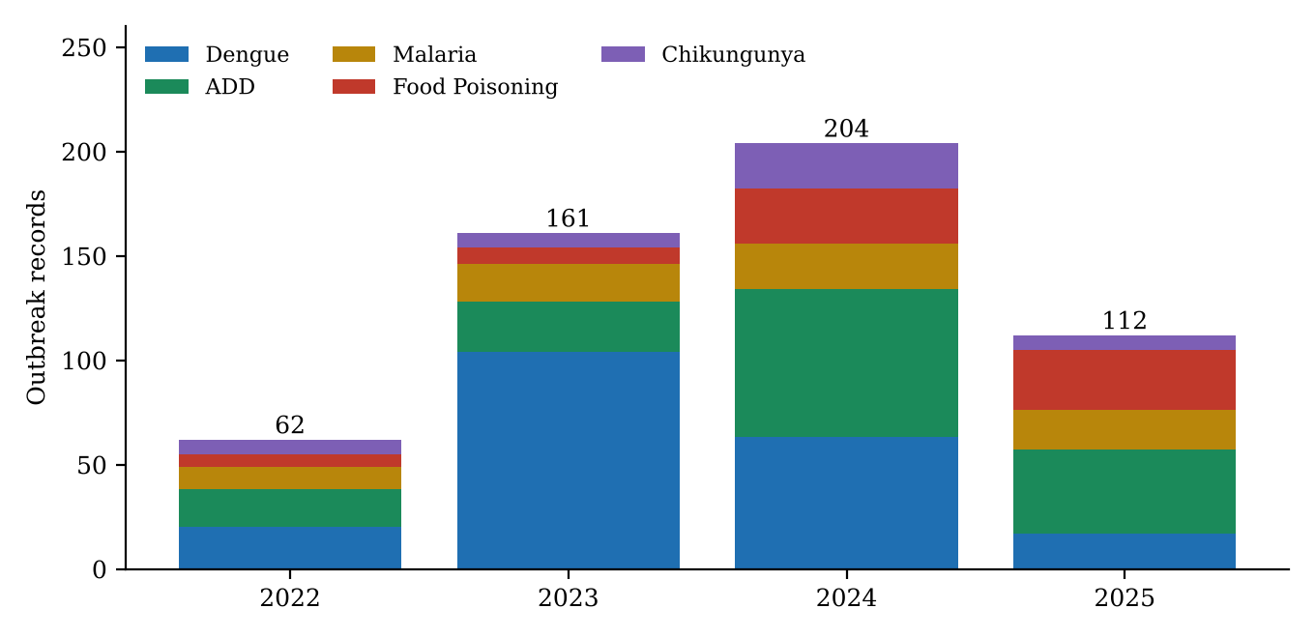
Figure 1: Outbreak records of the five primary disease families by year, 2022–2025.
Reporting volume is uneven across years. 2024 stands out with 204 records and more than 10,000 reported cases, and every calendar week of 2024 had at least one outbreak record. 2022 has the fewest records (62). Because annual volumes differ so strongly, patterns are interpreted from the pooled distribution and also checked year by year (Section 4.6).

4.2 Profile of the Five Disease Families
Table 8: Summary profile of the five primary disease families, 2022–2025
Disease family | Transmission | Records | Cases | Deaths | Cases per event | Case-fatality (%) | Districts
Dengue | Vector-borne | 204 | 3,144 | 93 | 15.4 | 2.96 | 31
Acute Diarrheal Disease | Water-borne | 153 | 9,050 | 93 | 59.2 | 1.03 | 33
Malaria | Vector-borne | 70 | 2,133 | 51 | 30.5 | 2.39 | 15
Food Poisoning | Food-borne | 69 | 5,927 | 29 | 85.9 | 0.49 | 27
Chikungunya | Vector-borne | 43 | 701 | 0 | 16.3 | 0.00 | 15

Dengue is the most frequently reported disease (204 events) but with relatively small clusters (15.4 cases per event), while food poisoning is reported least often among the big four yet produces the largest clusters (85.9 cases per event). ADD generates the largest total number of cases (9,050). Chikungunya has the fewest events and no reported deaths. These differences already show that events and cases measure different things, a theme taken up in Section 4.7.
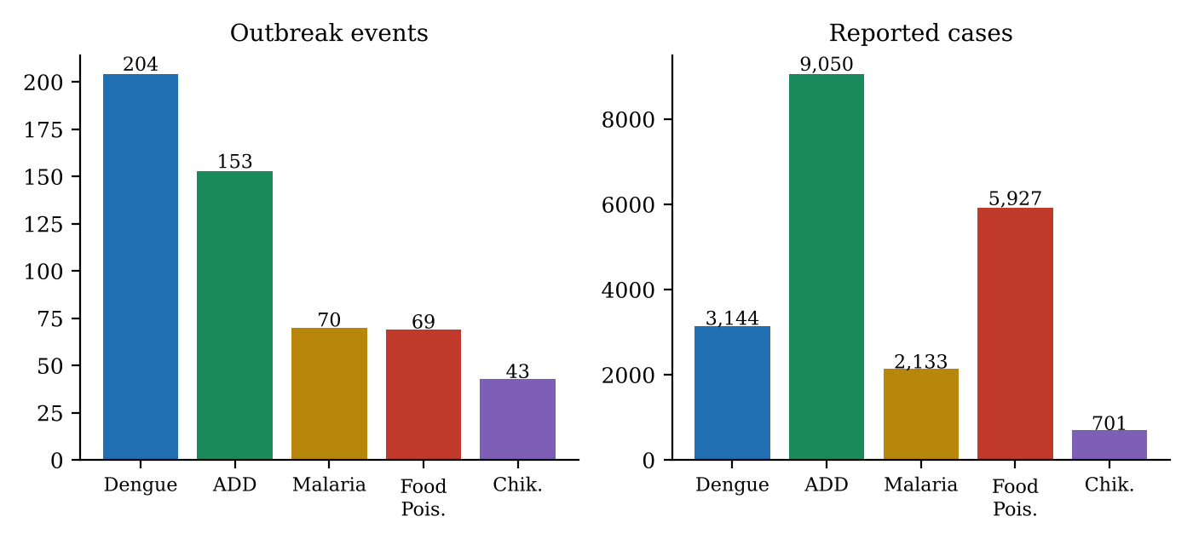
Figure 2: Outbreak events compared with reported cases for each disease family (2022–2025).

4.3 Seasonal Patterns by Disease
Figure 3 shows the number of outbreak events reported in each calendar month for each disease, pooled over 2022–2025, and Figure 4 shows the same information as a heat map in which each row shows how a disease's events are spread over the year.
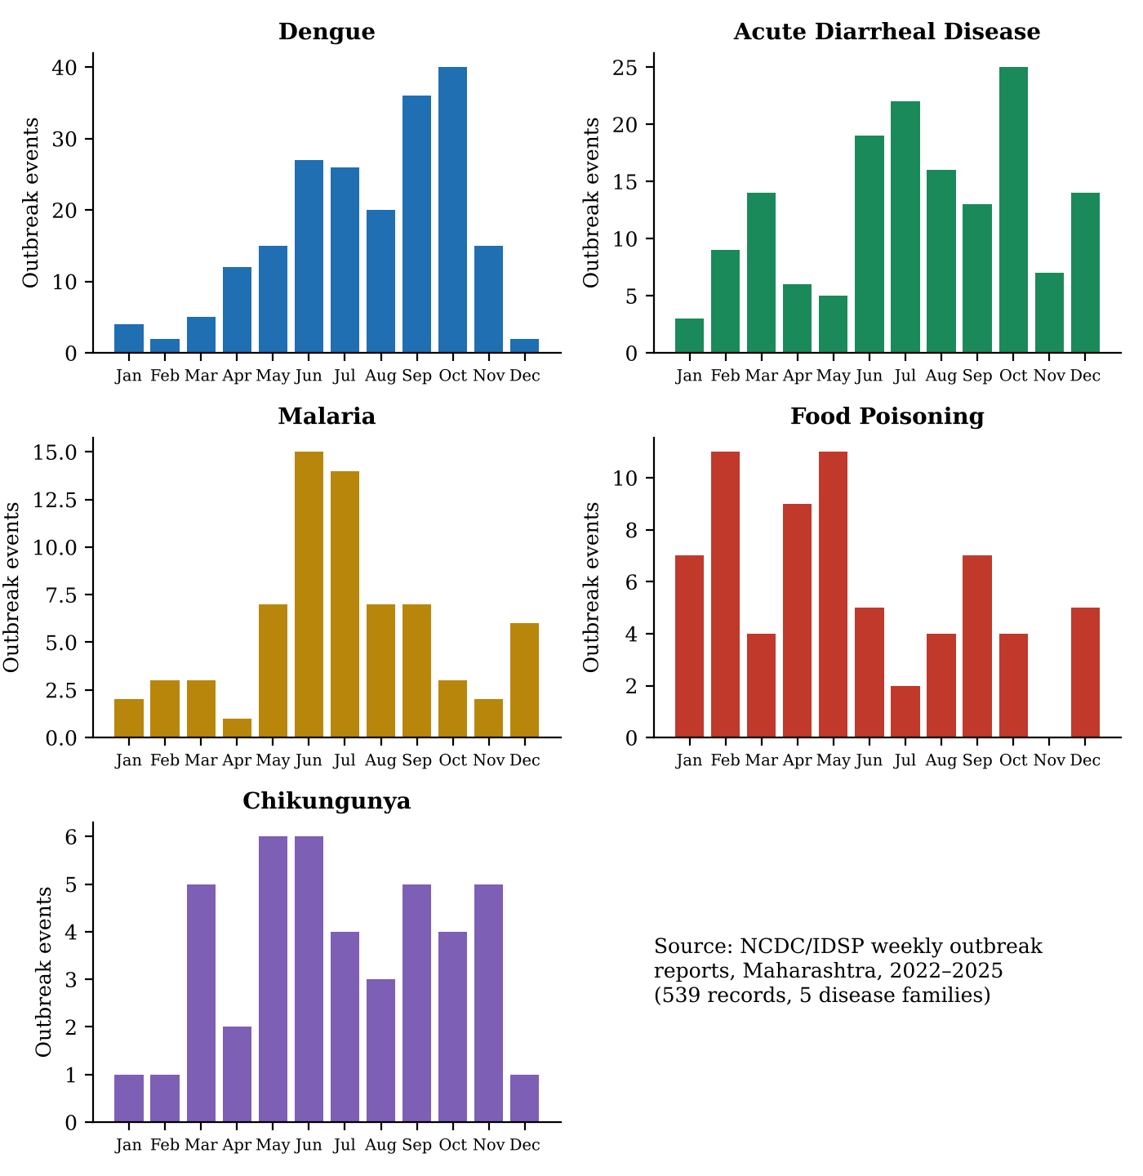
Figure 3: Monthly outbreak events by disease, Maharashtra, 2022–2025.
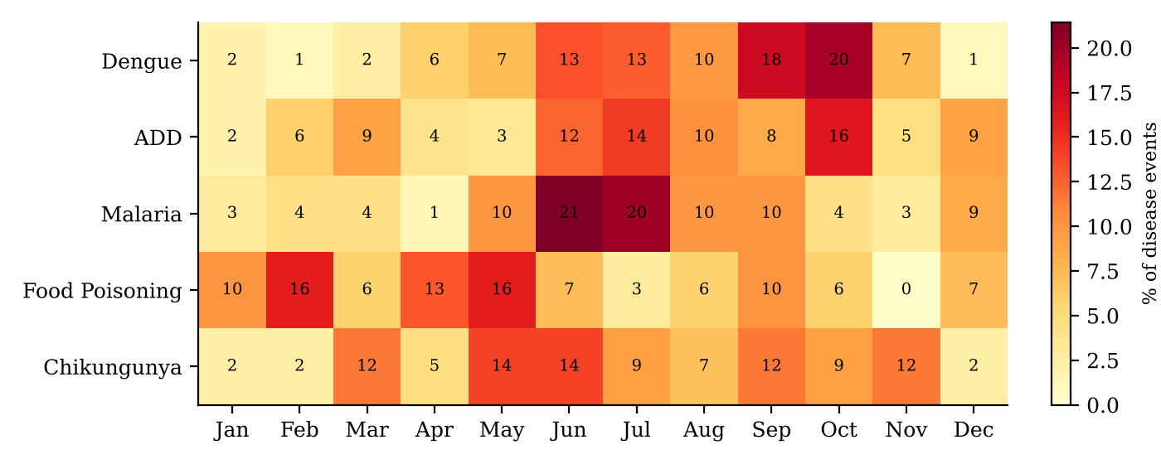
Figure 4: Share of each disease's events falling in each calendar month (%).

4.3.1 Dengue: a late-monsoon and post-monsoon disease
Dengue events rise from May and climb through the monsoon, reaching their highest levels in September (36 events) and October (40 events). Events from June to October make up 149 of 204, or 73.0%; the three busiest months (October, September and June) hold 50.5% of all events, and August to October alone holds 47.1%. December and February are almost silent (2 events each). Dengue is also the disease most resistant to outliers: no single record dominates its case burden, and its reported-case peak stays in October (566 cases) whether or not the largest records are removed. Dengue was reported from 31 districts, so the pattern is statewide rather than local.

4.3.2 Acute Diarrheal Disease: a sustained monsoon plateau with an October rise
ADD shows elevated activity from June to August (19, 22 and 16 events respectively, together 57 events or 37.3%) and a secondary rise in October (25 events, the highest single month). The three busiest months (October, July, June) hold 43.1% of events. Of all five diseases, ADD has the most repeatable month-by-month pattern across years (Section 4.5). It has the widest reach, with 33 districts reporting outbreaks. A notable feature is a spike of 1,582 cases in February, which, as Section 4.8 shows, is caused by a single institutional outbreak of 1,000 cases in Nanded in week 6 of 2024.

4.3.3 Malaria: an early-monsoon disease concentrated in eastern Vidarbha
Malaria events are concentrated in May to July (7, 15 and 14 events), which together hold 51.4% of all events; the contiguous May–July window is the strongest of any disease. In each of the four years the peak or near-peak activity fell within May to July. Geographically it is the most concentrated disease: Gadchiroli (27 events, 38.6%) and Chandrapur (16 events, 22.9%) together account for 43 of 70 events (61.4%).

4.3.4 Food Poisoning: two non-monsoon windows
Food poisoning does not follow the monsoon. Its events cluster in January–February (18 events, 26.1%) and April–May (20 events, 29.0%), and not a single event was reported in November in any of the four years. Because food poisoning is typically a point-source event linked to a particular meal or gathering, the timing reflects when such clusters were notified. No cause such as weddings or catering is inferred from the data.

4.3.5 Chikungunya: a diffuse pattern
Chikungunya has only 43 events spread across the year. May and June each have 6 events, and March, September and November have 5 each. The three busiest months hold just 39.5% of events, the lowest concentration of the five diseases, and no contiguous high-activity window exists. Pune district accounts for 11 of 43 events (25.6%).

4.4 Temporal Concentration
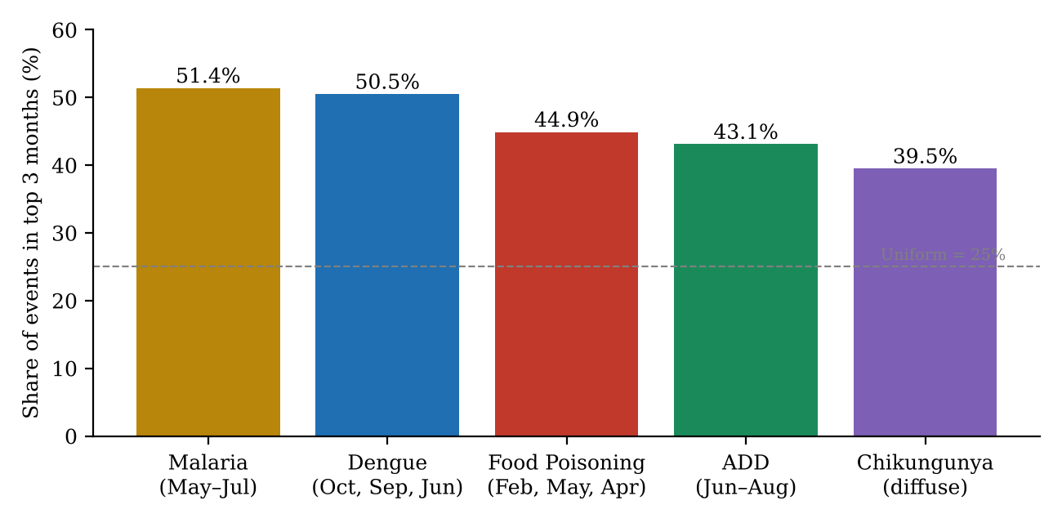
Figure 5: Three-month concentration ratio (CR3) by disease.
Table 9: Concentration metrics of reported events
Disease family | CR3 (events) | Months in CR3 | Event CV | Event Gini | Concentration tier
Malaria | 51.4% | May, Jun, Jul | 0.753 | 0.395 | High
Dengue | 50.5% | Jun, Sep, Oct | 0.736 | 0.414 | High
Food Poisoning | 44.9% | Feb, Apr, May | 0.564 | 0.315 | Moderate
Acute Diarrheal Disease | 43.1% | Jun, Jul, Oct | 0.524 | 0.298 | Moderate
Chikungunya | 39.5% | Mar, May, Jun | 0.515 | 0.289 | Low / diffuse

Malaria and dengue are the two most concentrated diseases: more than half of their events fall in three months. Food poisoning and ADD are moderately concentrated. Food poisoning is interesting because its case concentration (CR3 for cases of 66.7%) is far above its event concentration (44.9%), a first sign that its case totals are dominated by a few large outbreaks.

4.5 Inter-Annual Stability of Seasonal Patterns
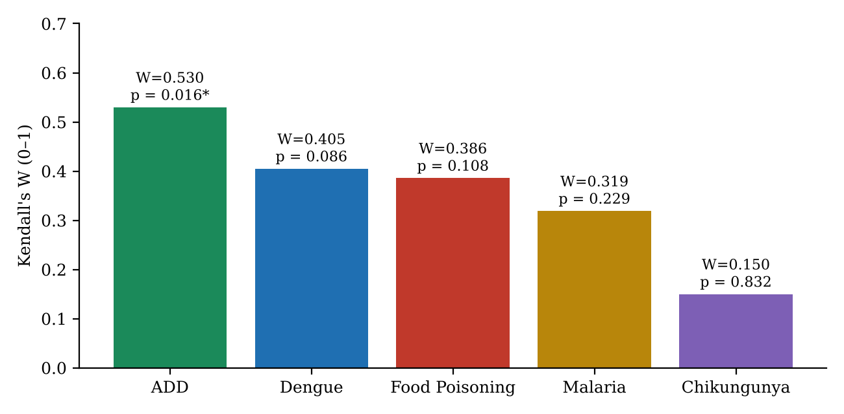
Figure 6: Kendall's coefficient of concordance W for the monthly ranking across 2022–2025 (* p < 0.05).
Table 10: Stability of the monthly pattern across years
Disease family | Kendall's W | p-value | Peak month of event counts by year (2022, 2023, 2024, 2025)
Acute Diarrheal Disease | 0.530 | 0.016* | Dec; Jun/Aug; Jul; Oct
Dengue | 0.405 | 0.086 | Sep; Oct; Jun/Jul; Aug
Food Poisoning | 0.386 | 0.108 | May; Feb/May; Feb; Jan/Apr
Malaria | 0.319 | 0.229 | May; May/Aug/Sep/Dec; Jul; Jun
Chikungunya | 0.150 | 0.832 | May; Jul/Sep/Oct; Jun/Nov; Aug

Only Acute Diarrheal Disease reaches a conventional level of significance (W = 0.530, p = 0.016), and it also remains significant after the false-discovery-rate adjustment (q = 0.034), though not under the stricter Bonferroni threshold. Dengue's W of 0.405 is moderate but not significant. Its precise peak month moves between June/July (2024) and October (2023), even though in every year its activity sits inside the June–October window. Malaria's W is also not significant, yet its core timing is the most consistent of all: the peak fell in May to July in all four years, with a maximum displacement of two months. Chikungunya's W of 0.150 indicates essentially no year-to-year agreement, which is largely an artefact of its small annual counts (7, 7, 22 and 7 events).
Reading the result correctly: "not significant" does not mean "no seasonality". With only four years of data and sparse monthly counts, Kendall's W has little statistical power. The significant ADD result is exploratory, and the p-values rely on a chi-square approximation that is imperfect when m = 4.

4.6 Tests for Non-Uniform Timing
Table 11: Kruskal–Wallis and permutation tests of non-uniform monthly timing
Disease family | Kruskal–Wallis H (p) | Permutation χ² (p) | Conclusion
Dengue | 35.3 (0.0002) | 110.4 (0.0001) | Strongly non-uniform; passes Bonferroni
Malaria | 26.5 (0.0055) | 39.7 (0.0001) | Non-uniform; permutation passes Bonferroni
Acute Diarrheal Disease | 16.3 (0.132) | 42.1 (0.0001) | Permutation test passes; Kruskal–Wallis does not
Food Poisoning | 26.4 (0.0057) | 22.0 (0.024) | Weaker evidence; significant after FDR only
Chikungunya | 12.1 (0.355) | 11.4 (0.416) | No evidence against uniform timing

The tests agree with the concentration results. Dengue, Malaria and ADD show strong departures from an even monthly spread. Food poisoning is weaker, and Chikungunya cannot be distinguished from a uniform distribution. Dengue deserves a comment: the permutation test says its pooled monthly distribution is far from uniform, while Kendall's W says the exact ranking of months is not stable from year to year. These statements are compatible. Dengue reliably concentrates in the second half of the year, but the busiest month varies.

4.7 Event Frequency versus Case Volume
Counting outbreaks and counting patients answer different questions. An event count tells us how often a cluster crossed the threshold for notification. A case count tells us how large the clusters were. The difference is most visible for food poisoning (Figure 3 earlier and Figure 7 below) and for ADD in February, where the share of cases is far greater than the share of events. In ADD the 9 February events contain 17.5% of all ADD cases (1,582 of 9,050) but only 5.9% of events. In malaria, March and January show a similar excess of cases over events, caused by a few unusually large clusters.

4.8 Outlier Sensitivity
Three food-poisoning records are especially large: Kolhapur in week 7 of 2024 (651 cases), Parbhani in week 6 of 2025 (629 cases) and Solapur in week 6 of 2023 (335 cases). Together they account for 1,615 cases, which is 74.7% of all February cases (2,162) and 27.3% of the four-year food-poisoning total (5,927), although February holds only 11 of the 69 events.
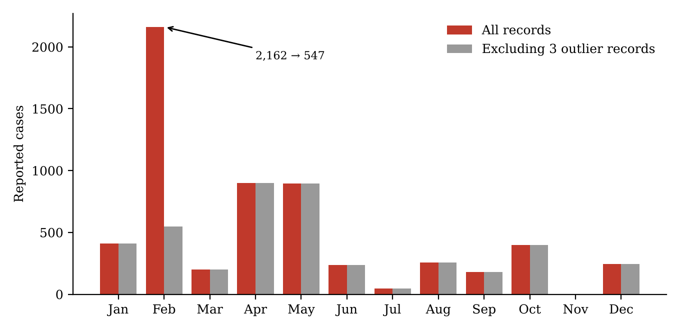
Figure 7: Monthly food-poisoning cases with and without the three largest outbreak records.
When these three records are set aside for the sensitivity test, February drops from 2,162 to 547 cases, the peak reported-case month moves from February to April (899 cases), and February's share of cases falls from 36.5% to 12.7%. The February "peak" is therefore not evidence of a seasonal rise in food poisoning, but of three large point-source outbreaks. The records were not deleted from the database.
Table 12: Effect of removing the most influential records
Disease | Records set aside | Cases removed | Peak case month before → after
Food Poisoning | 3 (Kolhapur, Parbhani, Solapur) | 1,615 | February → April
Acute Diarrheal Disease | 1 (Nanded, 2024 W06) | 1,000 | February → October
Malaria | 1 (Gadchiroli, 2024 W01) | 385 | December → May
Chikungunya | 1 (Kolhapur, 2023 W42) | 145 | October → September
Dengue | None | 0 | October → October (no change)

This analysis shows that dengue's seasonal signal is robust, whereas case-based peaks for the other four diseases depend heavily on single records. For that reason event counts are used as the main measure of timing throughout this report.

4.9 Geographic Patterns
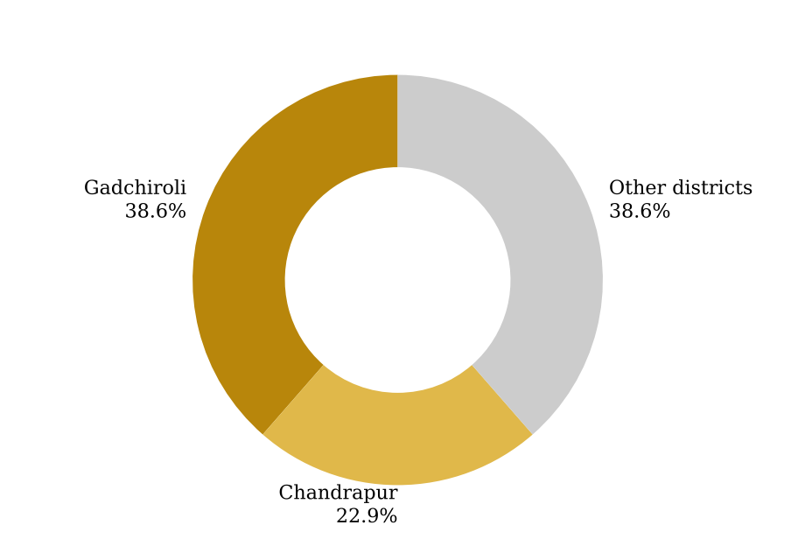
Figure 8: District share of reported malaria outbreak events, 2022–2025.
- Malaria is geographically concentrated: Gadchiroli and Chandrapur in eastern Vidarbha produce 61.4% of events, and both peak in June–July. The statewide malaria picture is therefore mainly a picture of this region.
- Chikungunya is dominated by Pune district (25.6% of events, peaking in September).
- Dengue is spread across 31 districts. Among the eight districts with at least 10 events, Pune (26 events, 12.7%) and Thane (19 events, 9.3%) lead. Several district peaks fall in September or earlier than the statewide October peak, for example Raigad and Kolhapur in June.
- ADD is reported in 33 districts, the widest spread, with Nagpur, Amravati and Kolhapur among the high-volume districts.
A higher number of events in a district should not be read as higher disease risk. It reflects where outbreaks were detected, investigated and notified, which depends on surveillance intensity, laboratory access and administrative practice.

4.10 The 2026 Partial-Year Comparison (Weeks 1–32)
For the first 32 weeks of 2026, 45 primary-cohort outbreak records were reported (2,126 reported cases, no deaths): 6 Dengue, 18 ADD, 1 Malaria, 19 Food Poisoning and 1 Chikungunya.
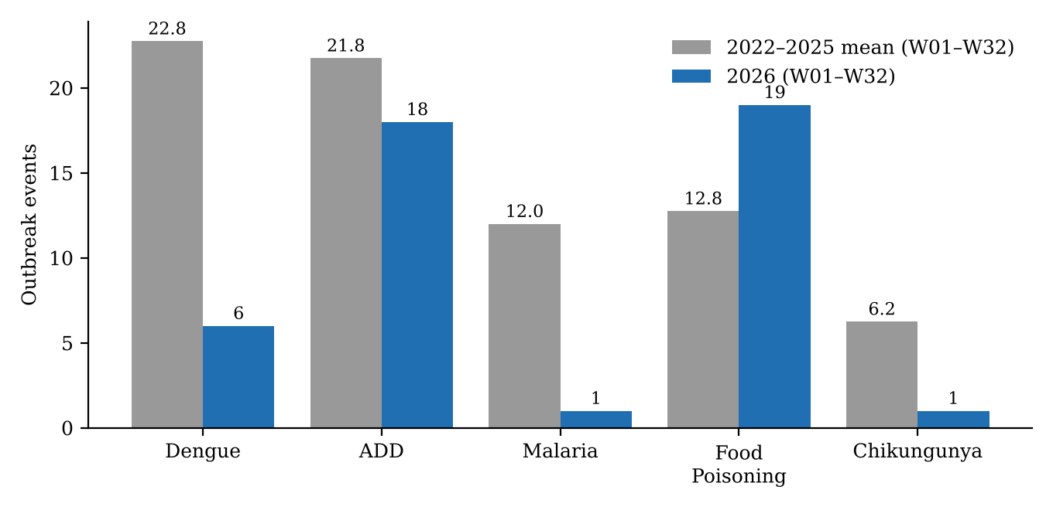
Figure 9: Outbreak events in weeks 1–32 of 2026 compared with the 2022–2025 mean for the same weeks.
Table 13: 2026 W01–W32 compared with the same weeks of 2022–2025
Disease | 2022–25 mean | 2026 | Difference | Interpretive note
Dengue | 22.8 | 6 | −73.6% | Truncation: 55.4% of dengue events occur after week 32
Acute Diarrheal Disease | 21.8 | 18 | −17.2% | Near the historical mean; all 2026 records use the "Diarrhoeal" spelling
Malaria | 12.0 | 1 | −91.7% | Marked reporting deficit; single Gadchiroli event
Food Poisoning | 12.8 | 19 | +49.0% | All 19 records labelled "Suspected Food Poisoning"
Chikungunya | 6.3 | 1 | −84.0% | One event (Pune); later weeks unobserved

The comparison must be read with care. The low dengue count cannot be taken as a mild year, because the weeks in which dengue historically rises have not yet been observed. The food-poisoning increase coincides with a change in labelling ("Suspected" prefix on every record), so reporting practice and real activity cannot be separated. The malaria deficit is striking and deserves follow-up with the reporting district rather than any inference of true decline. The 2026 data are an out-of-sample check, not a validation or a forecast.

4.11 Field Observations: PHC Nallasopara West
This section reports what was observed and discussed during my facility visit on 2 October 2026. I distinguish my direct observations (what I observed on site) from the informant report (what the Medical Officer explained), as they carry different evidential weight.

4.11.1 Site context
The site is a municipal government health post of the Vasai-Virar Municipal Corporation in Nallasopara West, Palghar district. It serves a densely populated peri-urban catchment with informal chawl settlements and multi-storey tenements. It runs a daily outpatient department (OPD), maternal and child immunisation, basic rapid diagnostic testing and community outreach. Palghar district itself includes both tribal, forested areas and dense urban belts such as Nallasopara, a mix that makes it a useful contrast to the forest-fringe malaria districts of eastern Vidarbha.
Table 14: Field visit summary
Item | Detail
Date and time | 2 October 2026, 10:30–11:45 a.m.
Facility | PHC Nallasopara West, VVMC Health Post, Palghar, Maharashtra
Methods | Structured environmental observation; one semi-structured key-informant interview
Informant | Medical Officer In-Charge (not named in the report)
Completed community questionnaires | 0
Key-informant interviews | 1
Consent | Verbal and institutional consent from the Medical Officer; no patient data accessed

4.11.2 Direct observations (field notes)
- OPD triage and footfall (about 10:40 a.m.). The waiting corridor was busy, and triage was handled manually by nursing staff. Approximately 60% of the patients present had acute febrile illness or gastrointestinal complaints.
- Diagnostic point of care (about 11:15 a.m.). A dedicated oral rehydration corner was accessible with clean dispensers. Rapid diagnostic test cards for malaria and dengue (NS1) were in stock and being used by the laboratory technician.
- Perimeter survey (recorded later in the visit). Unlined roadside drainage ditches with intermittent stagnant water were seen along the facility lane. Nearby residential chawls relied heavily on 200-litre blue plastic drums for domestic water storage because of scheduled municipal supply intervals.
These observations are consistent with the conditions that vector-control guidance associates with mosquito breeding (stagnant water and uncovered storage containers), but one morning of observation cannot establish how widespread these conditions are.

4.11.3 The local surveillance pathway
The Medical Officer described how a case moves from the patient to the national bulletin. Patients present at the OPD and symptoms are entered by hand in daily physical registers. Rapid tests (malaria antigen cards and dengue NS1/IgM cassettes) are used for initial diagnosis; samples are sent to the sub-district or district reference laboratory for ELISA confirmation when tests are positive or when unusual clustering occurs. At the close of each day, positive rapid tests are tallied in Form L and symptomatic or presumptive cases in Form P. Each week, usually on Monday, these tallies are consolidated and submitted electronically to the Palghar District Surveillance Unit.
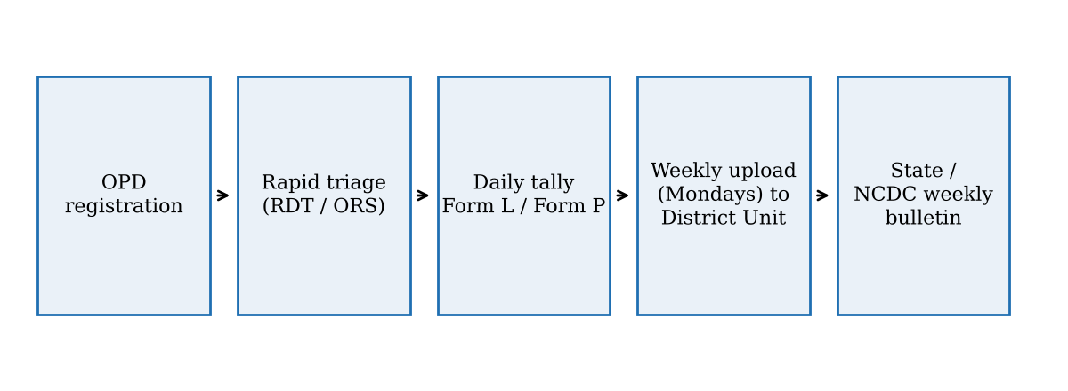
Figure 10: Local surveillance pathway at the health post, from patient registration to the national bulletin (from the key-informant interview).

4.11.4 Key-informant interview (paraphrased)
Table 15: Summary of the interview by module
Module | What the Medical Officer reported (paraphrased)
1. Seasonal patterns and surge dynamics | Footfall rises in two periods. With the monsoon onset in June–July, gastroenteritis and diarrhoea increase rapidly because of contaminated municipal lines and overflowing unlined drains. From September to November, fever dominates the OPD, with clinically suspected dengue and viral fevers peaking as stagnant pools dry out slowly. In Nallasopara, malaria is mainly Plasmodium vivax linked to construction-site stagnation, and dengue is linked to domestic and peri-domestic containers such as overhead tanks and plastic drums.
2. Testing and reporting | Diagnosis relies on clinical evaluation and rapid tests; ELISA confirmation comes from the reference laboratory. Daily register entries are tallied into Forms L and P and sent weekly to the district unit.
3. Response and containment | When three or more suspected cases cluster in one lane or chawl, the sanitation team is alerted. Teams inspect water storage, distribute chlorine tablets, carry out fogging and set up temporary ORS booths. Main hurdles are stock-outs of rapid test kits during sudden dengue surges, slow confirmatory ELISA results, and self-medication through private pharmacies before patients reach the health post.
4. Food-borne illness | Food poisoning presents as sudden cohorts of roughly 15–40 people arriving within hours of a feast, wedding or religious event, whereas ADD presents as steady individual household cases over the monsoon. High ambient heat in April–May is believed to speed bacterial growth in street food, dairy and stored water, producing an early pre-monsoon rise.
5. Data systems and technology | Official bulletins aggregate validated clusters that meet notification thresholds; mild or moderate cases treated and discharged from the OPD may never appear in a bulletin unless a cluster investigation is declared. Direct digital entry at the triage desk with automatic threshold alerts and integration with laboratory results would reduce duplicate manual transcription.

The interview supports a point made in the methodology: the published outbreak bulletins sit at the end of a filtering chain. Many patients treated at the OPD, and many who never reach the OPD, do not enter the surveillance record. A threshold of three or more clustered cases for local action is far below the size of a notified outbreak, so the bulletins show only the tip of the visible illness.

4.11.5 Photographic documentation
The photographs below are from the project's field-work image archive. They show the facility and its surroundings and are included to document the setting described in the field notes. In line with the ethical protocol, none of the selected images shows identifiable patients.
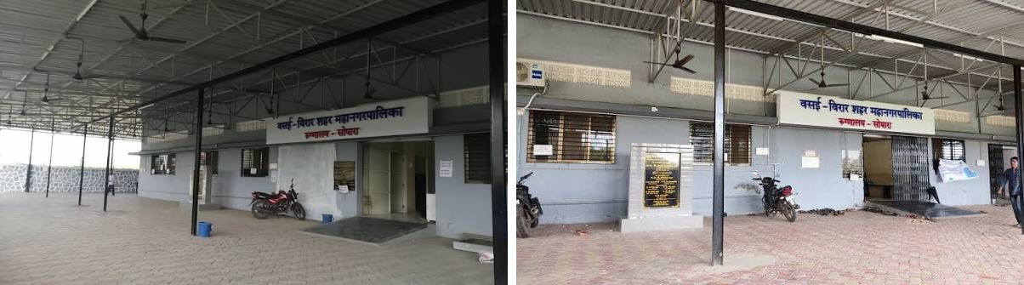
Figure 11: Front of the Vasai-Virar Municipal Corporation health post (Sopara) with the covered outpatient frontage, from the field archive.
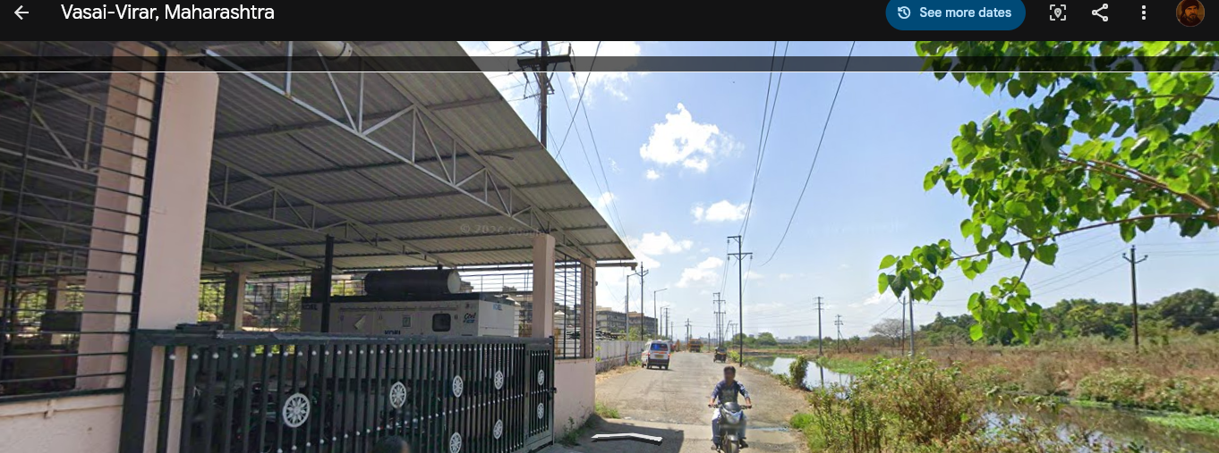
Figure 12: Street-level view of the lane beside the facility showing an open water-logged channel at the roadside, from the field archive.
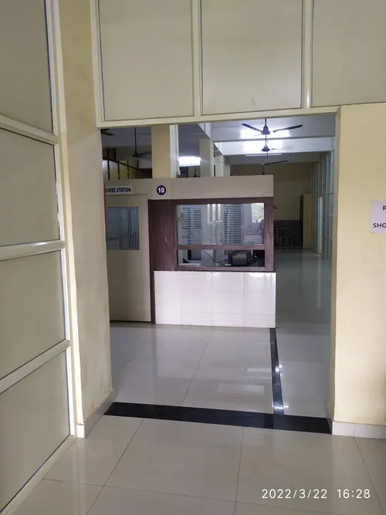
Figure 13: Indoor corridor and service counter of the municipal facility, from the field archive (image time-stamped 22 March 2022).
Note: some archive images may come from public mapping or listing sources and not from the 2 October 2026 visit itself. Replace or supplement them with your own dated photographs, taken with permission, before submission, and credit any third-party image in the caption.

4.12 Comparing the Surveillance Data with the Field Evidence
Table 16 sets the statewide surveillance findings beside what the health-post informant described. The comparison is contextual. It does not test the statistics, because the surveillance data cover 36 districts and hundreds of outbreaks whereas the field evidence is one facility and one informant.
Table 16: Statewide NCDC/IDSP pattern compared with the local facility report
Disease | NCDC/IDSP surveillance (2022–2025) | Medical Officer (Nallasopara West) | Reading of the comparison
Dengue | Jun–Oct concentration (73.0% of events); busiest months Oct and Sep; W = 0.405 | Fever surge Sep–Nov, linked to domestic water drums in the post-monsoon period | Broadly consistent in timing; local account suggests a slightly later end (November) and gives a plausible local mechanism
Malaria | May–Jul window (51.4%); 61.4% of events in Gadchiroli and Chandrapur | Cases peak Jul–Sep; mainly P. vivax linked to construction-site puddles | Local peak is later and the setting urban; the statewide pattern is driven by eastern forest districts, so the two describe different places
ADD | Jun–Aug elevation, October secondary rise; only significant W (0.530) | Sharp rise at first heavy monsoon rain from sewage ingress into old lines | Consistent: onset with monsoon
Food Poisoning | Bimodal Jan–Feb and Apr–May; large point-source clusters (85.9 cases per event) | Sudden cohorts of 15–40 after feasts; pre-monsoon heat effect in Apr–May | Consistent on the cluster character and Apr–May; local clusters are smaller than the largest notified ones
Chikungunya | Diffuse, no stable monthly pattern (W = 0.150) | Sporadic household clusters with prolonged joint pain | Consistent: no strong seasonal signal

Interpretive rule used in this project: the field evidence gives context for how and why the numbers look as they do; it neither proves nor modifies the statistics. The two layers describe different things: the NCDC/IDSP dataset summarises reported outbreak events across Maharashtra, whereas the interview represents one facility-level perspective in Nallasopara West.

4.13 Evidence Strength and Overall Discussion
To summarise how much weight each disease's findings can bear, the findings were graded into four tiers: A (strong descriptive evidence), B (moderate), C (variable or context-dependent) and D (insufficient).
Table 17: Evidence strength by disease
Disease | Seasonal window | Repeatability | Geographic focus | Outlier vulnerability | Tier
Dengue | Jun–Oct (peak Sep–Oct) | Moderate; peak month shifts | Statewide (31 districts) | Highly resilient | A
Acute Diarrheal Disease | Jun–Aug plus Oct | Substantial (W = 0.530) | Statewide (33 districts) | Cases sensitive | B
Malaria | May–Jul | High timing recurrence (4 of 4 years) | Eastern Vidarbha (61.4%) | Cases sensitive | B
Food Poisoning | Jan–Feb and Apr–May | Point-source, intermittent | Dispersed | Extreme | C
Chikungunya | None clear | Unstable (W = 0.150) | Pune (25.6%) | Highly sensitive | D

Four themes run through the results. First, each disease has its own calendar, so a single "monsoon season" message is too blunt for planning: malaria precedes dengue, ADD rises with the first rains, and food poisoning follows gatherings rather than weather. Second, repeatability is weaker than the pooled pictures suggest: the busiest month moves from year to year, and only ADD shows significant agreement between years. Third, case counts mislead where outbreaks are large, so timing is best read from events. Fourth, what is reported is shaped by the reporting system: label changes in 2026, unpublished weeks in 2023, district differences in detection and the threshold-based nature of outbreak notification all influence what appears in the bulletins.

4.13.1 Limitations
- The data show reported outbreak clusters, not population incidence; no incidence, prevalence or individual risk can be calculated.
- No weather data were linked, so no climate causation is claimed; calendar months are labels, not meteorological measurements.
- Districts differ in reporting intensity, so district counts are not measures of risk.
- Weeks 15, 51 and 52 of 2023 were not published, and 2026 ends at week 32.
- Dominant years influence pooled results: 2023 supplies 51.0% of dengue baseline events and 2024 supplies 46.4% of ADD events.
- With four annual profiles, Kendall's W is exploratory and the p-values approximate.
- The field work is a single-facility snapshot with one informant, based on paraphrased notes, and is subject to recall bias.

CHAPTER 5: CONCLUSION AND RECOMMENDATIONS

5.1 Summary of Findings
The project set out to ask what seasonal patterns appear in disease outbreak reports in Maharashtra and how they differ across diseases. Using 539 validated outbreak records of five disease families over 2022–2025 (20,955 reported cases and 266 reported deaths), a partial-year comparison for 2026, and a field visit to a municipal health post, the main conclusions are as follows.
- Distinct temporal signatures. Dengue concentrates in June–October with its highest months in September and October; ADD stays elevated from June to August with a second rise in October; Malaria clusters sharply in May–July; Food Poisoning shows two non-monsoon windows (January–February and April–May); Chikungunya is diffuse with no dominant month.
- Repeatability varies. Only ADD shows statistically significant year-to-year agreement of its monthly pattern (W = 0.530, p = 0.016, exploratory). Malaria's core window recurs in all four years even though W is not significant. Dengue's window is stable but its peak month shifts between June and October.
- Events and cases diverge. A handful of mass-exposure records dominate case totals: three records give 74.7% of February food-poisoning cases, one 1,000-case outbreak creates ADD's apparent February peak, and one 385-case cluster creates malaria's December bump. Dengue is the only disease whose case pattern survives outlier removal.
- Geography differs by disease. Malaria is concentrated in Gadchiroli and Chandrapur (61.4% of events), Chikungunya in Pune (25.6%), whereas Dengue and ADD are reported across more than 30 districts.
- 2026 is only a partial check. Weeks 1–32 show 45 events, with dengue and chikungunya low because the surge weeks are unobserved, ADD near its historical mean, malaria markedly low and food poisoning above its mean with a change in labelling.
- The field evidence gives context. The Medical Officer's account of a June–August diarrhoeal surge, a September–November fever season, sudden feast-related food-poisoning cohorts, and sporadic chikungunya broadly matches the surveillance picture, while also showing how many cases never enter the bulletins.

5.2 What I Learned
Working on this project showed that the hardest part of data science is often before the analysis: turning 237 PDF bulletins into a trustworthy table, with every row traceable to its source, took more effort than any statistical test. It also taught the discipline of limits. It would have been easy to claim that rain "causes" outbreaks or that a district with many events is "dangerous"; the data support neither claim, and learning to say exactly what the data can and cannot show is part of doing science honestly. Finally, the visit to the health post made clear that every row in a dataset stands for people, registers, rapid test kits and decisions taken by tired front-line staff.

5.3 Recommendations
The following recommendations are operational and administrative. They are drawn from the surveillance patterns and the field evidence and are not clinical guidelines. Because the data describe reported outbreaks and not total disease burden, they should be treated as planning cues to be reviewed by public health professionals.
Table 18: Evidence-based recommendations
Area | Recommendation | Basis in this study
Calendar-informed preparedness: Malaria | Position rapid test kits, medicines and vector-control resources in Gadchiroli and Chandrapur by the end of April, ahead of the May–July window. | 51.4% of events in May–July; 4 of 4 years; 61.4% in two districts
Calendar-informed preparedness: Dengue | Activate municipal vector-control squads, source-reduction drives and fever-bed capacity in early August in urban districts such as Pune and Thane. | Events climb from June; Sep–Oct is the peak; 73.0% in Jun–Oct
Calendar-informed preparedness: ADD | Complete pipeline checks, chlorination and water-source disinfection in May, before the June–August window. | Elevated Jun–Aug; only significant inter-annual concordance; field report of sewage ingress at first rain
Local dengue prevention | Run a household campaign before and during September–November on covering and emptying domestic water drums and tanks, supported by regular drain cleaning. | Field observation of uncovered 200-litre drums and stagnant drains; informant account of breeding within 7–10 days
Test-kit logistics | Keep buffer stocks of dengue and malaria rapid tests at health posts from August, and shorten confirmatory laboratory turnaround. | Informant reported stock-outs and ELISA delays in surges
Two-track outbreak response | Use a routine response for frequent small clusters (about 10–50 cases) and a separate rapid protocol for rare very large institutional or feast-related clusters (300+ cases). | Three food-poisoning records and one ADD record account for thousands of cases
Data systems | Allow direct digital entry at OPD triage with automatic cluster alerts and laboratory integration, replacing duplicate paper transcription. | Informant account of manual registers and Forms L/P
Surveillance data quality | Standardise disease labels and spellings, state whether cases are suspected or confirmed, and publish all weeks. | 2026 label shifts; missing 2023 weeks; 116 raw labels for 5 families
Public communication | Publish a simple seasonal disease calendar for each district, like a weather forecast, using the observed windows with clear caveats. | Informant interest in data-driven alerts; distinct disease calendars

5.4 Scope for Future Work
- Link district-level rainfall, temperature and humidity records to the outbreak data to test climate associations formally.
- Extend the baseline as more years of bulletins are published, which would allow more powerful tests of repeatability.
- Complete the planned community questionnaires and a wider set of interviews across settlement types and districts, including a forest-fringe malaria district.
- Add population denominators where available so that rates can be examined alongside counts.
- Observe the unobserved weeks 33–52 of 2026 when they are published to complete the dengue comparison.

REFERENCES
1. Benjamini, Y., & Hochberg, Y. (1995). Controlling the false discovery rate: A practical and powerful approach to multiple testing. Journal of the Royal Statistical Society: Series B (Methodological), 57(1), 289–300.
2. Bhatt, S., Gething, P. W., Brady, O. J., et al. (2013). The global distribution and burden of dengue. Nature, 496(7446), 504–507.
3. Braun, V., & Clarke, V. (2006). Using thematic analysis in psychology. Qualitative Research in Psychology, 3(2), 77–101.
4. Kendall, M. G., & Babington Smith, B. (1939). The problem of m rankings. The Annals of Mathematical Statistics, 10(3), 275–287.
5. Kruskal, W. H., & Wallis, W. A. (1952). Use of ranks in one-criterion variance analysis. Journal of the American Statistical Association, 47(260), 583–621.
6. mid-day online correspondent. (2026, September 18). Mumbai records nearly 6,000 malaria cases during monsoon; BMC intensifies disease control drive across city. mid-day.com.
7. National Centre for Disease Control (NCDC), Ministry of Health and Family Welfare, Government of India. Integrated Disease Surveillance Programme: Weekly outbreak reports, 2022–2026 (weeks 1–32). https://ncdc.mohfw.gov.in
8. National Centre for Disease Control (NCDC), Ministry of Health and Family Welfare, Government of India. IDSP key activities and achievements. https://ncdc.mohfw.gov.in (accessed 27 September 2026).
9. Raj, J., Soorya, V., & Anitha Kumari, K. R. (2022). Trends and seasonality of vector borne diseases in Kerala. International Journal of Community Medicine and Public Health, 9(10), 3701–3709. https://doi.org/10.18203/2394-6040.ijcmph20222559
10. Sakure, K., Tankhiwale, S., Patil, V., & Khadse, R. (2026). The demographic and seasonal variation of dengue virus infection in Gondia, a tribal district in Maharashtra, India. International Journal of Current Pharmaceutical Review and Research, 18(2), 1532–1537. https://doi.org/10.25258/ijcpr.18.2.253
11. Shukla, D., Nayak, P., & Mishra, R. N. (2016). Burden of infectious diseases and their seasonal variation in India. International Journal of Health Sciences and Research.
12. Khan, U. (2026). Analysis of seasonal disease patterns using government health data: Project repository, data pipeline and field-work archive. GitHub: https://github.com/RizzyCoder19/Field-Project
13. Khan, U. (2026). From Data to the Ground: Seasonal disease patterns in Maharashtra (project website). https://fieldprojects.vercel.app

APPENDICES

Appendix A: Monthly Outbreak Events and Cases by Disease (2022–2025)
Table 19: Outbreak events by month
Month | Dengue | ADD | Malaria | Food Poisoning | Chikungunya | All five
Jan | 4 | 3 | 2 | 7 | 1 | 17
Feb | 2 | 9 | 3 | 11 | 1 | 26
Mar | 5 | 14 | 3 | 4 | 5 | 31
Apr | 12 | 6 | 1 | 9 | 2 | 30
May | 15 | 5 | 7 | 11 | 6 | 44
Jun | 27 | 19 | 15 | 5 | 6 | 72
Jul | 26 | 22 | 14 | 2 | 4 | 68
Aug | 20 | 16 | 7 | 4 | 3 | 50
Sep | 36 | 13 | 7 | 7 | 5 | 68
Oct | 40 | 25 | 3 | 4 | 4 | 76
Nov | 15 | 7 | 2 | 0 | 5 | 29
Dec | 2 | 14 | 6 | 5 | 1 | 28
Total | 204 | 153 | 70 | 69 | 43 | 539

Table 20: Reported cases by month
Month | Dengue | ADD | Malaria | Food Poisoning | Chikungunya | All five
Jan | 71 | 151 | 198 | 410 | 17 | 847
Feb | 15 | 1,582 | 15 | 2,162 | 15 | 3,789
Mar | 112 | 635 | 347 | 199 | 38 | 1,331
Apr | 147 | 180 | 25 | 899 | 17 | 1,268
May | 199 | 289 | 374 | 894 | 60 | 1,816
Jun | 507 | 846 | 227 | 236 | 76 | 1,892
Jul | 497 | 1,040 | 190 | 47 | 57 | 1,831
Aug | 461 | 1,300 | 108 | 255 | 48 | 2,172
Sep | 392 | 633 | 139 | 182 | 126 | 1,472
Oct | 566 | 1,383 | 55 | 399 | 164 | 2,567
Nov | 157 | 493 | 7 | 0 | 78 | 735
Dec | 20 | 518 | 448 | 244 | 5 | 1,235
Total | 3,144 | 9,050 | 2,133 | 5,927 | 701 | 20,955

Appendix B: Short Field Questionnaire (Planned Instrument)
The 20-item rapid questionnaire prepared for community intercept surveys (5–8 minutes) is summarised below. It begins with a verbal consent script and ends with an investigator log. It was prepared for deployment in a wider study; no completed community questionnaires are included in this report.
Table 21: Structure of the short questionnaire
Part | Items | Content
I. Respondent and location profile | 1–5 | Form ID, date, location, settlement type, respondent category, years of residence
II. Perceived disease timing | 6–10 | Months when illness rises; diseases observed; peak months of dengue/chikungunya; triggers of diarrhoea; group food-poisoning events
III. Environmental risk and municipal response | 11–14 | Visible risk factors; drinking-water source; timing of fogging and chlorination; visibility of health notices
IV. Reporting and data perceptions | 15–19 | Where families seek care first; awareness of IDSP/NCDC; whether reports capture all illness; usefulness of weekly alerts; one practical suggestion
V. Investigator log | 20 | Stagnant water within 50 m; fogging marks; solid waste accumulation

Appendix C: Interview Guide Modules
Table 22: Modules of the semi-structured interview guide
Module | Core themes
1. Seasonal chronology and local disease onset | Shifts in illness across the year; match of dengue and malaria timing with state data; when gastrointestinal illness becomes critical
2. Outbreak detection, thresholds and reporting pathways | What triggers recognition of an outbreak; how information travels to IDSP; challenges in laboratory confirmation
3. Food poisoning and point-source events | Typical settings of large food-borne clusters
4. Environmental risk factors and interventions | Persistent breeding grounds; whether municipal action is proactive or reactive
5. Public communication, data use and technology | Resident awareness; usefulness of a seasonal forecast
6. Systemic bottlenecks and closing reflection | Single biggest bottleneck; validation question

Appendix D: Observation Checklist Items Used During the Visit
- OPD triage method and approximate share of febrile or gastrointestinal patients.
- Availability of oral rehydration corner, dispensers and supplies.
- Availability and use of rapid diagnostic test kits for malaria and dengue.
- State of drainage along the facility lane (lined or unlined; stagnant water).
- Domestic water storage practices in neighbouring residences (container type and covers).

Appendix E: Photographs and Field Documents
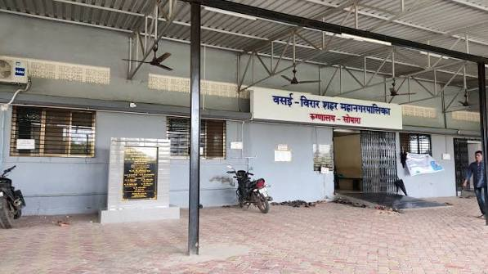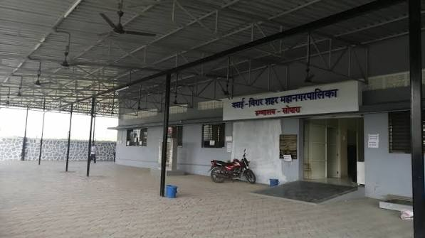
Appendix F: Repository and Dataset Guide
Table 23: Where to find the project materials
Item | Location in repository RizzyCoder19/Field-Project
Clean analytical dataset (809 records) | data_pipeline/analysis/NCDC_Maharashtra_CLEAN_ANALYTICAL.csv
Raw extracted master dataset | data_pipeline/master/NCDC_Maharashtra_MASTER_RAW.csv
Disease label audit and family mapping | data_pipeline/phase5A_disease_audit/
Seasonal distributions and indices | data_pipeline/phase5B_seasonal_analysis/
Concentration, stability, outlier and statistical tests | data_pipeline/phase5C_advanced_analysis/
Interpretation, limitations and unsupported claims | data_pipeline/phase5D_interpretation_validation/
Field instruments and ethics | field_work/
Website source code | website/ (live at https://fieldprojects.vercel.app)

Appendix G: Project Planner
Table 24: Project Activity Timeline (2026)
Activity | May | Jun | Jul | Aug | Sep | Oct
Topic selection and proposal | ■■
Literature review | ■■ | ■■
NCDC bulletin download and archival (237 PDFs) |  | ■■ | ■■
Data extraction and cleaning |  |  | ■■ | ■■
Dataset verification and provenance audit |  |  |  | ■■
Statistical analysis (seasonal, geographic, tests) |  |  |  | ■■ | ■■
Project website development (Next.js, D3.js) |  |  |  |  | ■■ | ■■
Field visit preparation (instruments, permissions) |  |  |  |  | ■■
Field visit to PHC Nallasopara West (2 Oct 2026) |  |  |  |  |  | ■■
Report writing (Chapters 1–3) |  |  |  |  | ■■ | ■■
Report writing (Chapters 4–5) |  |  |  |  |  | ■■
Final review, formatting and submission |  |  |  |  |  | ■■
Note: Shaded blocks indicate the active execution period for each project task across the semester.

Appendix H: Guide Interaction Diary
Table 25: Record of Interactions with the Project Guide
Sr. | Date | Discussion Points / Guidance Received | Guide’s Signature
1 | 15 May 2026 | I met with my project guide to discuss initial topic ideas and proposed analyzing seasonal disease trends in Maharashtra using IDSP surveillance data. My guide approved the topic, helped define the primary scope, and advised me to review published epidemiological literature on national disease surveillance.
2 | 18 June 2026 | I presented my initial literature review draft to my guide. We discussed state-level disease patterns and identified the research gap regarding multi-disease seasonal stability. My guide approved my planned 2022–2026 study timeframe.
3 | 22 July 2026 | I reviewed my data extraction methodology and pipeline with my guide. My guide recommended establishing strict provenance documentation for all 237 weekly bulletins and creating a formal disease harmonisation matrix. We also selected non-parametric statistical methods suited for short longitudinal series.
4 | 21 August 2026 | I demonstrated my cleaned dataset, exploratory seasonal charts, and web dashboard progress. My guide advised me to analyse both event frequencies and case counts to account for outbreak outlier effects. We also reviewed my field visit questionnaire and interview guide.
5 | 06 October 2026 | I debriefed my guide on my field visit to PHC Nallasopara West conducted on 2 October 2026. We reviewed my interview transcript with the Medical Officer and discussed integrating local clinical observations alongside the statewide surveillance findings.
6 | 14 October 2026 | I submitted my near-final draft covering Chapters 1 through 5. My guide reviewed my data visualisations, suggested additions to the methodological limitations and “What I Learned” sections, and approved the final project website presentation.
7 | 20 October 2026 | I presented my completed project report for final evaluation. My guide verified that all Mumbai University guidelines were met, approved the bound submission, and signed the project certificate. We also conducted a preparatory viva discussion.

