**DeepFake Video detection Using Deep Learning**

In this project DL algorithm is used to detect Deepfake faces detection from video input.

To train above model we have used Deepfake faces dataset from KAGGLE repository which contains more than 95000 images and this dataset can be downloaded from below URL

<https://www.kaggle.com/datasets/dagnelies/deepfake-faces>

Above dataset contains two different class labels such as Fake and Real

To detect Deepfake faces we have downloaded videos from below URL

<https://github.com/aaronchong888/DeepFake-Detect/blob/master/train_sample_videos/metadata.json>

From above URL file we can see fake and real videos which we downloaded and tested with our model

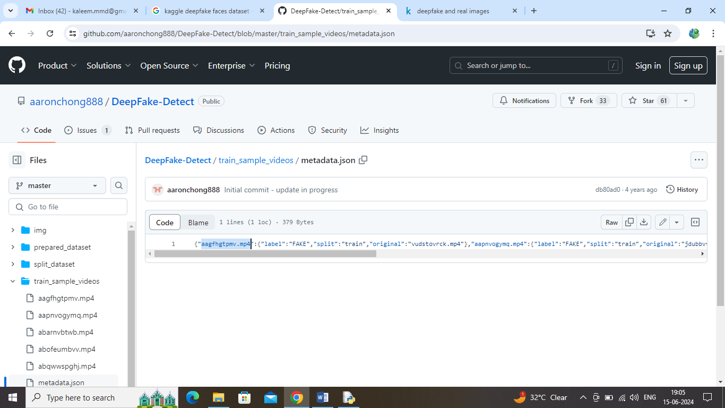

In above URL screen you can see ‘aagfhgtpmv.mp4’ video is fake and ‘abarnvbtwb.mp4’ is the real video and this model is successfully predicting this videos.

To implement this project we have designed following modules

1. Upload Deepfake Faces Dataset: using this module will upload dataset images to application and then application will read all images and then resize to equal sizes and then creating X and Y training array
2. Train DL Model: this module will shuffle, normalize and then split all images into 80:20 percent train and test ratio. 80% images will be input to DL algorithm to train a model and this model will be applied on 20% test data to calculate prediction accuracy
3. Video Based Deepfake Detection: using this module will upload test video and then DL model will analyse faces from each frame slowly and then predict video as Real or Deepfake. Once after prediction will get video playing output with result as fake or real.

To run project double click on run.bat file to get below screen

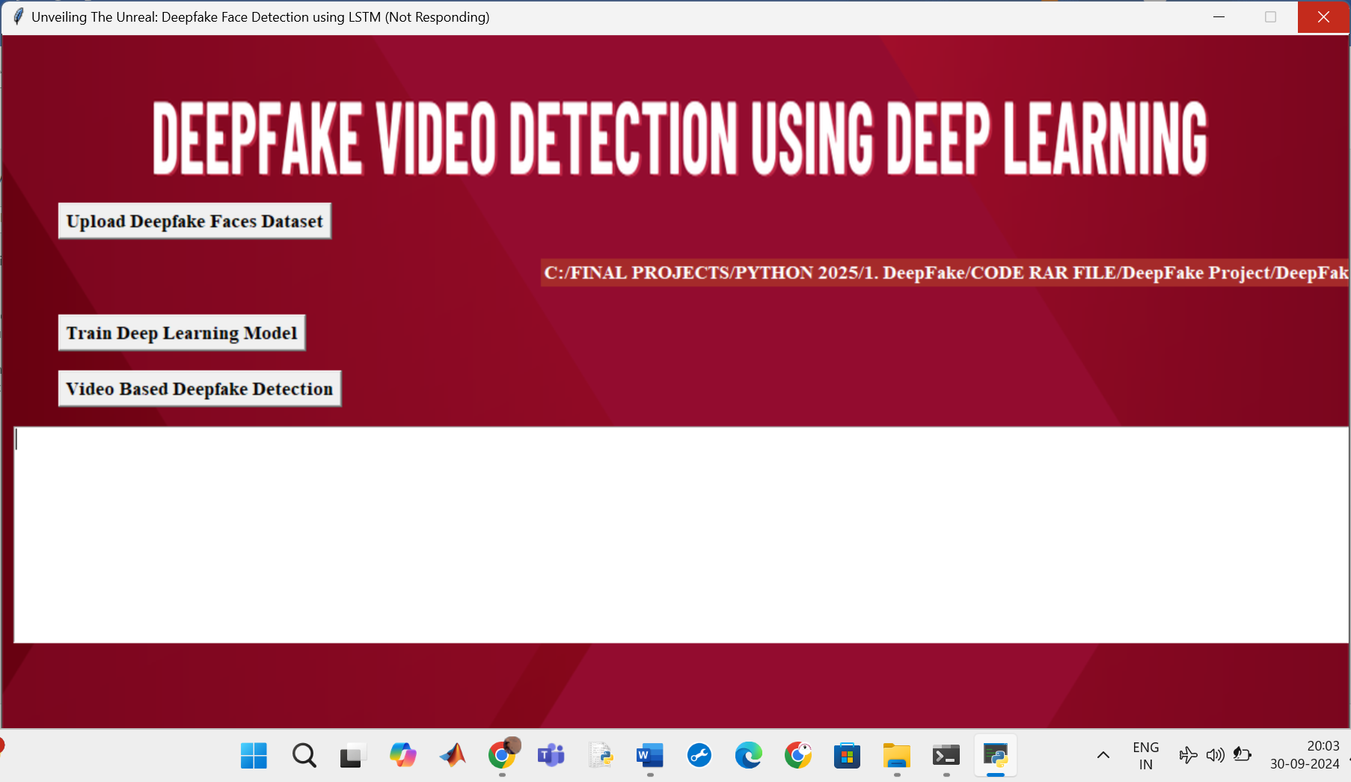

In above screen click on ‘Upload Deepfake Faces Dataset’ button to load dataset and get below page

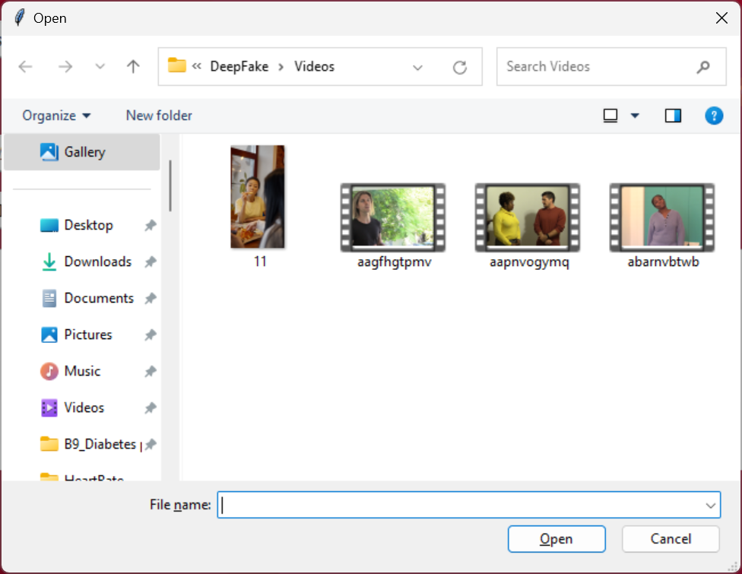

In above screen selecting and uploading dataset annotation file and then click on ‘Open’ button to get below output

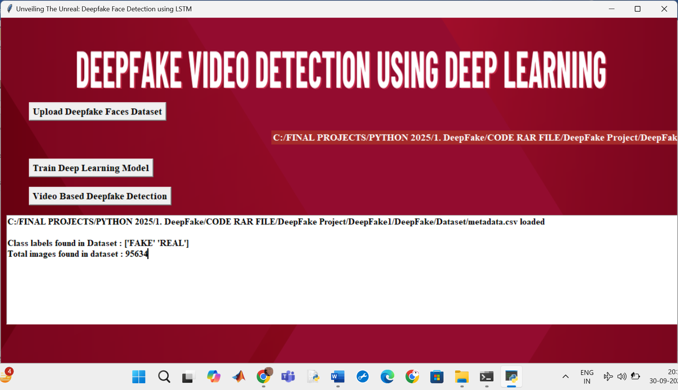

In above screen can see dataset loaded and can see different class labels found in dataset and then can see number of images found in dataset and now click on ‘Train DL Model’ button to train algorithm and get below page

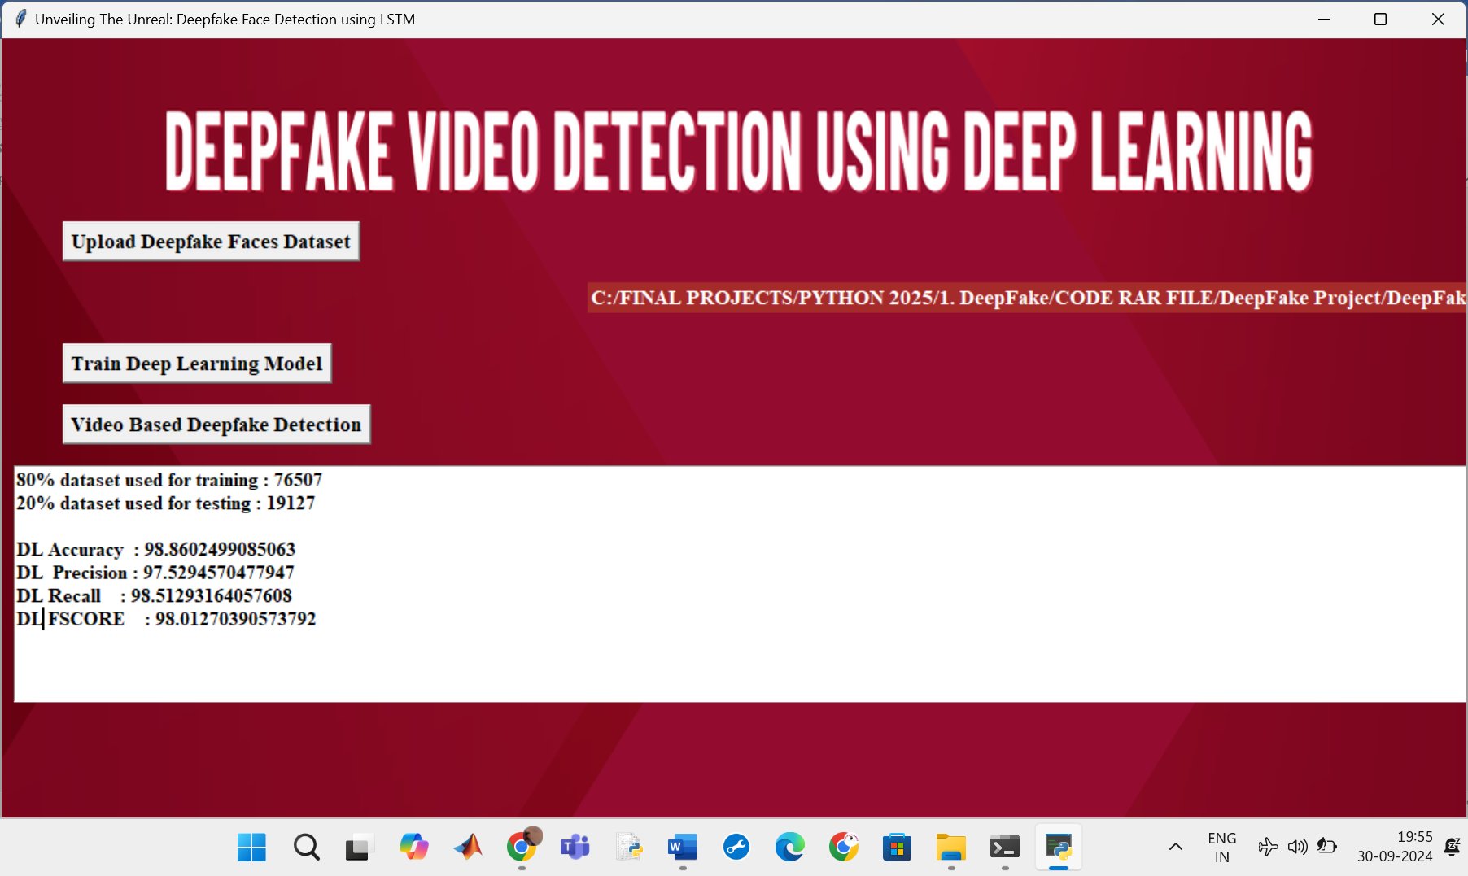

In above screen can see train and test dataset size and then can see DL got 99% accuracy and can see other metrics like precision, recall and FSCORE. Now click on ‘Video Based Deepfake Detection’ button to upload test video and get below page

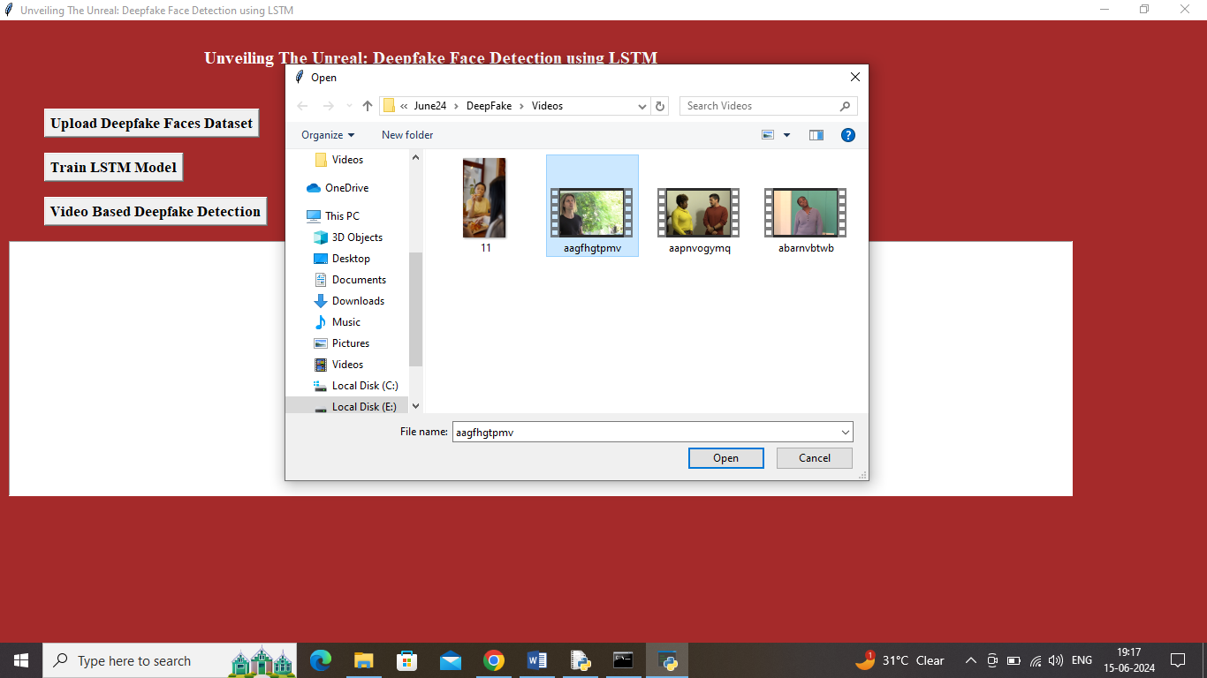

In above screen selecting and uploading 11.mp4 video and then click on ‘Open’ button to start analysing video and get below page



In above screen in blue colour text can see video analysis started and after thorough analysis by DL will get below output

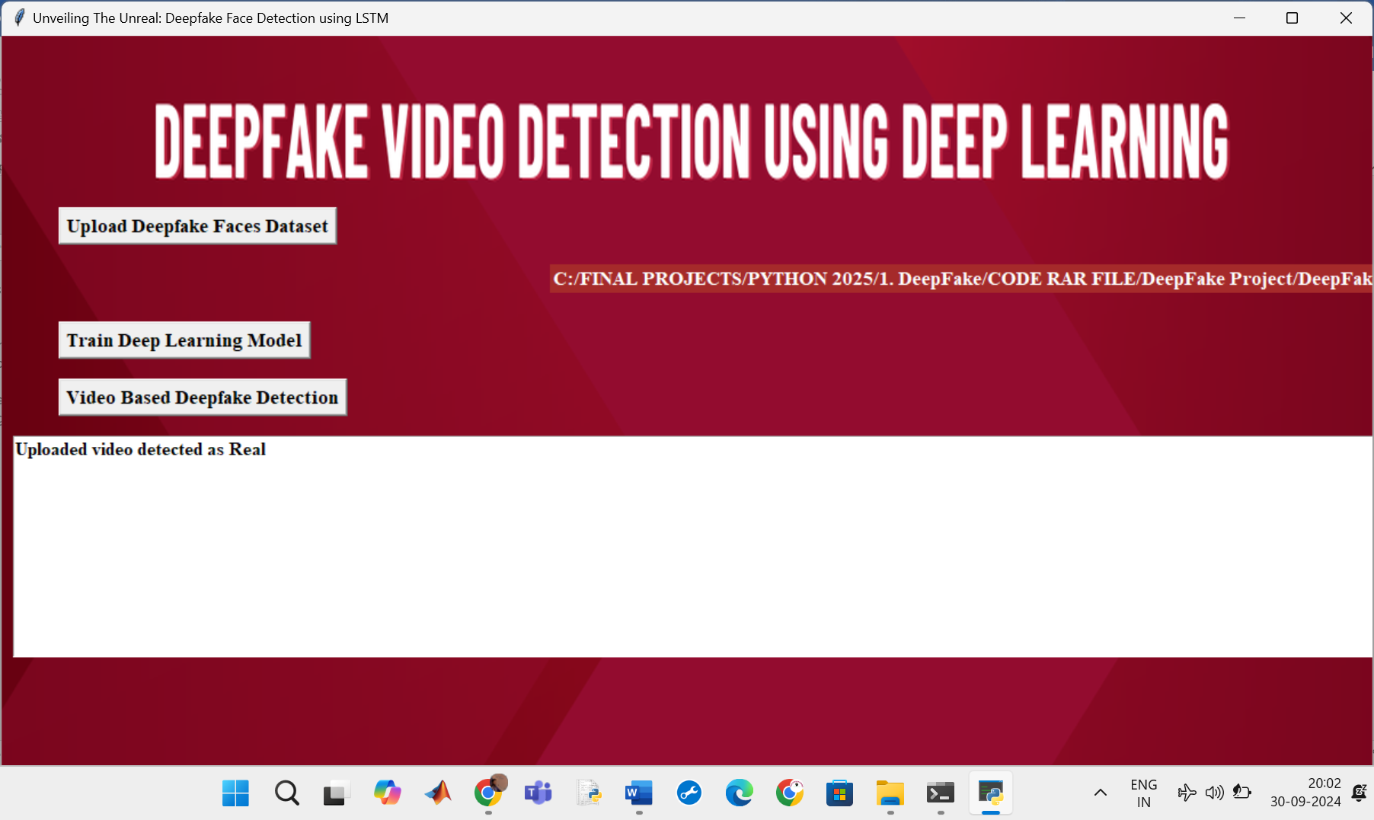



In above screen uploaded video predicted as ‘Real’ and now test with other fake video



In above screen uploading ‘aagfhgtpmv.mp4’ video and then click on ‘Open’ button to load video and get below output

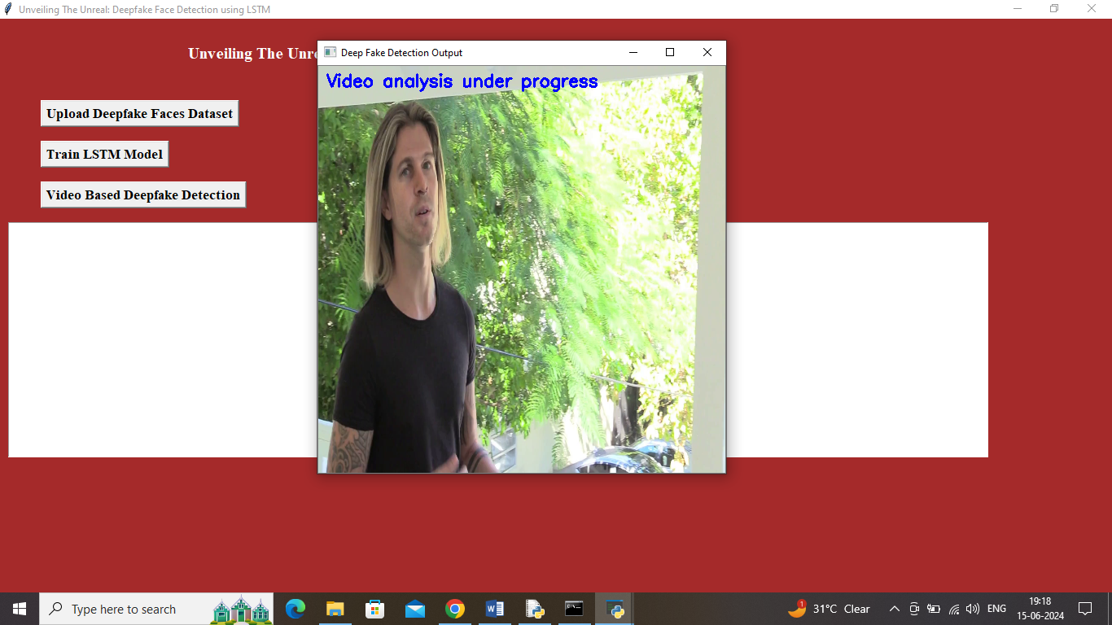

In above screen video analysis under progress and once after analysis will get below output

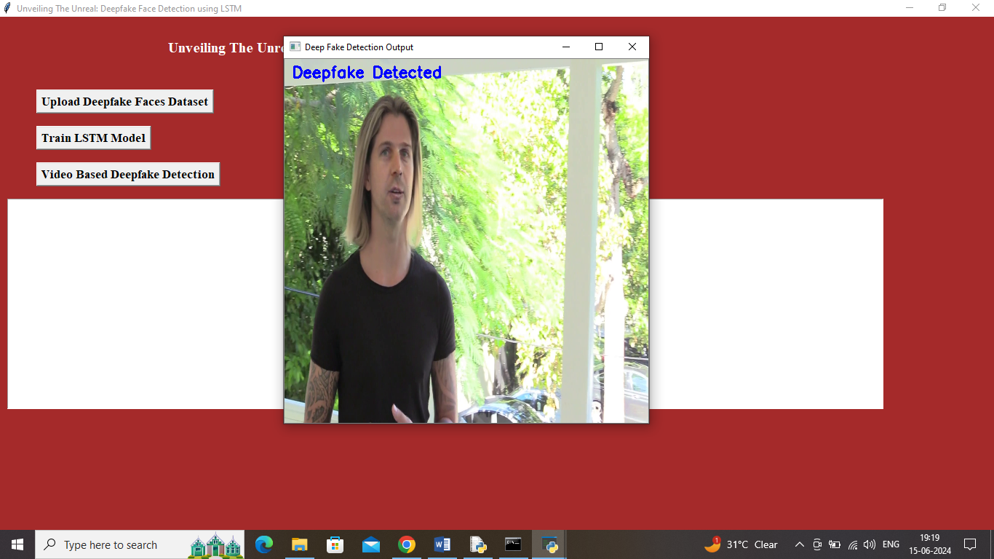

In above screen uploaded video is detected as Deepfake and similarly you can upload and test other video